World War I Propaganda Poster Project

Directions:
Create a World War I themed propaganda poster. You must decorate the poster to be eye
catching so that if a person were walking down the street it would get their attention.
Make sure it is on the right track and appropriate for school. This is due beginning of class on April 20th or 23rd.

Choose one of the following WWI propaganda poster topics:

⇒ Buying Victory Bonds which encouraged public financial support for the war effort.
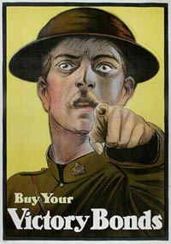

⇒ Saving/Conserving Food Canadians were encouraged to ration and not waste their food.
⇒ Keeping Your Mouth Shut – Canadians were urged not to talk openly about the war
effort in case an enemy spy was listening.
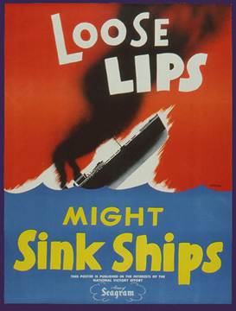
⇒ Joining the Army – young men were encouraged to sign-up for the army.
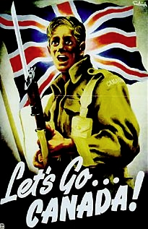

⇒ Demonizing the Enemy (Making the Germans look bad) Canadians were shown
pictures of Germans as baby killing, crazed maniacs, for example.
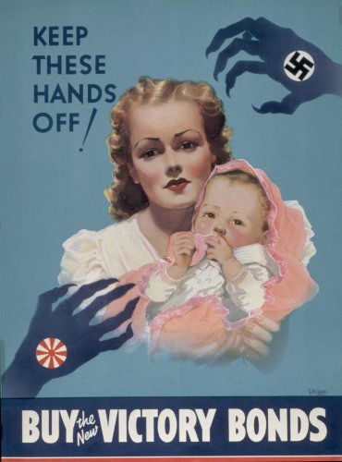

⇒ Women and the war effort – Canadian women were encouraged to help the war effort
by taking on jobs traditionally performed by males, such as working in factories and on
farms.
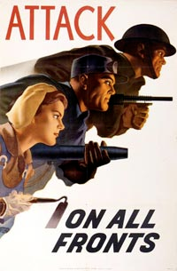

On the back of each poster should be a mini report about your assigned topic. Your mini report should include the following information:
• Who or what is your topic about?
• An analysis of your own propaganda poster. You should clearly explain the
significance your slogan as well as why you included all of the images used.
This mini report should be between 2 and 3 full, well written paragraphs.
Name:
WWI Propaganda Poster Rough Draft

Preliminary Items to be handed in prior to the creation of your propaganda poster end of class on April 16th or 17th:

1. Rough sketch of poster.
2. Answers to your guiding questions.

Draw a rough sketch of your poster in the area below:

Guiding Questions:
1. What topic will your poster be about?
2. Describe the poster you sketched in your own words.
3. What is this poster trying to get you to do?
4. How would this poster support the war efforts?
5. What historical facts are covered in this poster? What historical knowledge would the
viewer needs to fully understand your poster? Explain this part as thoroughly as possible.
6. What type of propaganda technique will you be using in your poster? How will your
poster reflects this type of propaganda?

