AP WORLD HISTORY – PERIOD V (1750 CE – 1900 CE)
Week 24– February 11th – February 15th
Due this Week:
2/13 Question/notes from Toussaint L’Ouverture’s Supplemental Reading
2/13 Notes from Supplemental Reading Land Based Empires
2/13 Revolutions Blog Post due by 10pm
2/14 Key Concept Folder Due
2/15 Atlantic Revolutions Handout Due
2/15 Comparing Revolutions Handout Due

Blogs will be through:
Period 1: https://18-19whapsterperiod1.blogspot.com/
Period 3: https://18-19whapsterperiod3.blogspot.com/ (link on class website)

Monday 2/11. Read supplemental reading on class website: Toussaint L’ouverture Reading on class website. Answer the following question in your notes, due 2/13.
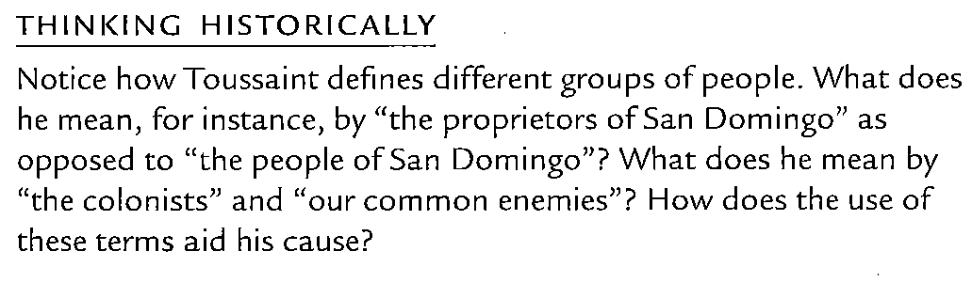
________________________________________________________________________________________
Tuesday, 2/12. Read supplemental reading on class website and take notes (like you do for chapter notes). Supplemental Reading titled “Land Based Empires” Notes due 2/13
________________________________________________________________________________________
Wednesday, 2/13. Start reading Chapter 26. Read pages 590 – 597 stop at “Western Intrusions and the Crisis in the Arab Islamic Heartlands”. Chapter 26 Notes due 2/19
________________________________________________________________________________________

Thursday, 2/14. Read pages 597 “Western” – page 604 “The Last Dynasty: The Rise and Fall of the Qing Empire in China”

Friday, 2/15. Read pages 604 “The Last” – page 612 stop at “Further Readings”. Study for Revolutions Quiz next class. Revolutions Packet due next class.

