AP WORLD HISTORY – PERIOD V (1750 CE – 1900 CE)
Week 23 – February 4th – February 8th
Due this Week:
2/5 Supplemental Reading Notes on Revolutions
2/5 White Man’s Burden Question due
2/7 Scramble for Africa reading questions due
2/7 Periodization Quiz

Blogs will be through:
Period 1: https://18-19whapsterperiod1.blogspot.com/
Period 3: https://18-19whapsterperiod3.blogspot.com/ (link on class website)

Monday 2/4 . Read Supplemental Reading on class website: White Man’s Burden and answer the following question: due 2/5
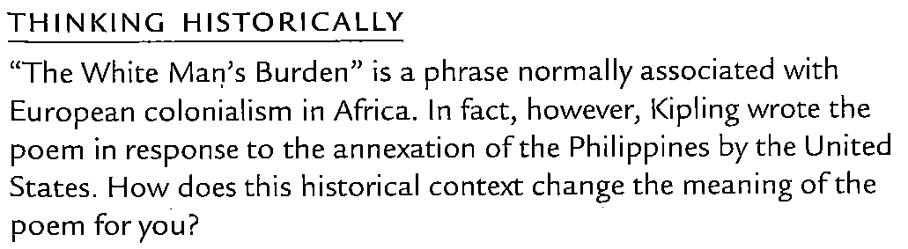________________________________________________________________________________________
Tuesday, 2/5. Read Supplemental Reading on class website: Scramble for Africa. Answer the following question, due 2/7: Study for Periodization quiz next class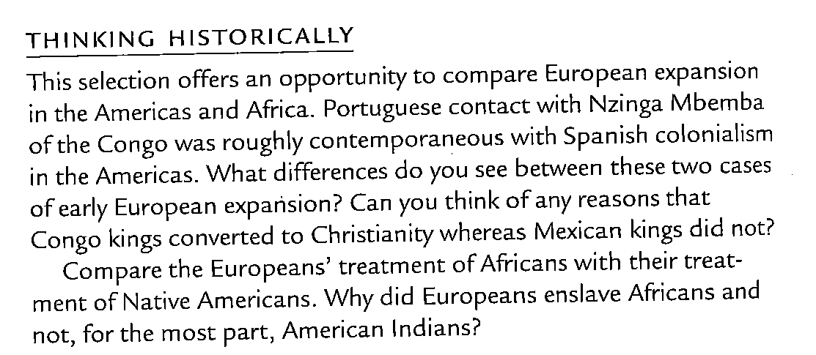
_____________________________________________________________________________________
Wednesday, 2/6. Start reading Chapter 25. Read pages 562 – 568 stop at “New Nations Confront Old and New Problems” Chapter 25 notes due 2/11.
________________________________________________________________________________________
Thursday, 2/7. Read pages 568 “New Nations” – page 578

Friday, 2/8. Read pages 579 – 588 stop at “Further Readings”

