AP WORLD HISTORY – PERIOD V (1750 CE – 1900 CE)
Week 21 - January 21st – January 25th
Due this Week:
1/22 Unit V Overview Notes
1/24 French Revolution Blog Post due by 10pm with 1 response
Blogs will be through:
Period 1: https://18-19whapsterperiod1.blogspot.com/
Period 3: https://18-19whapsterperiod3.blogspot.com/ (link on class website)

Monday 1/21 . No reading tonight.
Tuesday, 1/22. Start Chapter 23. Read pages 512 – 521 stop at “The Consolidation of the Industrial Order”. Chapter 23 Notes due on 1-28.
Wednesday, 1/23. Read pages 521 “The Consolidation” – page 527 stop at “Cultural Transformations”
Thursday, 1/24. Read page 527 “Cultural” – page 537 stop at “Further Readings”

Friday, 1/25. Read supplemental reading on class website. Notes/answers due Monday 1/30.
- Communist Manifesto
  - In your notes answer the question: (due 1/30)
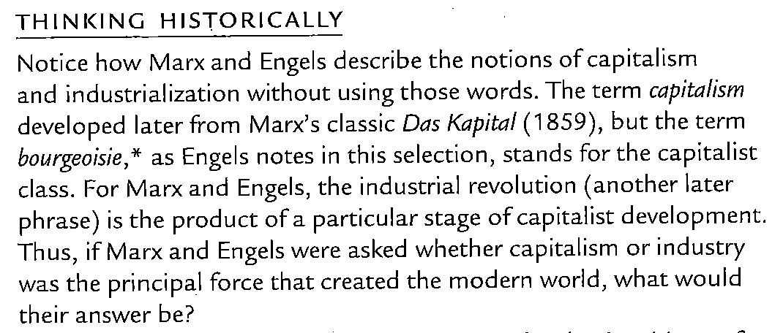
- The French Declaration of the Rights of Man and Citizen
- French Declaration of Rights of Women
  - In your notes answer this question: (due 1/30)
