Global Maritime Expansion

I. Global Maritime Expansion Before 1450

A. Pacific Ocean

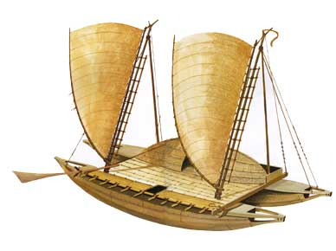
1. Polynesian Voyages--the ancestors of the Polynesians originated in Asia. After centuries of island-hopping migration, Polynesians developed more sea-worthy canoes, some as long as 120 feet (that's 40 yards--nearly half the length of a football field). Polynesian voyagers eventually reached the mainland of the Americas, where they gained access to the sweet potato, which was domesticated first in South America. Long-distance travel spread this nutritious crop as far away as New Zealand.

B. The Indian Ocean

1. Chinese Voyages--the Indian Ocean traders before 1400 operated outside the control of empires and the states they served, but China under the Ming dynasty was becoming more interested in these wealthy ports of trade. Between 1405 and 1433, the Ming sent out 7 imperial fleets, each with an enormous number of ships. The expeditions were led by Admiral Zheng He, a Chinese Muslim eunuch. After 1433, Ming emperors stopped sending out these fleets, influenced by Confucian advisers who thought that people who could not speak Chinese had little to offer them.

II. European Expansion 1400-1500

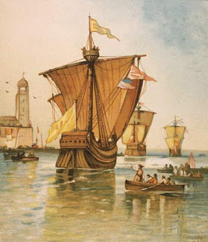

I. Portuguese Exploration

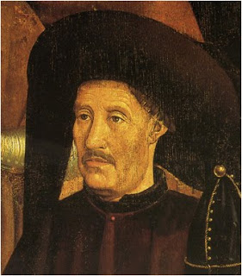

A. Henry the Navigator--younger son of ruling Aviz family. Became head of the religious military organization Order of Christ in 1420. Portuguese nobility, fired by the long, successful struggle against Islam in the Iberian peninsula, and were looking for allies to extend this struggle to retake Jerusalem from Islamic control--preferably with a partner east of the Holy City.

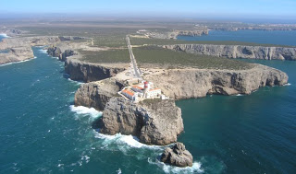

1. Legend of “Prester John”--a supposed long-lost Christian king, located somewhere in Africa (or maybe Asia--nobody is really sure). Henry’s plan seems to have been to seek out the kingdom of Prester John, and ally with it to “free” the Holy Land.

a) Basis in reality?--there were, of course, Christians in eastern Africa (the Coptic Church in both Egypt and Ethiopia), as well as Christians in the Arabian Peninsula, Persia, and India--none of them called Prester John, of course.

2. Systematic exploration--the Portuguese began a systematic exploration of the African Coast to look for the “western Nile” (apparently the Senegal River) that would take them to the kingdom of Prester John.

B. Benefits of Arab Contact

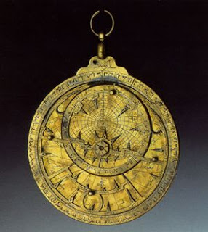

1. Navigational tools--from their Muslim contact, Portuguese sailors had learned to use an astrolab and a compass, and to build a modified ship they called the caravel, which had a lateran sail that allowed the ship to tack better--necessary to navigate on the open ocean (particularly against the wind)

2. Navigational maps--as the exploration process progressed, Portuguese mapmakers grew more skilled, and gathered more information, to draw more accurate maps. These new maps included not only more accurate depictions of land masses, but also indications of the direction and strength of trade winds and sea currents

3. Knowledge of Arab trade routes--Portuguese were also hoping to tap into some of the wealth the Arabs generated from their trade with Africa and Asia.

II. The Expeditions

A. To the “Western Nile”

1. Cape Bojador--the southernmost point known to Europeans to this time. It was a fairly unattractive place, port along the Atlantic coast with Sahara Desert as its hinterland. It eventually was discovered that sailing well into the Atlantic--out of the sight of land--was a better route.

a) Porto Santo (1419)-- “Discovered” by an expedition that got caught in a storm and blown off course; became an important launching point for future expeditions.

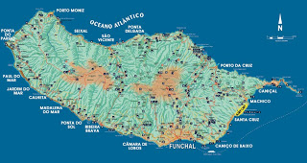

b) Madeira Islands (1420)--became an important source for wood to construct ships (madeira is portuguese for wood); it was colonized, and becomes an important source for industrial agricultural products.

2. Tangiers--Portuguese disasterous attack on this city, held by Berbers. Portuguese army surrounded and forced to surrender; only way to save the army was to send youngest Aviz brother, Prince Fernando, into captivity. He died in captivity four years later. This tragedy seemed to spur Prince Henry on, however.

3. Cabo Branco (Cape Blanco)--an expedition to “make peace” with Africans ended up capturing a number of them, including a chief named Adahu, who provided the Portuguese with much information.

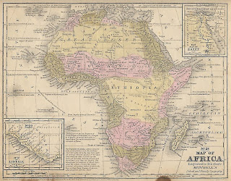

B. The Atlantic Islands and the Development of Slavery--the Portuguese colonized the islands they “discovered” in the Atlantic, probably because they used these as stations during expeditions. Using the model of the islands of the Mediterranean, plantation agriculture using slave labor was quickly developed--particularly the cultivation of sugar cane, which used slave labor; many slaves from Africa were used to cultivate sugar cane in the Mediterranean, and the importation of African slaves to work the plantations on these Atlantic islands seemed a natural progression.
1. Madeira Islands--sugar cane, and grapes (Madeira wine)

2. Azores Island (1427)

3. Cape Verde Islands (1460)

4. Sao Tome (1470)--all these islands were colonized, in contrast to the “factories” that were established on the African coast as trading outposts.

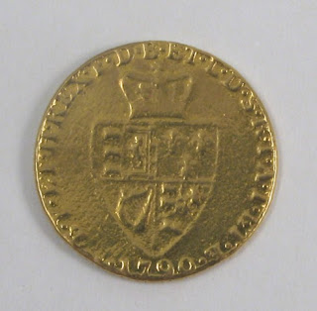

C. Guineas and Gold--Guinea was the name applied to the land south of the Sahara Desert, and to the people living there. It later became applied to a several countries in sub-Saharan Africa. It also became a slang term for the gold coin minted in Great Britain between 1663 and 1813, made with gold mined in Guinea--and those coins were often traded for slaves (Guinea slaves)

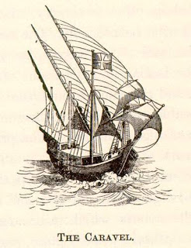

1. Caravel--in 1441, the first expedition to use the caravel was made, and at a village along the Rio do Ouro several people were kidnapped, taken back to Portugal, and sold as slaves--the beginning of the slave trade in Europe (Arabs had dealt in the African slave trade for hundreds of years to this point).

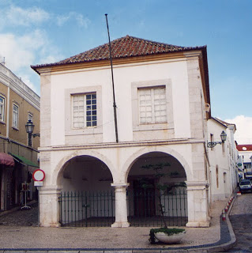

2. Bay of Arguin (1448)--first Portuguese fort constructed on African coast from which trade was conducted with Africans. The few Portuguese agents in these forts were called “factors,” which is how these establishments became known as “factories.”

3. Cape Verde (1444)--Dinis Dia, inspired by the earlier discovery that the Sahara Desert ended, found the westernmost part of Africa. From this point on, Portuguese merchants became more involved in the exploration process, because of the potential wealth to be gained from establishing trade networks; the Portuguese monarchy was happy to take a cut of the trade proceeds without having to risk anything.

a) Fenao Gomes--one of the merchants who financed their own expeditions. Gomes and his crew “discovered” the Gold Coast (modern Ghana).

D. King Joao II--succeeded his father Afonso V to the throne, he actively supported his own expeditions, and signalled a renewed drive on the part of the Portuguese crown to seek a sea route to Asia; within four years of his gaining the crown, Portuguese expeditions round the Cape of Good Hope.

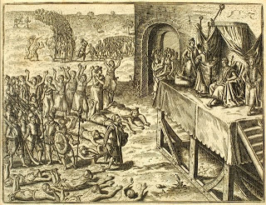

1. Voyage of Diogo Cao (1482)--Cao discovered that the western coast of the African continent turned south and ran for over a thousand miles before turning again. Cao also became the first European to come into contact with the Kingdom of the Kongo, which became an important trading partner and the first successful effort to convert sub-Saharan Africans to Christianity.

2. Christopher Columbus--was turned down by King Joa in 1484 (and again in 1488).

3. Bartolomeu Dias (1487)--sent on expedition to find the southern cape of Africa. He was successful, but did not at first recognize his feat because his small fleet had been caught in a serious storm as they approached the cape, and passed in the midst of that. He reported back that his fleet had rounded the “Cape of Storms,” but king changed the name to “Cape of Good Hope” because investors would be scared off from an expedition that had to pass by the Cape of Storms.

II. Spanish Exploration

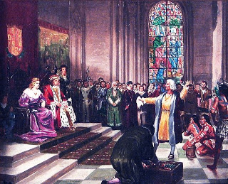

A. Christopher Columbus--son of a Genoese shopkeeper. Columbus aspired to greatness on the seas; from his early teen years on he gained sailing experience. He developed a theory that one could reach Asia by sailing west from Europe, largely because of a miscalculation.

1. Columbus in Lisbon--Portugal is the westernmost country in Europe, and had sailors sailing the Atlantic long before the rise of Prince Enrique (Henry) the Navigator. With the fall of Constantinople, Lisbon had become the place for seafaring adventurers.

a) Columbus’ proposal (1485)--to Joao (or John) II, that he be outfitted with three ships and a year’s time to make the voyage to Asia and back. King Joao turned this request over to his councilors, who concluded that Columbus had badly miscalculated the circumference of the earth, and that the trip was impractical.

b) Columbus’ proposal (1488)--same sales pitch, same result. Decision was also probably influenced by knowledge that a Portuguese expedition had yet to return from an attempt to round the continent of Africa.

2. Columbus in Cadiz--Columbus had already utilized his Genoese connections to find half the money for the expedition; he had to rely upon a European monarch for the other half of the funding, however.

a) Proposal to Henry VIII of England, who did not decide in favor before Columbus was finally able to persuade the dual monarchs of Spain to take the chance.

b) Ferdinand and Isabella--although the Kingdom of Spain was mostly broke from fighting the final battles to unite their kingdom, they were able to find some money in the treasury (and force contributions from some of their subjects) to fund the expedition

c) Departure--from Palos de la Fronterra on August 3, 1492. The three ships made a stop in the Canary Islands for final repairs, then departed on September 6.

d) Arrival--land was spotted on October 12 (Columbus Day in much of the Spanish-speaking world)

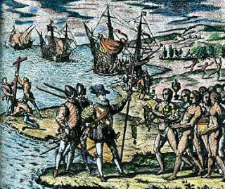

3. Columbus in the New World

a) Caribbean Islands--Columbus’ first encountered a gentle, friendly people the Spanish called the Tainos, who seemed to welcome the strangers

b) Columbus was attracted to their gold jewelry, and attempted to ascertain where they obtained it--but they had great difficulty communicating with each other, since neither party spoke the others’ language.

c) Kidnapped 12 “Indios” to take back to Spain (kind of like specimens); tellingly, all 12 died shortly after their arrival in Spain

d) Columbus made three other voyages, and served for a time as governor of “New Spain” (when he was accused of misusing his power and theft, and briefly thrown in jail), but it is not clear that he ever understood the importance of his “discovery.”
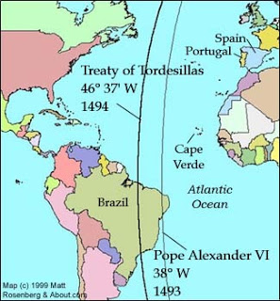

E. Treaty of Tordesilla (1494)--divided the world outside of Europe into two spheres of influence--Portuguese and Spanish. These spheres were divided by the Pope in a line running north/south from 370 leagues west of the Cape Verde Islands.

1. Spanish proposal--after Columbus’ “discovery,” Spain insisted upon dividing world into two different areas for making claims of surzenity, or control. Spain’s proposal was to demarcate the line 100 leagues west of the Cape Verde Islands.

2. Portuguese response--King Jao insisted that the line be drawn at 370 leagues--why? Why not 200, or 300? Did the Portuguese have information about the existence of a large land mass on the other side of the Atlantic?

III. Voyage of Vasco da Gama
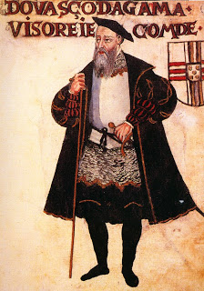

A. Arming the caravel--in preparation for sailing into the Indian Ocean--known to be dominated by Islamic traders, a method was devised to put cannons below deck, behind doors built into the bulkhead. This provided da Gama and his successors an immense advantage, because they were the most heavily armed ships in the Indian Ocean.

B. The Voyage

I. Portuguese Age of Exploration 1415-1530
1. da Gama left in 1497. Hoping to avoid the difficulties faces by Dias, Gama used the trade winds of the Atlantic to his advantage--but still almost missed the Cape of Good Hope.

2. After rounding the Cape, the expedition made slow progress up the east coast of Africa, before finding a local pilot knowledgeable of the Indian Ocean, who guided the fleet across to India.

3. Returned to Portugal in 1499.

IV. The Aftermath

A. Spice trade--after reaching India, Portuguese explorers continued to press eastward, eventually reaching the Spice Islands, China, and Japan.

1. As on the coast of Africa, the Portuguese established factories to carry out trade, which allowed them to dominate the spice trade to Europe for about 100 years.

2. Asciento system--in the early years of Portuguese dominance, they were able to insist that ships that traded in the Indian Ocean by a license to trade there; as more ships followed the Portuguese example of heavily arming their ships, this became less effective; Portuguese also found it difficult to maintain such a huge empire with fewer than 300 ships and less than 10,000 Portuguese to run it.

3. Succession problems--the fall of the House of Aviz, and the ascension of Philip II of Spain to the throne of Portugal, made the lucrative spice trade a ready target for Philip’s growing list of enemies--particularly the Dutch, who take over much of the Portuguese empire in Asia by 1620.

