AP World History - Thematic Overview
Social Structures
Relations among humans
Gender roles and relations
Family and kinship
Racial and ethnic constructions
Social and economic classes

Development and Transformation of Social Structures (SOC)

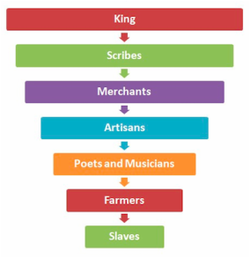
This theme is about relations among human beings, how human societies develop ways of grouping their members, and norms that govern interactions between individuals and social groups. Additionally, this theme explores the processes through which social categories, roles, and practices are created, maintained, and transformed.

EXAMPLE: The chart to the right shows the social structure of ancient Mesopotamia.

Learning Objectives:
- SOC-1 Explain how distinctions based on kinship, ethnicity, class, gender, and race influenced the development and transformations of social hierarchies.
- SOC-2 Evaluate the extent to which different ideologies, philosophies, and religions affected social hierarchies.
- SOC-3 Evaluate the extent to which legal systems, colonialism, nationalism, and independence movements have sustained or challenged class, gender, and racial hierarchies over time.
- SOC 4 Explain how the development of specialized labor systems interacted with the development of social hierarchies
- SOC-5 Explain how social categories, roles, and practices have been maintained or challenged over time.
- SOC-6 Explain how political, economic, cultural, and demographic factors have affected social structures over time.

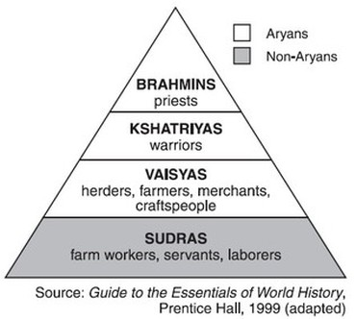
QUICK SUMMARY
- Relations among humans
  - Gender roles and relations
  - Family and kinship
  - Racial and ethnic constructions
  - Social and economic classes

- Different from “Culture”
  - Social is how we deal with each other
  - Culture is how we deal with our world

EXAMPLE: The chart above shows the social structure of Gupta India. This is the early development of the caste system which is a distinctive characteristic of South Asia (India) throughout most of history.
KEY VOCABULARY for SOCIAL STRUCTURES

Term | Definition | Historical Example or Picture
Hierarchy
Stratification
Egalitarian
Diversification
Elites
Aristocracy
Middle Class
Merchant Class
Working Class
Patriarchy
Matriarchy
Filial Piety
Caste System
Guilds
Minority Group
Social Mobility
Meritocracy
Social Darwinism
Feminism

Conceptual Thinking (response should be in a complete, well-developed paragraph)

Most people are affected by the societies around them as well as the people who make up that society. Who has influenced you? (Remember, not all influences are good. You should think about good and bad influences.) Who are you around the most? How do they influence you?

Politics
State Building, Expansion, and Conflict
Forms of government
Leaders / groups
State structures
War and conflict
Diplomacy / treaties
Courts / laws

State Building, Expansion, and Conflict
(SB/POL)

This theme explores how hierarchical systems of rule have been constructed and maintained over time and the impact of these processes.

This theme encourages the comparative study of different state forms (e.g. kingdoms, empires, nation-states) across time and place and the interactions among them.
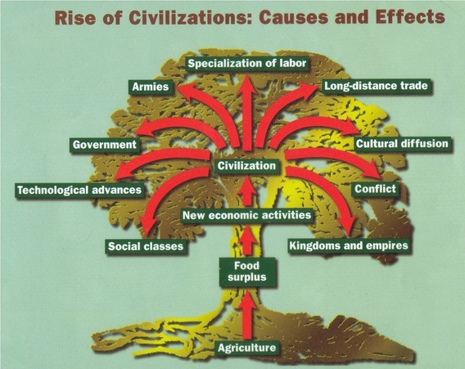

EXAMPLE: How did governments develop out of early civilizations?

Learning Objectives:
- SB-1 Explain how different forms of governance have been constructed and maintained over time.
- SB-2 Explain how and why different functions and institutions of governance have changed over time.
- SB-3 Explain how and why economic, social, cultural, and geographical factors have influenced the processes of state building, expansion, and dissolution.
- SB-4 Explain how and why internal and external political factors have influenced the process of state building, expansion, and dissolution.
- SB-5 Explain how societies with states and state-less societies interacted over time.
- SB-6 Explain the political and economic interactions between states and non-state actors over time.

QUICK SUMMARY
- Different forms of government
  - Kingdoms, empires, dynasties, nation-states
- How different kinds of societies need different forms of government
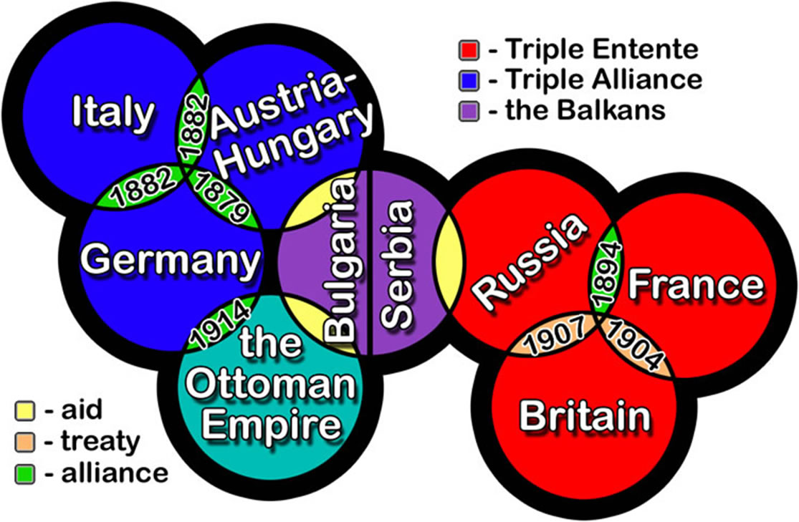
  - Leaders/groups
  - State structures
  - War and conflict
  - Diplomacy/treaties
  - Courts/laws

EXAMPLE: The chart to the right shows the complex alliance system that was in place in Europe before the start of WWI.

KEY VOCABULARY for STATE BUILDING (SB/POL)

Term | Definition | Historical Example or Picture
Civilization
City-State
Divine Right
Kingdom
Empire
Nation / Nation-State
Agrarian
Autocracy
Theocracy
Constitutional Democracy
Monarchy
Colonialism
Imperialism
Communism
Fascism
Bureaucracy / Bureaucrat
Law Code / Legal Code
Mandate of Heaven
Diplomacy
Caliphate
Nationalism

Conceptual Thinking (response should be in a complete, well-developed paragraph)

Politics involves how nations lead themselves and what issues they see as important. What role do politics and government have in your life? How are you influenced by these things? What issues are important to you?

Interactions
Between Humans and the Environment

How the environment changed humans:
races, diets, lifespans, migrations, spread of disease

How humans changed the environment:
irrigation, farming, land development

Interaction Between Humans and the Environment
(ENV/INT)

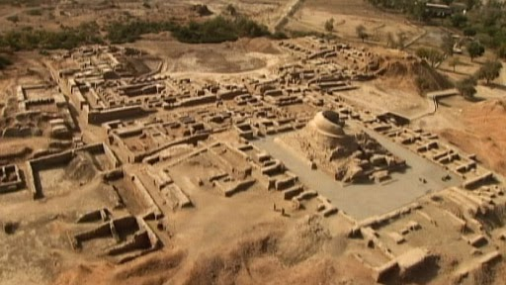
The interaction between humans and the environment is a fundamental theme in world history, as the environment shaped human societies, but increasingly, human societies also affect the environment.

EXAMPLE: The early Indus River civilizations of Harappa and Mohenjo-Daro are believed to have disappeared due to environmental degradation or natural disaster (flood or earthquake).

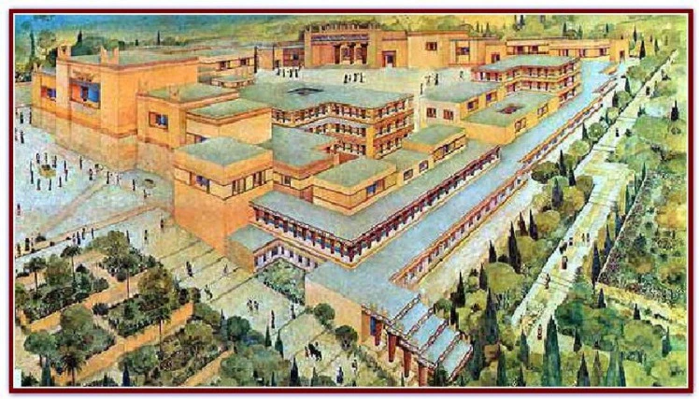

Learning Objectives:
- ENV-1 Explain how different types of societies have adapted to and affected their environments.
- ENV-2 Explain how environmental factors, disease, and technology affected patterns of human migration and settlement over time.
- ENV-3 Evaluate the extent to which migration, population, and urbanization affected the environment over time.
- ENV-4 Explain how environmental factors have shaped the development of diverse technologies, industrialization, transportation methods, and exchange and communication networks.
- ENV-5 Evaluate the extent to which the development of diverse technologies, industrialization, transportation methods, and exchange and communication networks have affected the environment over time.

QUICK SUMMARY
- How the environment changed humans
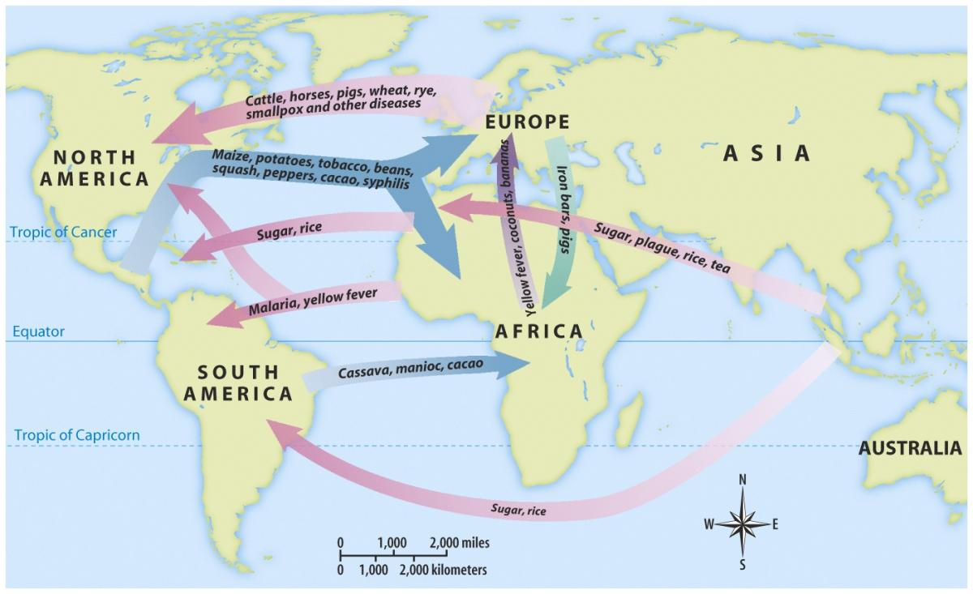
  - Races, diets, lifespans, migrations, spread of disease
- How humans changed the environment
  - Irrigation, farming, land development
  - Biggest during Industrial Revolution (1700s)

EXAMPLE: The map to the right shows the diffusion of crops and diseases.

KEY VOCABULARY for INTERACTIONS WITH THE ENVIRONMENT (ENV/I)

Term | Definition | Historical Example or Picture
Nomad
Pastoralist
Agriculture
Natural Resources
Demographics
Domestication of Animals
Irrigation
Overgrazing
Metallurgy
Deforestation
Desertification
Qanat System
Plague
Diaspora
Crop Yield
Migration
Urbanization
Columbian Exchange
Industrialization
Green Revolution
Epidemic vs. Pandemic

Conceptual Thinking (response should be in a complete, well-developed paragraph)

Historians consider how the environment affected the population’s development or how the population changed the environment to suit their needs, patterns of settlement, migration (push/pull factors), demographic trends, and the spread of disease. How do you interact with the environment? How does the environment interact with you?

Culture
Development and Interaction of Cultures

Spreading of beliefs, actions, and knowledge between and within societies:
Religion and philosophy
Art / music / literature
Architecture
Technology
Education

Diffusion: spread of culture from one society to another

Development and Interaction of Cultures
(CUL)

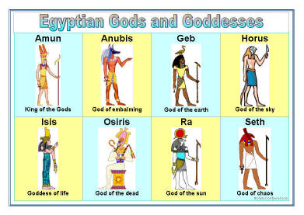
This theme explores the origins, uses, dissemination, and adaptation of ideas, beliefs, and knowledge within and between societies and how the processes of adopting or adapting new belief and knowledge systems are complex and often lead to syncretic (fusion of) cultural forms and practices.

EXAMPLE: The ancient Egyptians were polytheistic - believing in many gods who controlled nature

Learning Objectives:
- CUL-1 Explain how religions, belief systems, philosophies, and ideologies originated, developed, and spread as a result of expanding communication and exchange networks.
- CUL-2 Explain how religions, belief systems, philosophies, and ideologies affected political, economic, and social developments over time.
- CUL-3 Explain how cross-cultural interactions resulted in the diffusion of culture, technologies, and scientific knowledge.
- CUL-4 Explain how technological and scientific innovations affected religions, belief systems, philosophies, and ideologies over time.
- CUL-5 Explain how the arts are shaped by and reflect innovation, adaptation, and creativity of specific societies over time.
- CUL-6 Explain how expanding exchange networks shaped the emergence of various forms of transregional culture, including music, literature, and visual arts.
QUICK SUMMARY
- Spreading of beliefs, actions, and knowledge between and within societies
  - Religions and philosophy
  - Art / music / literature
  - Architecture
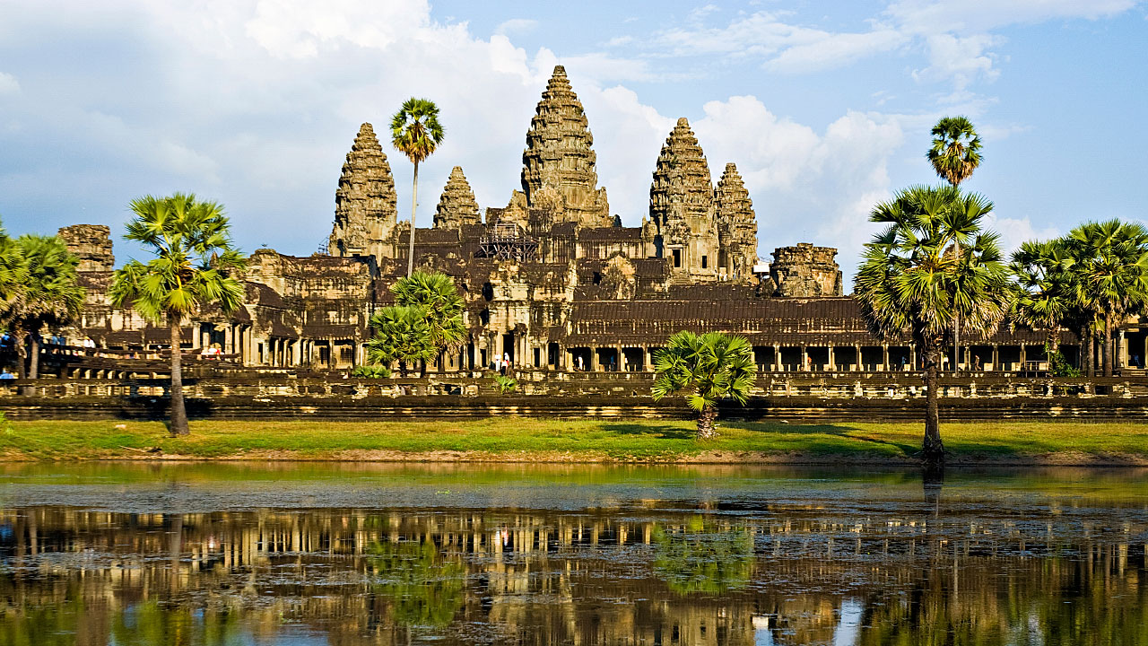
  - Technology
  - Education
- Diffusion – spread of culture from one society to another

EXAMPLE: Angkor Wat (to the right) is one of the largest religious complexes in the world. Located in Cambodia, it was originally a Hindu temple but gradually transformed into a Buddhist temple.

KEY VOCABULARY for CULTURE (CUL)

Term | Definition | Historical Example or Picture
Religion
Religion vs. Belief Systems
Philosophy
Ideology
Polytheistic vs. Monotheistic
Monumental Architecture
Reincarnation
Ancestor Veneration
Monasticism
Animism
Syncretism
Schism
Ethnic Enclaves
Government Propaganda
Pop Culture

Conceptual Thinking (response should be in a complete, well-developed paragraph)

Religion, belief systems, philosophies, and ideologies often play an important role in how societies function. Include details on your religion/belief system. Do you practice a religion? If so, how does it influence you? If not, where do you see religious influence around you? (Remember, there are no right or wrong answers. We're just trying to think like historians.)

Conceptual Thinking (response should be in a complete, well-developed paragraph)

Historians often look at what art, education, and intellectual influences on societies as well as what intellectual products (art and literature, inventions, etc) they produce. What have been the biggest influences on your intellectual development? (Consider people, classes, books, movies, etc.)

Economics
Creation, Expansion, and Interaction of Economic Systems

Major transitions in trade: From bartering to regional trade to long-distance trade

Economic systems: Agricultural, pastoral, industrial

Labor systems: Forced labor, farmers, capitalism, socialism

Creation, Expansion, and Interaction of Economic Systems (ECON)

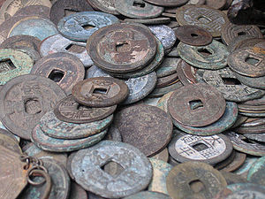
This theme surveys the diverse patterns and systems that human societies have developed to produce, distribute, and consume desired goods and services across time and place.

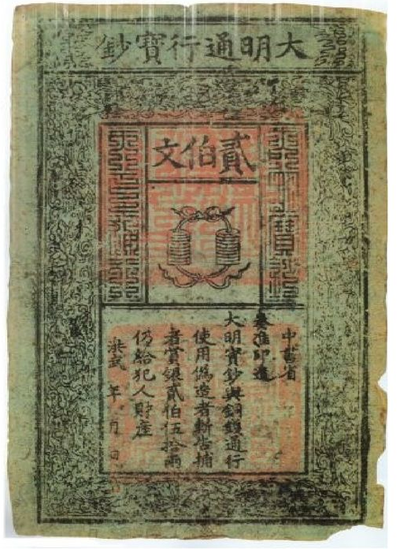
EXAMPLE: Ancient Chinese coins dating back to the earliest Chinese dynasties. China was also the first to use paper money 1,400 years ago.

Learning Objectives:
- ECON-1 Explain how technology shaped economic production and globalization over time.
- ECON-2 Explain the causes and effects of economic strategies of different types of communities, states, and empires.
- ECON-3 Explain how different modes and locations of production and commerce have developed and changed over time.
- ECON 4 Explain the causes and effects of labor reform movements.
- ECON-5 Explain how and why labor systems have developed and changed over time.
- ECON-6 Explain how economic systems and the development of ideologies, values, and institutions have influenced each other.

QUICK SUMMARY
- Major transitions in trade
  - From bartering to regional trade to long-distance trade
- Economic systems
  - Agricultural, pastoral, industrial
- Labor systems
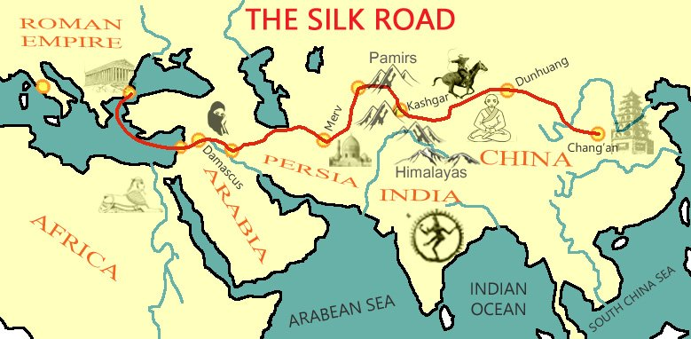
  - Forced labor, farmers, capitalism, socialism

EXAMPLE: The map to the right shows the Silk Road, one of the most important trade routes in history before the modern era.

KEY VOCABULARY for ECONOMIC SYSTEMS (ECON)

Term | Definition | Historical Example or Picture
Hunter-Forager
Pastoralist
Agriculture
Subsistence Farming
Cash Crops
Specialization of Labor
Luxury Goods
Bills of Exchange
Artisans
Merchants
Coerced Labor
Chattel Slavery
Military Obligations
Industrialization
Mercantilism
Export Economies
Capitalism
Socialism
Liberalism
Markets

Conceptual Thinking (response should be in a complete, well-developed paragraph)

All societies have some sort of economic system. Most produce and trade products with other societies. Consider your economic status. How do your parents’ jobs or lack of jobs affect you? (Economics can have big consequences. Think about the time you spend with your parents along with the money they bring to the family.) What career do you see yourself in someday? How do you plan to achieve that economically? How will this career affect your future economically?

Technology and Innovation

Technology and Innovation

Technology - making and using tools to change the natural state of the environment - isn’t an instant global event. Innovation and technological development tends to happen independently in different regions and then is spread along trade routes from their place of origin. This theme will likely focus on the effects of technology on societies over time.

Conceptual Thinking (response should be in a complete, well-developed paragraph)

Not all technology has wires and electricity. Changing the way you plow your fields, grow food, fight disease, make swords, or design a car is also technology. Think about five inventions that really matter to you. (They don’t have to be things you use every day.) Why do they matter to you?

