Time Period 3: Theme 1: Interaction Between Humans and the Environment
The era of 600 to 1450 CE was a time when civilization spread geographically; it covered many parts of the globe and great migrations of people had wide impacts on settled areas.
Demography and Disease:
- long distance trade promoted spread of
- Bubonic Plague, or “Black Death”: 1340s-1600s
  - most victims died within a few days of being infected
  - population decreased drastically, causing great labor shortages and workers even demanded higher wages; peasants rebelled and weakened the feudal system
  - China’s decreasing population contributed to the decline of the Yuan dynasty
  - Europe’s population dropped by 25% during the 14th century
  - spread rapidly through long-distance trade, through fleas that infested rats and humans
- spread through movements of missionaries, nomads, traders, and increasing interaction
- urbanization; major cities emerged
- Tang and Song:
  - increasing population; 45 million by 600 CE → 115 million by Song dynasty in 1200 CE, partially due to agricultural revolution and better transport systems
  - established cities grew; 2,000,000 population in the Tang capital of Xi’an
  - Song capital of Hangzhou = 1,000,000 residents; other Chinese cities often had 100,000 people
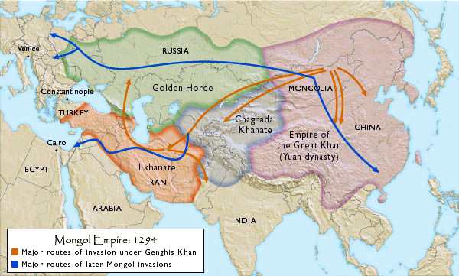
- Feudal Europe = more agricultural production due to increase in crops → population growth

Migration:
- movement of people included Bantus, Turks, Mongols, and Vikings
- The Vikings: (800 - 1100 CE)
  - Scandinavian nomadic group
  - seasonal raids to supplement farm production; ransacked towns/villages across Europe; small boats used in battle influenced their success
  - explored North Atlantic Ocean (Iceland, Canada, Greenland, Newfoundland, NE US coast); established settlements in Scotland, Northern France, and Eastern Europe
  - looted and destroyed communities, churches, and monasteries
- The Seljuk Turks: (1000 - 1450 CE)
  - pastoral nomadic group from central Asia, often mercenaries
  - invaded Baghdad by 1055 and took over Abbasid Caliphate; by 1071, pushed Byzantine Empire out of Anatolia
- The Afghan Turks (1000 - 1450 CE)
  - began raids into India in 10th century
  - by late 12th century, settled in Northern India and began Delhi Sultanate (1206 - 1526 CE)
- The Mongols
  - pastoral nomadic group from Asia, united by Genghis Khan
  - horsemanship, archery; created largest land empire
  - westward expansion into Africa was stopped in 1260 when halted by Mamluks of Egypt
  - carried new foods, inventions, and ideas to other civilizations
- Bantus:
  - Bantu Migration from the Sahara in Africa, spread south and east
  - language became a basis of formation for later languages
- Merchants spread Nestorian Christianity to India, Central Asia, and China
- Ibn Battuta’s and Marco Polo’s travels → spread culture
- Arabs moved from the Arabian peninsula to the Middle East, northern Africa, and southern Europe, helping spread Islam
- migration had environmental effects: deforestation, soil erosion, flooding
- plants cultivated and animals domesticated as moved toward new areas
- spread of Bantu and Swahili languages
Patterns of Settlement:
- Japanese island configuration led to the development of isolated communities
- Explorations of Vasco De Gama
  - was able to reach India by sea and gain access to Spice Islands
- Maya (300 - 900 CE)
  - borrowing from Olmecs, developed large domains and lived in scattered settlements on the Yucatan peninsula in southeastern Mexico
- Aztecs (1400 - 1521 CE)
  - urban capital of Tenochtitlan consisted of 150,000 inhabitants build on island of Lake Texcoco
  - fell to Spanish due to disease and warfare
  - irrigated agriculture (chinampas)
- Incas (1400 - 1540 CE)
  - conquered a large area and absorbed many tribes in South America
  - grew into a stretch of land that covered 3,000 miles from north to south; fell to Spanish
Technology:
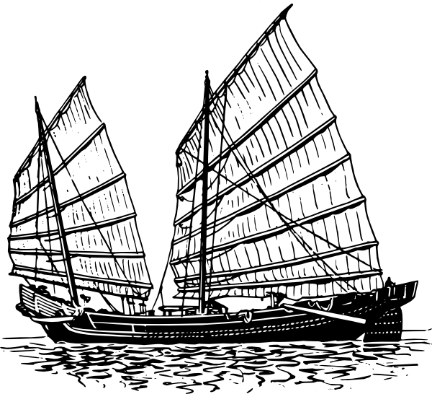
- gunpowder and rockets (late 1000s)
- compass, aided maritime navigation
- porcelain - chinaware
- moveable type
- improved shipbuilding; Chinese junk ships - massive hulls, carried lots of cargo
- mathematics in India; number system including zero
- iron production in China increased
- spread of printing and gunpowder from East Asia
- safe and reliable transportation

