Period 6 Review Packet

Key Concept 6.1 Science and the Environment

- Researchers made rapid advances in science that spread throughout the world, assisted by the development of new technology.

- On the grid below, explain how TWO new modes of communication and ONE new mode of transportation reduced the problem of geographic distance.

Comm 1:

Comm 2:

Trans:

- Define Green Revolution: _______________________________________________________________________________

____________________________________________________________________________________________________

In the space below, explain how the listed technologies and agricultural innovations increased global food production.
Chemical Fertilizers, Pesticides, Herbicides
Advanced Irrigation /
Land Management
Seed Hybridization /
Genetically-Modified Organisms

- In the space below, provide THREE examples of medical innovations that increase the ability of humans to survive and live longer lives
Medical Innovation 1:

Medical Innovation 2:

Medical Innovation 3:

- In the space below, identify THREE energy technologies that helped to raise productivity and increase the production of material goods.
Energy Tech 1:

Energy Tech 2:

Energy Tech 3:

- During the period of unprecedented global population expansion, humans fundamentally changed their relationship with the environment.

- In the space below, provide examples of human activity that contributed to the following:

Deforestation
Desertification
Increased consumption of fresh water and clean air

Based on your answers above, provide TWO examples as to how this has led to competition over resources

- In the space below, identify causes and consequences of climate change

Cause | Consequence

- Disease, scientific innovations, and conflict led to demographic shifts

- Identify two diseases associated with poverty and explain why they persisted during the time period.

Poverty-related Disease 1:

Poverty-related Disease 2:

Identify two new epidemics and explain why they represent a threat to human survival

New Epidemic 1:

New Epidemic 2:

Identify two diseases associated with increased longevity and changing lifestyles

Longevity-related Disease:

Lifestyle-related Disease:

- Explain the impact of more effective birth control on the following:

Control over Fertility
Transformed Sexual Practices

- Identify and explain THREE new types of military technology

Military Tech 1:

Military Tech 2:

Military Tech 3:

Identify and explain TWO new types of military tactics

Tactic 1:

Tactic 2:

Identify and explain THREE examples of mass wartime casualties

Wartime Casualties 1:

Wartime Casualties 2:

Wartime Casualties 3:

Key Concept 6.2 Global Conflicts and Their Consequences

- Europe dominated the global political order at the beginning of the 20th century, but both land-based and transoceanic empires gave way to new states by the century’s end.

- In the space below, identify an internal factor and an external factor that resulted in the collapse of older, land-based empires.

 | Internal Factor for Collapse | External Factor for Collapse
Ottoman Empire
Russian Empire
Qing Dynasty in China

- In the space below, identify TWO colonies that negotiated for their independence and explain the process they undertook

Colony 1:

Colony 2:

- In the space below, identify TWO colonies that achieved independence through armed struggle and explain the process they undertook

Colony 1:

Colony 2:

- Emerging ideologies of anti-imperialism contributed to the dissolution of empires and the restructuring of states.

- In the space below, identify TWO examples of African and/or Asian nationalist leaders/parties that challenged imperial rule and the methods they used.

Nationalist 1:

Nationalist 2:

- In the space below, identify THREE movements that challenged colonial rule and inherited imperial boundaries and the methods they used.

Regional Movement:

Religious Movement:

Ethnic Movement:

- In the space below, identify THREE transnational movements that sought to unite people across national boundaries and the methods they used.

Movement 1:

Movement 2:

Movement 3:

- In the space below, identify how a movement to redistribute land and resources developed in the listed regions.

Latin America:

Africa:

Asia:

- Political changes were accompanied by major demographic and social consequences.

- In the space below, identify TWO instances in which the redrawing of old colonial boundaries led to population displacement and resettlements.

Colonial Boundary/Nation | Redrawn Boundary/Nation-State | Impact on Population

- In the space below, identify an instance in which the migration of colonial subjects to imperial metropoles (the former colonizing country, usually major cities) maintained cultural and economic ties between the colony and metropole even after the dissolution of empress.

Metropole: | Colonial Subject:
Relationship before Dissolution/Migration | Relationship after Dissolution/Migration

- On the grid below, identify an instance as to how the proliferation of conflicts led to various forms of genocide or ethnic violence

Date (years): | Relative Location (AP Region):
Perpetrators: | Victims:
Causes: | Outcomes:

- Military conflicts occurred on an unprecedented scale.

- Define Total War: _____________________________________________________________________________________

Why are World War One and World War Two considered total wars?

____________________________________________________________________________________________________________________________________________________________________________________________________________________________________________________________________________________________________________________________________
On the grid below, explain how each ideology compelled their peoples to mobilize and wage war during WW1 and/or WW2.

Ideology | Mobilization for War
Fascism
Nationalism
Communism

On the grid below, explain how each of the images was used to mobilize populations for war during WW1 and WW2

Nation: | 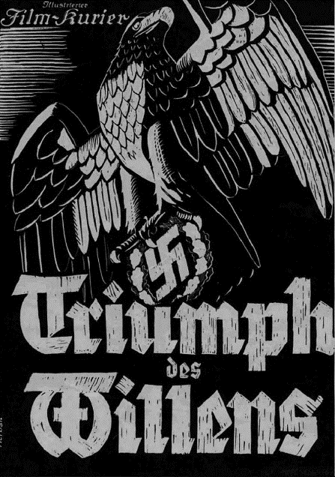
Type of Media:

Significance:

Nation: | 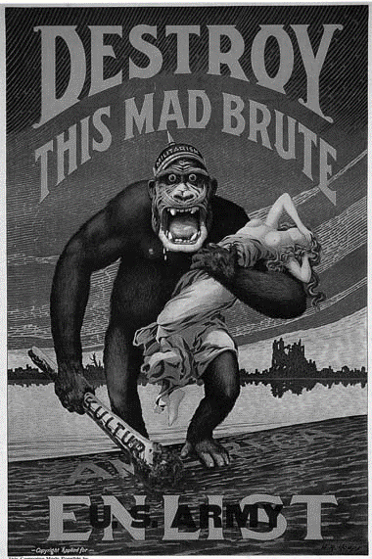
Type of Media:

Significance:

Nation: | 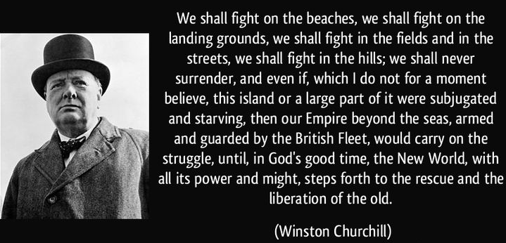
Type of Media:

Significance:

- In the space provided, explain how each of these factors was a source of global conflict

European & Japanese Imperialism
Competition for Resources
Economic Crises like the Great Depression

- Why did the Soviet Union and the United States emerge as superpowers following World War Two?

____________________________________________________________________________________________________________________________________________________________________________________________________________________________________________________________________________________________________________________________________

In the space provided, identify THREE areas of non-military ideological competition between the Soviet Union and United States during the Cold War period.

Competition Area | Soviet Union | United States

- Identify and explain the two major military alliances that developed during the Cold War period.

Alliance 1:

Alliance 2:

Identify and explain THREE a proxy war that occurred during the Cold War period on the grids below.

Date (years): | Relative Location (AP Region):
Major Nation-State Combatants: | Key Individuals/Groups:
Causes: | Outcomes:

Date (years): | Relative Location (AP Region):
Major Nation-State Combatants: | Key Individuals/Groups:
Causes: | Outcomes:

Date (years): | Relative Location (AP Region):
Major Nation-State Combatants: | Key Individuals/Groups:
Causes: | Outcomes:

- Although conflict dominated much of the 20th century, many individuals and groups –including states – opposed this trend. Some individuals and groups, however, intensified these conflicts.

- For each of the images below, explain how they were representative of the promotion of nonviolence as a way to bring about political change

Identify/Label

Date (year)

What is the image depicting?
How does the image represent a challenge to war?

Identify/Label | 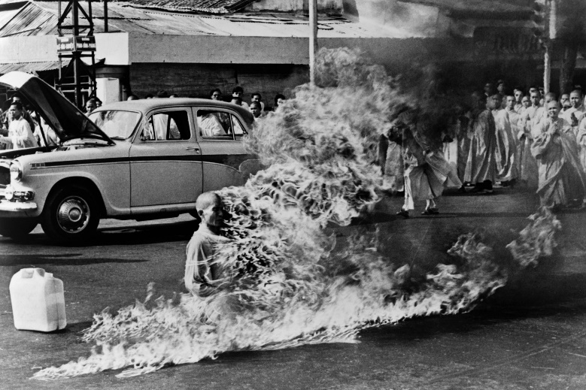
Date (year)

What were they protesting against?
How does the event represent a challenge to war?

Individual | 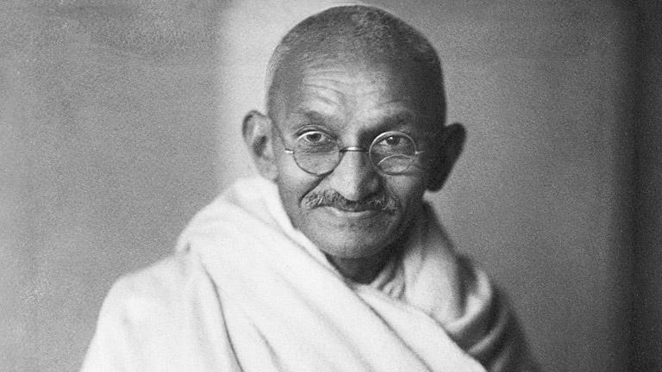
Date (year)

What were they protesting against?

How did the person promote nonviolence?

Individual | 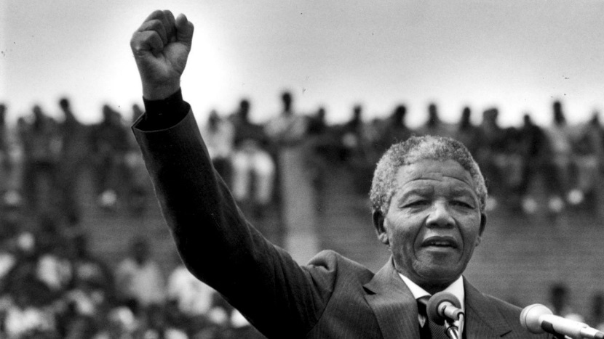
Date (year)

What were they protesting against?

How did the person promote nonviolence?

- In the space provided, identify and explain how groups and/or individuals opposed and promoted alternatives to the existing economic, political, and social orders.

Non-Aligned Movement
Anti-Apartheid Movement in South Africa
Tiananmen Square Protests

- In the space provided, provide TWO examples as to how militaries and militarized states often responded to the proliferation of conflicts in ways that further intensified conflict.

Military/Militarized State | Conflict Responded To: | Effect of Response:

- In the space provided, explain how more movements used violence against civilians to achieve political aims by identifying TWO groups, explaining their methods of violence, and the outcomes of such violence.

Date (years): | Relative Location (AP Region):
Group Name: | Motivations:
Methods: | Outcomes:
Date (years): | Relative Location (AP Region):
Group Name: | Motivations:
Methods: | Outcomes:

Key Concept 6.3 New Conceptualizations of Global Economy, Society, and Culture

- States responded in a variety of ways to the economic challenges of the 20th century.

- In the space provided, identify and explain two examples of how in the communist states of the Soviet Union and China, governments controlled their national economies.

China: | Soviet Union:

- At the beginning of the 20th century in the United States and parts of Europe, governments played a minimal role in their national economies. In the space provided, provide TWO examples of how with the onset of the Great Depression, governments began to take a more active role in economic life.

Economic Intervention 1: | Economic Intervention 2:

- In the space provided, provide TWO examples of how in newly independent states after World War II, governments often took on a strong role in guiding economic life to promote development.

New State Economic Guidance 1: | New State Economic Guidance 2:

- In the space provided, provide TWO examples of how in a trend accelerated by the end of the Cold War, many governments encouraged free market economic policies and promoted economic liberalization in the late 20th century.

State 1: | Free Market Policies Pursued:
State 2: | Free Market Policies Pursued:
- States, communities, and individuals became increasingly interdependent, a process facilitated by the growth of institutions of global governance.

- In the space below, identify THREE examples of international organizations that formed to maintain world peace and to facilitate international cooperation.

Organization 1:

Organization 2:

Organization 3:

- In the space below, identify THREE examples of changing economic institutions and regional trade agreements that reflect the spread of principles and practices associated with free market economics throughout the world.

Institution/Agreement 1:

Institution/Agreement 2:

Institution/Agreement 3:

- In the space below, identify examples of movements throughout the world that protested the inequality of environmental and economic consequences of global integration

Environmental Protest Movement:

Economic Protest Movement:

- People conceptualized society and culture in new ways; rights-based discourses challenged old assumptions about race, class, gender, and religion. In much of the world, access to education, as we as participation in new political and professional roles, became more inclusive in terms of race, class, and gender.

In the space below, identify and explain various movements that challenged previously held assumptions in the listed categories

How did they challenge previously held assumptions?
Race:

Class:

Gender:

Religion:

In the space below, provide an example of increased access to education AND an example of increased participation in new political and professional roles

Access to Education:

Political & Professional Participation:

- Popular and consumer culture became more global.

In the space below provide an example of both popular culture and consumer culture and explain its relation to globalization.

Consumer Culture:

Popular Culture:

Key Terms

- Adolf Hitler
- Allied Powers
- Mustafa Kemal Ataturk
- Bolsheviks
- Central powers
- Chiang Kai-Shek
- Fascism
- Great Depression
- Great War (World War I)
- League of Nations
- Mass consumption
- Mass culture
- Benito Mussolini
- Nazis
- New Deal
- Nonviolent Resistance
- Joseph Stalin
- Mohandas Gandhi
- Apartheid
- Arab-Israeli War
- Axis Powers
- Berlin Wall
- Fidel Castro
- Civil Rights Movement
- Cold War
- Decolonization
- First World
- Holocaust
- Martin Luther King Jr.
- Korean War
- Mao Zedong
- Neocolonialism
- North Atlantic Treaty Organization
- Prague Spring
- Second World
- Sexual Revolution
- Superpowers
- Third World
- Vietnam War
- Warsaw Pact
- Zionism
- AIDS
- Developing world
- European Union
- Feminist Movements
- Globalization
- Global Warming
- International Monetary Fund
- Ayatollah Khomeini
- Nelson Mandela
- Nongovernmental Organizations
- Silicon Valley
- Supranational organizations
- Tiananmen Square protests
- Truth commissions
- World Bank
- Al Qaeda

Key Dates

- 1904 to 1905 – Russo-Japanese War
- 1914 Panama Canal Opened
- 1914 – 1918 – World War One
- 1917 – Russian Revolution
- 1929 – New York Stock Market Collapse
- 1937 – Rape of Nanking
- 1931 – Pearl Harbor
- 1945 – Bombing of Hiroshima & Nagasaki
- 1947 – Partition of India
- 1949 – Chinese Communist Revolution
- 1950 to 1953 – Korean War
- 1957 – Sputnik
- 1959 – First Silicon Chip developed
- 1959 – Cuban Revolution
- 1962 – Cuban Missile Crisis
- 1963 – Nuclear Test-Ban Treaty
- 1966 to 1976 – Chinese Cultural Revolution
- 1967 – Six Day War
- 1973 – Yom Kippur War
- 1975 to 1979 – Cambodian Genocide
- 1979 – Iranian Revolution
- 1979 – Deng Xiaoping implements “Socialist Market Economy”
- 1987 – First Palestinian Intifada
- 1989 – Tiananmen Square protests
- 1990 – Last African colony (Namibia) gains independence
- 1991 – First Persian Gulf War
- 1991 – USSR formally disbands
- 1994 – NAFTA formed
- 1994 – Rwandan Genocide
- 1994 – First open race elections in South Africa
- 1999 – European Union formed
- 2001 – 9/11 Attacks
- 2003 – US invasion of Iraq

