Period 4 Review Packet

Key Concept 4.1 Globalizing Networks of Communication and Exchange

- In the space below, give an example of economic prosperity and economic disruption that resulted from an intensification of existing regional trade patterns and the new global circulation of goods for each of the listed regions.

 | Prosperity | Disruption
Indian Ocean Trade Routes
Mediterranean Sea Routes
Trans-Sahara
Overland Eurasia

- In the space below, provide THREE examples of European technological developments in cartography and navigation that built on previous knowledge developed in the classical, Islamic, and Asian worlds.

 | Region of Previous Knowledge | Purpose of Technology
Tech 1:
Tech 2:
Tech 3:

- Remarkable new transoceanic maritime reconnaissance occurred in this period.

- Explain the importance that travel to and trade with West Africa played in the formation of Portugal’s global trading-post empire.

____________________________________________________________________________________________________________________________________________________________________________________________________________________________________________________________________________________________________________

- Explain why the Spanish sponsorship of voyages across the Atlantic and Pacific dramatically increased European interest in transoceanic travel and trade.

____________________________________________________________________________________________________________________________________________________________________________________________________________________________________________________________________________________________________________
- Explain why Northern Atlantic crossings for fishing and settlements continued and spurred European searches for multiple trade routes to Asia.

____________________________________________________________________________________________________________________________________________________________________________________________________________________________________________________________________________________________________________
- The new global circulation of goods was facilitated by royal chartered European monopoly companies that took silver from Spanish colonies in the Americas to purchase Asian goods for the Atlantic markets. Regional markets continued to flourish in Afro-Eurasia by using established commercial practices and new transoceanic shipping services developed by European merchants.

- In the space below, provide TWO examples of how the role of European merchants in Asian trade was characterized mostly by transporting goods from one Asian country to another market in Asia or the Indian Ocean region.

 | Asian Source Nation | Good Traded | Asian/Indian Ocean Recipient
Europe 1:
Europe 2:

- Explain how the new global circulation of silver from the Americas was intimately tied to commercialization and the creation of a global economy.

____________________________________________________________________________________________________________________________________________________________________________________________________________________________________________________________________________________________________________

- Define mercantilism: ___________________________________________________________________________________
____________________________________________________________________________________________________

In the space below, provide TWO examples of how joint-stock companies were used by European rulers to control their domestic and colonial economies.

 | European Home Nation | Methods of Domestic/Colonial Control
Joint Stock Company 1:
Joint Stock Company 2:

In the space below, provide TWO examples of how joint-stock companies were used by European merchants to compete against one another in global trade.

Means of Global Trade Competition
Joint Stock Company 1:
Joint Stock Company 2:

- In the space below, explain the movement of goods, wealth, and free and unfree laborers as part of the Atlantic system

 | Source Location | Receiving Location | Significance
Good:
Wealth:
Free Laborers:
Unfree Laborers:

In the space below, provide TWO examples of the mixing of African, American, and European cultures as part of the Atlantic system

Relationship to the Atlantic system
Cultural Mixing 1:
Cultural Mixing 2:

- The new connections between the Eastern and Western hemispheres resulted in the Columbian Exchange.

- For each of the diseases or vermin listed below, explain how their transfer to the Americans as part of European colonization impacted Amerindian populations.

Vector | Impact on Amerindian Populations
Mosquitos
Rats
Influenza
Smallpox
Measles

- In the space below, provide examples of staple food crops and cash crops that originated in the Americas but transferred to Europe, Asia, and Africa as part of the colonial exchange. Additionally, for each crop listed, discuss its impact on Afro-Eurasia.

Impact on Afro-Eurasia
Staple Crop 1:
Staple Crop 2:
Cash Crop 1:
Cash Crop 2:

Explain the role that coerced labor played in plantation economies that produced cash crops for Afro-Eurasia.

____________________________________________________________________________________________________________________________________________________________________________________________________________________________________________________________________________________________________________

- In the space below, provide examples of Afro-Eurasian fruit trees, grains, sugar, and domesticated animals that were brought by Europeans to the Americans. For each example, explain its impact on the Americas.

Impact on the Americas
Fruit Tree:
Grain:
Sugar
Domesticated Animal 1:
Domesticated Animal 2:
In the space below, provide ONE example of food brought to the Americans by African slaves.

Food Introduced by African Slaves: | Impact on the Americas:

- What impact did the diversity of American food crops have on Afro-Eurasian peoples?

____________________________________________________________________________________________________________________________________________________________________________________________________________________________________________________________________________________________________________
- In the space below, provide TWO examples of how European colonization and the introduction of European agriculture and settlement practices in the Americas affected the physical environment.

European Practice 1: | Environmental Impact:
European Practice 2: | Environmental Impact:

- In the space below, provide TWO examples of how the increase in interactions between newly connected hemispheres and intensification of connections within hemispheres expanded the spread and reform of existing religions

Existing Religion | Description of Change | Cause of Change

In the space below, provide TWO examples of syncretic belief systems and practices that resulted from the increase in interactions between newly connected hemispheres and intensification of connections within hemispheres.

Syncretic Religion | Religious Influences/Combinations | Cause of Syncretism

- Explain the relationship between merchant’s profits, taxes, and the funding of visual and performing arts during this period.

____________________________________________________________________________________________________________________________________________________________________________________________________________________________________________________________________________________________________________

Explain the impact that the expansion of literacy had on the populous during this period.

____________________________________________________________________________________________________________________________________________________________________________________________________________________________________________________________________________________________________________

For each of the pieces of art or literature listed below, identify its name, author, and historical significance

What work of art is depecited | 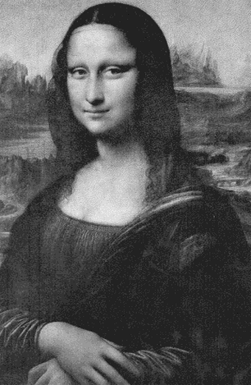
Who was the artist?

Explain its historical significance

What playwright is depicted? | 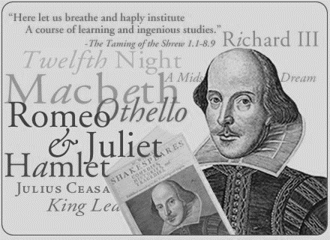
Explain his historical significance

Explain the importance of government sponsorship

Identify the work of art | 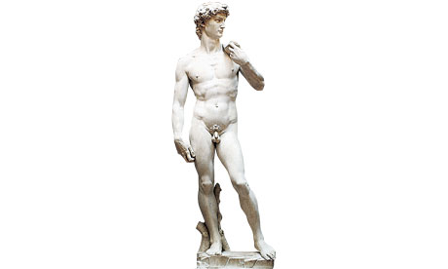
Who was the sculptor?

Explain its historical significance

Title of the Book | 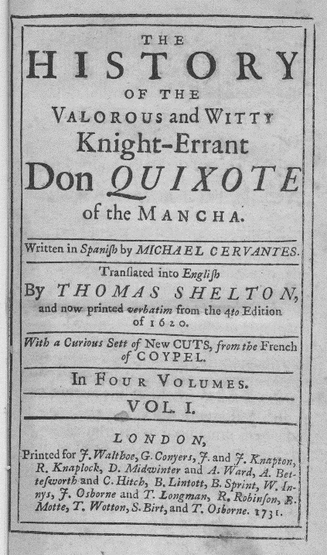
Who was the author?

Explain its historical significance

Key Concept 4.2 New Forms of Social Organization and Modes of Production

- Define Little Ice Age: _______________________________________________________________________________
_________________________________________________________________________________________________

What impact did the Little Ice Age have on agricultural practices and settlement in the Northern Hemisphere?

____________________________________________________________________________________________________________________________________________________________________________________________________________________________________________________________________________________________________________

- Traditional peasant agriculture increased and changed, plantations expanded, and demand for labor increased. These changes both fed and responded to growing global demand for raw materials and finished products.

- In the space below, provide TWO examples of the intensification of peasant labor.

Region | Cause of Labor Intensification | Products Produced

- Explain how the traditional incorporation of slaves into households and the export of slaves to the Mediterranean and the Indian Ocean represents a continuity for Africa.

____________________________________________________________________________________________________________________________________________________________________________________________________________________________________________________________________________________________________________
- Why did the growth of the plantation economy coincide with an increased demand for slaves in the Americas?

____________________________________________________________________________________________________________________________________________________________________________________________________________________________________________________________________________________________________________
- In the space provided, identify and explain THREE different types of coerced labor used by colonial economies in the Americas.

Coerced Labor 1: | Explanation
Coerced Labor 2: | Explanation
Coerced Labor 3: | Explanation

- As social and political elites changed, they also restructured ethnic, racial, and gender hierarchies.

- In the space below, provide TWO examples of how imperial conquests and widening global economic opportunities contributed to the formation of new political and economic elites.

New Elites 1: | Cause of their rise:
New Elites 2: | Cause of their rise:

- In the space below, identify TWO existing political and economic elites whose power fluctuated as they confronted new challenges to their ability to affect the policies of the increasingly powerful monarchs and leaders.

Existing Elites 1: | Challenges to their power:
Existing Elites 2: | Challenges to their power:

- In the space below, identify and explain notable gender and family restructuring that occurred during the time period.

Demographic changes in Africa that  resulted from the slave trade | Explanation:
Gender Restructuring: | Explanation:
Family Restructuring: | Explanation:

Key Concept 4.3 State Consolidation and Imperial Expansion

- Rulers used a variety of methods to legitimize and consolidate their power

- In the space below, identify and explain THREE examples of how rulers used religious ideas to legitimize their rule.

Religious Ideas | Associated Empire/Ruler | Explanation

In the space below, identify each example of art and monumental architecture, its associated empire, and how it was used to legitimize a ruler’s power.

Identify | 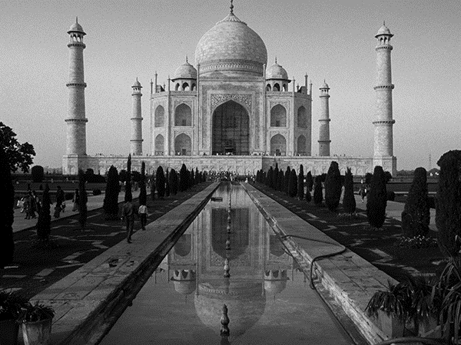
Associated Empire

How was it used to legitimize a ruler’s power?

Identify | 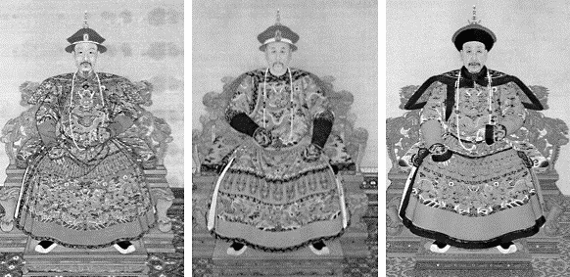
Associated Empire

How was it used to legitimize a ruler’s power?

Identify

Associated Empire

How was it used to legitimize a ruler’s power?

- In the space below, provide TWO examples of how states treated different ethnic and religious groups in ways that utilized their economic contributions while limiting their ability to challenge the authority of the state.

Empire | Ethnic/Religious Minority | Policies to limit challenges to authority

- In the space below, provide TWO examples of how rulers who wanted to maintain centralized control over their populations and resources used the recruitment of bureaucratic elites and the development of military professionals.

Empire | Elite / Military Professional | Role in Society/Government

- Explain the role of tribute collection and tax farming in the generation of revenue for territorial expansion. Use a specific example.
____________________________________________________________________________________________________________________________________________________________________________________________________________________________________________________________________________________________________________
- Imperial expansion relied on the increased use of gunpowder, cannons, and armed trade to establish large empires in both hemispheres.

- Explain how the European establishment of new trading-post empires in Africa and Asia, affected the power of states in the interior of West and Central Africa.

____________________________________________________________________________________________________________________________________________________________________________________________________________________________________________________________________________________________________________

Why did the European establishment of trading post empires in Africa and Asia, prove to be so profitable for the merchants and rulers involved in new global trade networks?

____________________________________________________________________________________________________________________________________________________________________________________________________________________________________________________________________________________________________________

- For each of the empires listed below, describe the process and outcome as each expanded dramatically in size.

 | Process of Expansion | Outcome of Expansion
Manchu
Mughal
Ottoman
Russian

- For each of the empires listed below, describe the process and outcomes as each formed new maritime empires in the Americas.

 | Process of Expansion | Outcome of Expansion
Portuguese
Spanish
Dutch
French
British

- Provide an example of each factor listed below and explain how each provided a significant challenge to state consolidation and expansion.

Challenge to State Consolidation & Expansion
Competition over trade routes:

State rivalries:

Local resistance:

Key Terms

- Atlantic system
- Aztec Empire
- Colonies
- Columbian Exchange
- Conquistadors
- Counter-Reformation
- Holy Roman Empire
- Inca Empire
- Jesuits
- Mestizos
- Mughal Empire
- New World
- Protestant Reformation
- Absolute monarchy
- Bullion
- Canton system
- Chartered companies
- Enclosure
- Mamluks
- Manchus
- Mercantilism
- Monetization
- Muscovy
- Qing dynasty
- Seven years’ War
- Thirty Years’ War
- Tokugawa Shogunate
- Cartography
- Creoles
- Forbidden City
- Great Plaza of Isfahan
- Oceania
- Palace of Versailles
- Peninsulars
- Taj Mahal
- Topkapi Palace

Key Dates

- 1453 – Ottomans capture Constantinople
- 1450s – Printing Press in Europe (Gutenberg)
- c. 1480s – Height of Aztec Empire
- 1488 – Dias rounds Cape of Good Hope
- 1492 – Columbus/Reconquista of Spain
- 1502 – 1st African Slaves to Americas
- 1517 – Martin Luther/Protestant Reformation
- 1519 to 1521 – Cortez conquered the Aztecs
- 1521 to 1523 – Magellan circumnavigates the Earth
- 1529 – 1st unsuccessful Ottoman siege of Vienna
- 1533 – Pizarro topples the Inca
- 1545 – Discovery of silver at Potosí
- 1571 – Battle of Lepanto
- 1600 – Battle of Sekigahara
- 1607 – Founding of the Jamestown Colony
- 1618 to 1648 – Thirty Years’ War
- 1644 to 1911 – Qing Dynasty
- 1653 – Cape Town colony founded (Dutch)
- 1683 – 2nd unsuccessful Ottoman siege of Vienna (Mehmet IV)
- 1689 – Glorious Revolution/English Bill of Rights

