Period 3 Review Packet

Key Concept 3.1 Expansion and Intensification of Communication and Exchange Networks

- Improved transportation technologies and commercial practices led to an increased volume of trade, and expanded the geographical range of existing and newly active trade networks.

- In the space below, for each of the given trade routes, identify a new trading city that developed AND explain why that specific trade route was critical to its growth and flourishing.

TRADE ROUTE | TRADING CITY | CAUSES OF GROWTH
Silk Road(s)
Mediterranean Sea
Trans-Saharan
Indian Ocean Basin

- In the space below, identify TWO communication and exchange networks that developed in the Americas. Explain a unique function/aspect of that network.

Network 1:

Network 2:

- In the space below, identify and explain the importance of THREE luxury goods that became increasingly significant during this time.

Luxury Good 1:

Luxury Good 2:

Luxury Good 3:

In the space below, identify and explain TWO new forms of credit and monetization that developed during this time.

Credit/Monetization 1:

Credit/Monetization 2:

Fill in the grids below by identifying the new technology, its location of origin, and its relationship to interregional trade.

Identify | 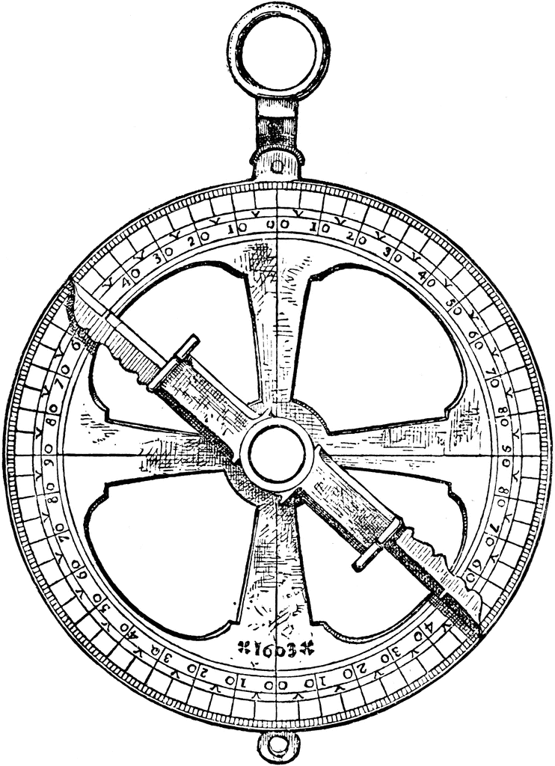
Location of Origin

Relationship to Interregional Trade

Identify | 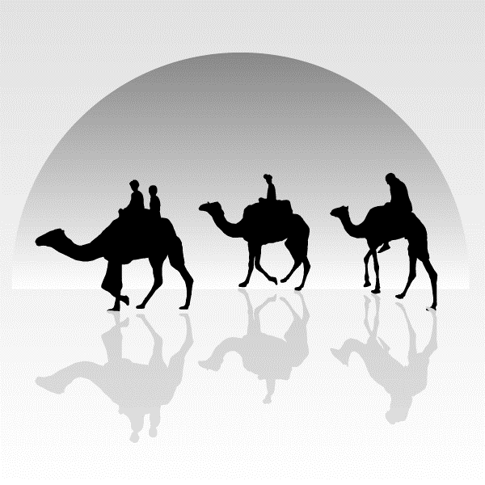
Location of Origin

Relationship to Interregional Trade

Identify | 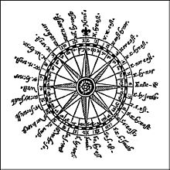
Location of Origin

Relationship to Interregional Trade

Identify | 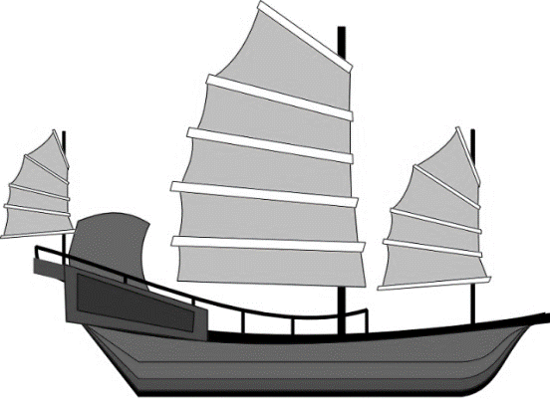
Location of Origin

Relationship to Interregional Trade

- In the space below, explain how each of the following state practices facilitated commercial growth.

Inca Road System

Trade Organizations
(Hanseatic League)

Commercial Infrastructure
(Grand Canal of China)

Paper Money

Coin Minting

- Explain how each of the empires listed below, facilitated Afro-Eurasian trade and communication by conquering other peoples. Use specific examples.

Islamic Caliphates
Byzantine Empire
Chinese Dynasties (Sui, Tang, Song)
Mongol Empire

- The movement of peoples caused environmental and linguistic effects.

- In the space below, provide TWO examples of how the expansion and intensification of long-distance trade routes often depended on environmental knowledge and technological adaptations to it.

Tech/Env Interaction 1:

Tech/Env Interaction 2:

- Explain the impact that the Bantu migration and their transmission of iron technologies and agricultural techniques had on the environment of Sub-Saharan Africa.

____________________________________________________________________________________________________________________________________________________________________________________________________________________________________________________________________________________________________________

Explain the impact that Polynesian migration had on the environment due to transplantation of food and domesticated animals to new islands.

____________________________________________________________________________________________________________________________________________________________________________________________________________________________________________________________________________________________________________

- In the space below, explain how migration and commercial contacts led to the diffusion of languages throughout a new region OR led to the emergence of new languages.

Language: | Migratory/Commercial Diffusion:

- Cross-cultural exchanges were fostered by the intensification of existing, or the creation of new, networks of trade and communication.

- Complete the grid below to identify the key facets of the Islamic religion.

ISLAM
Theism (mono, poly, etc) |  | Key God
Relative Location |  | Key Figures/Prophets
Approx. Founding |  | Moral Philosophy
Religious Text(s)

Explain how the following religions influenced the development of the Islamic faith

Christianity
Judaism/Hebrew Peoples
Zoroastrianism

Explain how Islam spread based on the methods listed below. Use specific examples

Military Expansion
Merchants/Trade Systems
Missionaries

- In the space below, identify TWO diasporic communities and explain how they introduced their culture into that of the indigenous peoples.

Diasporic Community 1:

Diasporic Community 2:

- In the space below, identify a traveler within Afro-Eurasia that wrote about their travels. Then, explain how their writings illustrate both the extent and the limitations of intercultural knowledge and understanding.

Traveler:

Extent of Intercultural Knowledge: | Limitations of Intercultural Knowledge:

- On the map provided, trace the diffusion of key cross-cultural interactions listed below during the period.

Christianity Neoconfucianism Hinduism Buddhism Islam Toltec/Mexica

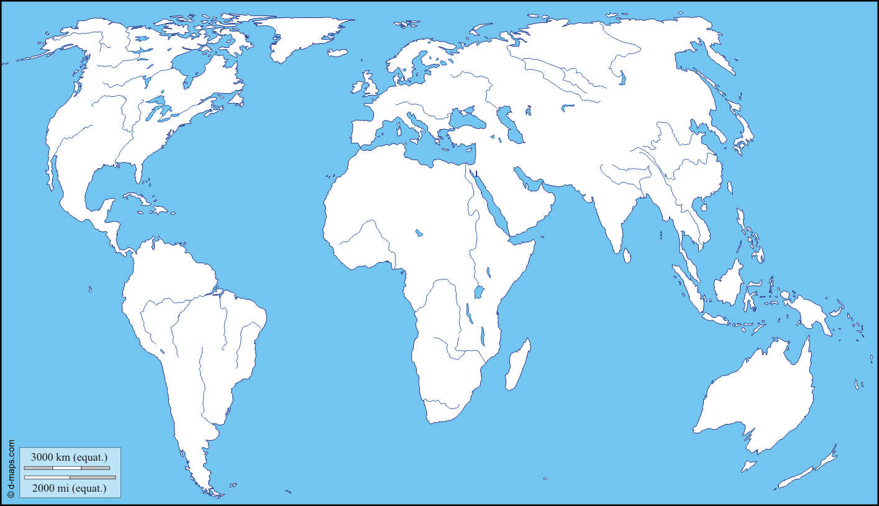

In the space below, identify TWO technologies and/or scientific innovations that diffused from their original location

Tech 1: | Original Location: | Impact of Diffusion:
Tech 2: | Original Location: | Impact of Diffusion:

- In the space below, identify THREE impacts of the diffusion of a disease like the bubonic plague had on the Eastern Hemisphere

Disease Impact 1:

Disease Impact 2:

Disease Impact 3:

In the space below, identify TWO crops that diffused from their original location.

Crop 1: | Original Location: | New Location:
Crop 2: | Original Location: | New Location:

Key Concept 3.2 Continuity and Innovation of State Forms and Their Interactions

- Empires collapsed and were reconstituted; in some regions new state forms emerged.

- For each of the empires listed that collapsed, and then later reconstituted itself, identify and explain one traditional source of power they drew from and one innovation they used that was better suited to their specific local context.

 | Traditional Source of Power/Legitimacy | Innovative Source of Power/Legitimacy
Byzantine Empire
Chinese Dynasty 1:
(Sui, Tang, Song)
Chinese Dynasty 2:
(Sui, Tang, Song)
Abbasid Caliphate

- In the space below, identify an Islamic state, Mongol Khanate, city-state, and decentralized form of feudalism that developed a new form of governance. Provide an explanation of what makes it unique.

Islamic State:

Mongol Khanate:

City State 1 (Italian Peninsula or Americas):

City State 2 (Southeast Asia or East Africa):

Decentralized Feudalism (Europe or Japan):

- Identify and explain an example of how some states synthesized local and foreign traditions.

Civilization: | Foreign Tradition: | Synthesized Tradition:

- In the space below, identify TWO

MAYAN CITY-STATES
Relative Location |  | Approx. Founding
Political/Economic Characteristics  (Leaders, Gov’t Style, Labor System, Trade, etc.) |  | Religious System  (Gods, Texts, Belief Characteristics, etc.)
Technological Innovations |  | Artistic/Scientific Innovations
MEXICA/AZTECS
Relative Location |  | Approx. Founding
Political/Economic Characteristics  (Leaders, Gov’t Style, Labor System, Trade, etc.) |  | Religious System  (Gods, Texts, Belief Characteristics, etc.)
Technological Innovations |  | Artistic/Scientific Innovations

INCA
Relative Location |  | Approx. Founding
Political/Economic Characteristics  (Leaders, Gov’t Style, Labor System, Trade, etc.) |  | Religious System  (Gods, Texts, Belief Characteristics, etc.)
Technological Innovations |  | Artistic/Scientific Innovations

- For each of the areas below where interregional conflict and contact occurred, identify technological and cultural transfers.

Technological & Cultural Transfers
Conflict between Tang China and
the Abbasids
Mongol empires
The Crusades
Chinese maritime activity led by
Ming Admiral Zheng He

Key Concept 3.3 Increased Economic Productive Capacity and Its Consequences

- Innovations stimulated agricultural and industrial production in many regions

- In the space provided, identify and explain TWO technological innovations that significantly increased agricultural production

Tech 1: | Role in Agriculture:
Tech 2: | Role in Agriculture:

- What factors caused Chinese, Persian, and Indian artisans and merchants to expand their production of textiles and porcelain for export?

____________________________________________________________________________________________________________________________________________________________________________________________________________________________________________________________________________________________________________

What factors caused China to expand the industrial production of iron and steel during this period?

____________________________________________________________________________________________________________________________________________________________________________________________________________________________________________________________________________________________________________

- The fate of cities varied greatly, with periods of significant decline, and with periods of increased urbanization buoyed by rising productivity and expanding trade networks.

- Identify and explain THREE causes of urban decline during this period

Factor 1: | Role in Urban Decline:
Factor 2: | Role in Urban Decline:
Factor 3: | Role in Urban Decline:

- Identify and explain THREE factors that led to urban revival during this period

Factor 1: | Role in Urban Revival:
Factor 2: | Role in Urban Revival:
Factor 3: | Role in Urban Revival:

- Despite significant continuities in social structures and in methods of production, there were also some important changes in labor management and in the effect of religious conversion on gender relations and family life.

- Explain each of the forms of labor organization that occurred during this period.

Free Peasant Agriculture
Nomadic Pastoralism
Craft Production and
Guild Organization
Coerced and Unfree Labor
Government-imposed Labor Practices
Military Obligations

- For each of the civilizations listed below, explain how despite the persistence of patriarchy, women exercised more power and influence than in previous periods.

Mongol Empire
West Africa
Japan
Southeast Asia

- In the space below, explain the role of serfdom in Japan and Europe and the elaboration of the mit’a system in the Inca Empire

European Serfdom
Japanese Serfdom
Incan Mit’a System

Identify and explain ONE instance of free peasants resisting attempts to raise dues and taxes by staging a revolt.

____________________________________________________________________________________________________________________________________________________________________________________________________________________________________________________________________________________________________________

Explain the cause of an increased demand for slaves in the regions listed below

Eastern Mediterranean
Central Eurasia
Incan Mit’a System

- In the space below, provide TWO instances as to how the diffusion of Buddhism, Christianity, Islam, and/or Neoconfucianism led to significant changes in gender relations and/or family structure.

Religion 1: | Impact on Gender/Family:
Religion 2: | Impact on Gender/Family:

Key Vocabulary

- Bantu Migrations
- Hinayana Buddhism
- Hinduism
- Laws of Manu
- Mahayana Buddhism
- Teotihuacan
- Caliphate
- Christendom
- Civil service examination
- Eunuchs
- Greek Orthodox
- Islam
- Jihad
- Meritocracy
- Monasticism
- Muhammad
- Quran
- Roman Catholicism
- Sharia
- Shiites
- Shinto
- Sunnis
- Tang Dynasty
- Ulama
- Vikings
- Angkor Wat
- Cahokia
- Crusades
- Compass
- Delhi Sultanate
- Dhimma system
- Dhows
- Feudalism
- Kublai Khan
- Mongols
- Rajas
- Sufism
- Black Death
- Dynasty
- English Peasant’s Revolt
- Humanism
- Inquisition
- Khan
- Monarchy
- Moors
- Ottoman Empire
- Red Turban Movement
- Shah
- Sikhism
- Tokapi Palace
- Zheng He

Key Dates
- 622 – Founding of Islam
- c. 730 – Printing invented in China
- 732 – Battle of Tours
- c. 900 – Decline of classical Maya
- 1054 – Great Schism in Christian Church
- 1066 – Norman conquest of England
- 1071 – Battle of Manzikert
- 1095 – First Crusade
- 1206 – Genghis Khan begins Mongol conquests
- 1258 – Mongols sack Baghdad, end of Abbasid caliphate
- 1271-1295 – Marco Polo’s travels
- 1279-1368 – Yuan (Mongol) Dynasty in China
- 1324 – Mansa Musa’s pilgrimage/hajj
- 1325-1349 – travels of Ibn Battuta
- 1347-1348 – Bubonic plague in Europe
- 1368-1644 – Ming Dynasty
- 1405-1433 – Zheng He’s 7 voyages
- 1438 – Rise of Inca Empire

