Period 2 Review Packet

Key Concept 2.1 The Development and Codification of Religious and Cultural Traditions

- Codification and further developments of existing religious traditions provided a bond among people and an ethical code to live by.

- Explain how Mesopotamian cultural and legal traditions influenced Judaism and Hebrew scriptures

Define Diaspora: ______________________________________________________________________________________

Complete the grid below to explain how various conquests of Jewish states contributed to the growth of diasporic communities

Exile of Jewish Tribes by Assyria
Babylonian Captivity
Roman Conquest of Jerusalem by Titus (Rome)

- Explain the core beliefs listed below as outlined in the Sanskrit scriptures formed the basis of the Vedic religions, specifically Hinduism.

Multiple manifestations of Brahma
Reincarnation
Social development of the caste system
Political development of the caste system

- New belief systems and cultural traditions emerged and spread, often ascertaining universal truths

- Complete the grid below to identify the key facets of the Buddhist religion.

BUDDHISM
Theism (mono, poly, etc) |  | Key God(s)
Relative Location |  | Key Figures/Prophets
Approx. Founding |  | Moral Philosophy
Religious Text(s)

How was Buddhism a reaction to the Vedic beliefs and rituals that dominated South Asia?

____________________________________________________________________________________________________________________________________________________________________________________________________________________________________________________________________________________________________________________________________

Identify and explain TWO ways that Buddhism spread throughout South Asia

- Complete the grid below to identify the key facets of the Confucian philosophical system

CONFUCIANISM
Theism (mono, poly, etc) |  | Approx. Founding
Relative Location |  | Key Figures/Prophets
Key Text(s)
Moral Philosophy

- Complete the grid below to identify the key facets of the Daoist religion

DAOISM
Theism (mono, poly, etc) |  | Key God(s)
Relative Location |  | Key Figures/Prophets
Approx. Founding |  | Moral Philosophy
Religious Text(s)

Explain how Daoism influenced Chinese culture within the following areas.

Medical Theories and practices
Poetry
Architecture

- Complete the grid below to identify the key facets of the Christian religion

CHRISTIANITY
Theism (mono, poly, etc) |  | Key God(s)
Relative Location |  | Key Figures/Prophets
Approx. Founding |  | Moral Philosophy
Religious Text(s)

Explain how Christian beliefs were influenced by the following religions/cultures

Judaism
Roman Culture
Hellenism

Identify and explain TWO ways that Christianity spread throughout Afro-Eurasia

- For each of the individuals listed below, explain their contribution to Greco-Roman philosophy and/or science

Socrates
Plato
Aristotle

- Fill the grids below as examples of how art and architecture reflected the religions and belief systems

Identify | 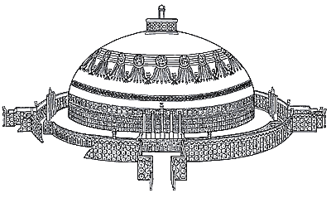
Religion associated with the image

Identify a unique characteristic of the art/architecture

Identify

Religion associated with the image

Identify a unique characteristic of the art/architecture

Identify | 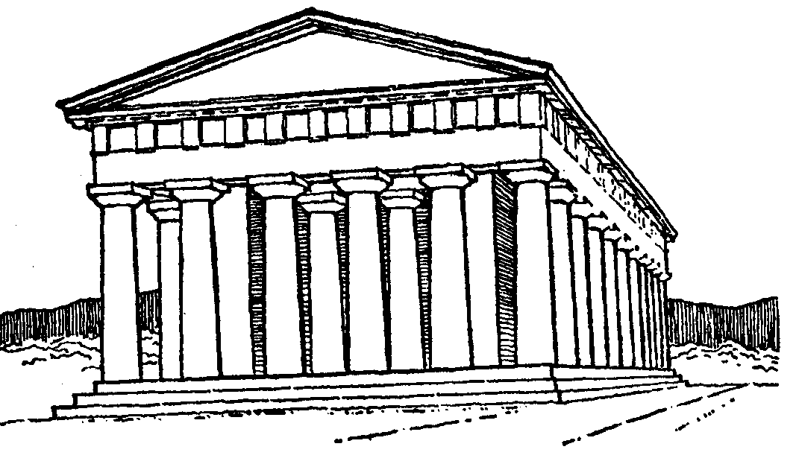
Religion associated with the image

Identify a unique characteristic of the art/architecture

Identify | 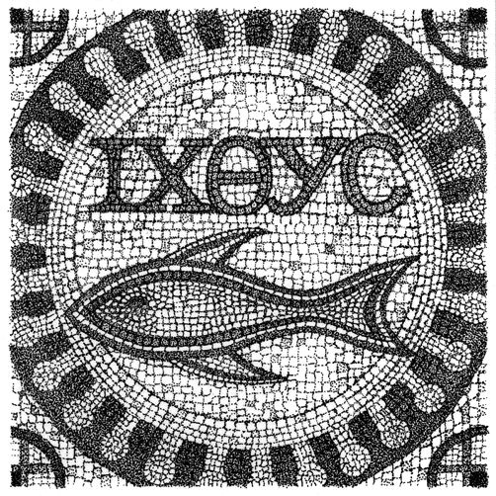
Religion associated with the image

Identify a unique characteristic of the art/architecture

- Explain how the following belief systems reinforced existing social structures, while also offered new roles and status for some men and women.

 | Confucianism | Christianity
Reinforcement of existing social structures
Impact on roles and status of men
Impact on roles and status of women

- Define and provide an example of each of the following religious and cultural traditions that persisted during the time period

Define Shamanism: ____________________________________________________________________________________

Location of Persistence: _________________________________________________________________________

Define Animism: ______________________________________________________________________________________

Location of Persistence: _________________________________________________________________________

Define Ancestor Veneration: _____________________________________________________________________________

Location of Persistence: _________________________________________________________________________

Key Concept 2.2 The Development of States and Empires

- On the map provided, identify the key states and empires that resulted as rulers imposed political unity on areas where previously there had been competing states.

- Southwest Asia: Persian empires
- East Asia: Qin and Han empires
- South Asia: Mauryan and Gupta empires
- Mediterranean region: Phoenicia and its colonies, Greek city-states and colonies, and Hellenistic and Roman empires
- Mesoamerica: Teotihuacan, Maya city-states
- Andean South America: Moche
- North America: from Chaco to Cahokia

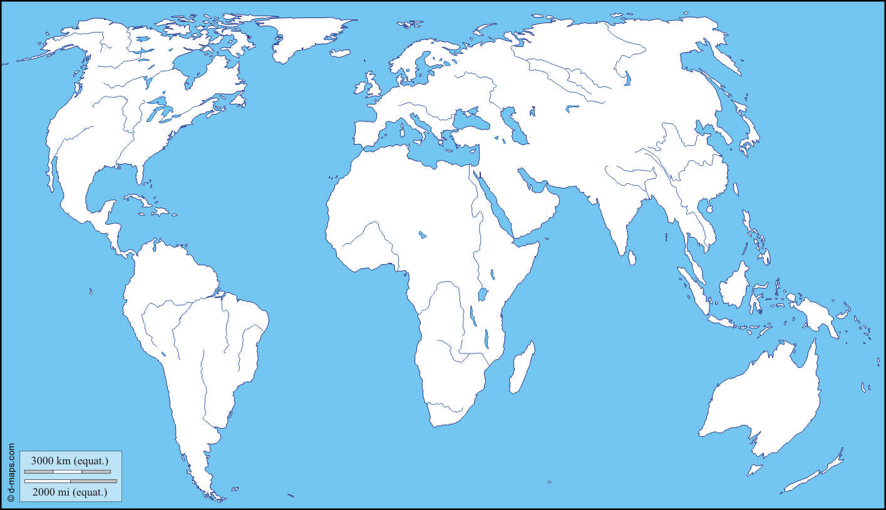

- Empires and states developed new techniques of imperial administration based in part, on the success of earlier political forms.

- In the grid below, explain how in these regions rulers created administrative institutions, including centralized governments as well as elaborate legal systems and bureaucracies

 | Centralized Governments | Legal System | Bureaucracies
China
Persia
Rome
South Asia

- Select TWO imperial governments identified in 2.2.I and explain how they promoted trade and military power over areas using a variety of techniques

 | Civ 1: | Civ 2:
Issuing Currency
Diplomacy
Development of supply lines
Construction of fortifications, defensive walls, and roads
Expanding the Military by drawing from new locations or conquered populations

- Unique social and economic dimensions developed in imperial societies in Afro-Eurasia and the Americas

- Select TWO of the imperial cites listed below and explain how they served as centers of trade, public performance of religious rituals, and political administration for states and empires

- Persepolis
- Chang’an
- Pataliputra
- Athens
- Carthage
- Rome
- Alexandria
- Constantinople
- Teotihuacan

 | City 1: | City 2:
Center of Trade
Public Performance of Religious Rituals
Political Administration

- Select TWO empires from 2.2.I and provide an explanation of social/economic/political/religions hierarchies within each.

Civ 1:
Civ 2:

- Select TWO of the methods listed below that imperial societies used to maintain the production of food and provide rewards for the loyalty of the elites

- Corvee labor
- Slavery
- Rents and tributes
- Peasant communities
- Family and household production

Method 1:
Method 2:

- Select TWO imperial societies from 2.2.I and explain how patriarchy continued to shape gender and family relations in each

Civ 1:
Civ 2:

- The Roman, Han, Persian, Mauryan, and Gupta empires encountered political, cultural, and administrative difficulties that they could not manage, which eventually led to their decline, collapse, and transformation into successor empires or states.

- Select TWO of the imperial societies identified in 2.2.IV and explain how excessive mobilization of resources, created economic difficulties and social tensions for them by concentrating too much wealth in the hands of the elites

Civ 1:
Civ 2:

- Select TWO of the imperial societies identified in 2.2.IV and explain how security issues along their frontiers, including the threat of invasions, challenged imperial authority

Civ 1:
Civ 2:

Key Concept 2.3 Emergence of Interregional Networks of Communication and Exchange

- Land and water routes became the basis for interregional trade, communication, and exchange networks in the Eastern Hemisphere

- On the grid below, explain how a variety of trade routes were affected by varying factors.

 | Climate / Location | Trade Goods | Ethnicity
Eurasian Silk Roads
Trans-Saharan caravan routes
Indian Ocean sea lanes
Mediterranean sea lanes

- New technologies facilitated long-distance communication and exchange

- Identify and explain TWO technologies that permitted the use of domesticated pack animals to transport goods across longer trade routes.

Tech 1:
Tech 2:

- Identify and explain TWO maritime innovations that stimulated exchange along trade routes from East Africa to East Asia.

Tech 1:
Tech 2:

- Alongside the trade in goods, the exchange of people, technology, religious and cultural beliefs, food crops, domesticated animals, and disease pathogens developed across extensive networks of communication and exchange.

- Explain how crops, including rice and cotton from South Asia to the Middle East, encouraged changes in farming and irrigation techniques. Provide a specific example.
____________________________________________________________________________________________________________________________________________________________________________________________________________________________________________________________________________________________________________________________________

- Explain how the spread of disease pathogens diminished urban populations and contributed to the decline of some empires. Provide a specific example.
____________________________________________________________________________________________________________________________________________________________________________________________________________________________________________________________________________________________________________________________________

- For each of the religions listed below, explain where they spread to and how they changed during this time

 | Where it spread | How it Changed
Christianity
Hinduism
Buddhism

Key Vocabulary
- Alexander the Great
- Aristotle
- Ascetic
- Asoka Maurya
- Augustus Caesar
- bodhisattva
- Buddha
- Chattel slavery
- Christianity
- Confucius
- Cosmology
- Cyrus the Great
- Daoism
- Democracy
- Dhamma
- Homer
- Hellenism
- Jainism
- Julius Caesar
- Legalism
- Mahabharata
- Mahayana Buddhism
- Millenarian movement
- Oligarchy
- Olmecs
- Pax Romana
- Pax Sinica
- Plato
- Royal Road
- satraps
- Shamans
- Silk Road
- Socrates
- Stupa
- Syncretism
- untouchables
- Upanishads
- Xiongnu
- White Huns
- Yellow Turban Revolution
- Zoroastrianism
- Zarathustra

