Period 1 Review Packet

Key Concept 1.1 Big Geography and the Peopling of the Earth

- Archeological evidence indicates that during the Paleolithic era, hunting-foraging bands of humans gradually migrated from their origin in East Africa to Eurasia, Australia, and the Americas, adapting their technology and cultures to new climate regions.

- What diverse and sophisticated tools were developed by humans to adapt to their new environments? Use fire as one example

Tool Name | Purpose
Fire

- Provide examples of how early small groups organized themselves

Political Organization
Social Organization
Examples of cultural exchange
Example of economic exchange

Key Concept 1.2 The Neolithic Revolution and Early Agricultural Societies

- Beginning about 10,000 years ago, the Neolithic Revolution led to the development of more complex economic and social systems.

- Label the following early permanent agricultural settlements on the map below

Mesopotamia, Nile River Valley, Sub-Saharan Africa, Indus River Valley, Yellow River Valley, Papua New Guinea, Mesoamerica, Andes

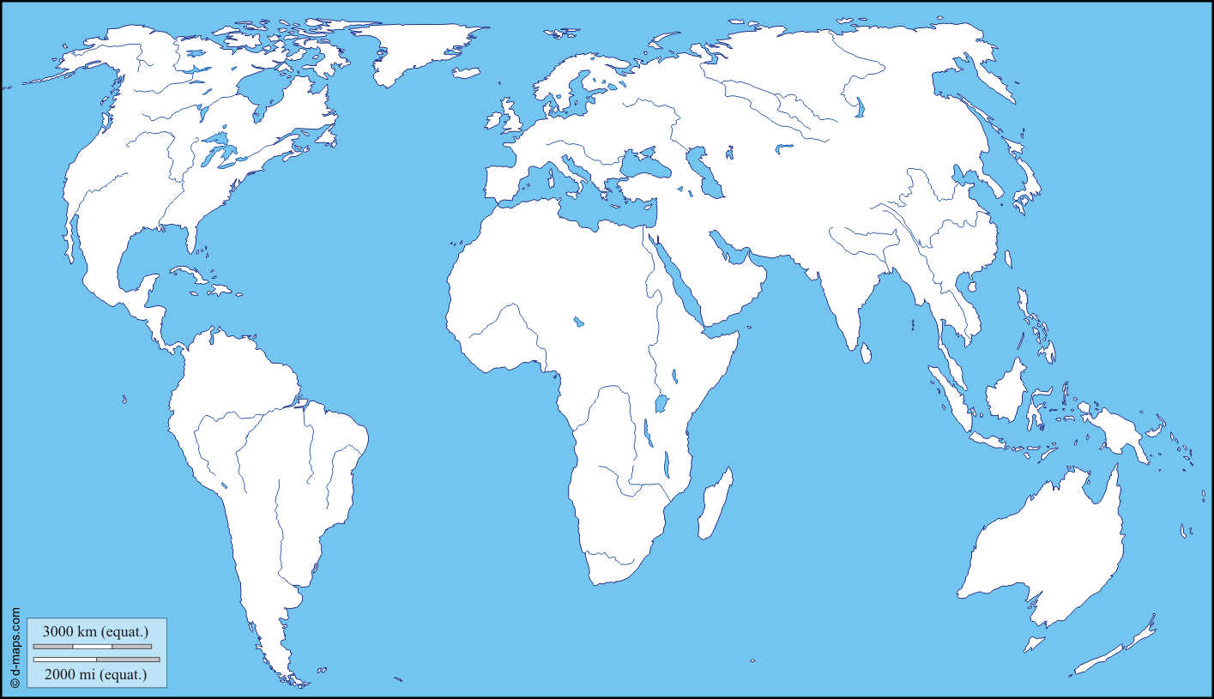

- From the settlements listed above, identify a locally available plant or animal that was domesticated

Mesopotamia
Nile River Valley
Sub-Saharan Africa
Indus River Valley
Yellow River Valley
Papua New Guinea
Mesoamerica
Andes

- Define Pastoralism: ____________________________________________________________________________________

What impact did overgrazing have on Afro-Eurasian lands?
____________________________________________________________________________________________________________________________________________________________________________________________________________________________________________________________________________________________________________

- Explain two methods of water control and/or land clearing methods used during this period.

- Agriculture and pastoralism began to transform human societies.

- Explain how pastoralism and agriculture led to the following:

Abundant Food Supplies
Labor Specialization
Development of Elites

- Identify and explain THREE technological innovations that led to improvements in agricultural production, trade, and transportation

Innovation | Impact on agricultural production, trade, and/or transportation

- Explain how patriarchal social organization developed in both pastoralist and agrarian societies.

Agrarian
Pastoralist

Key Concept 1.3 The Development and Interactions of Early Agricultural, Pastoral, and Urban Societies

- Identify the core and foundational civilizations that developed in diverse geographic and environmental settings

Tigris & Euphrates River Valleys
Nile River Valley
Indus River Valley
Yellow River Valley
Mesoamerica
Andes

- The first states emerged within core civilizations in Mesopotamia and the Nile Valley.

- For the civilizations listed below, explain how their rulers claimed divine connections to justify their power

China (Xia and Shang)
Egyptian Civilization
Mesopotamia (Sumer)

Select TWO civilizations from 1.3.I and explain the role of slavery as a means to mobilize surplus labor and resources over a large area.

Civilization Name | Mobilization of Surplus Labor

Select TWO civilizations from 1.3.I and explain how rulers organized and deployed their military to create powerful new states.

Civilization Name | Military Organization & Deployment

- Select ONE civilization and explain how geographic location made the favorably situated in relation to the categories listed

Civilization Name
Access to Natural Resources
Food Surpluses
Population Growth
Territorial Expansion

- Identify and explain TWO examples of how pastoralists transformed warfare against agrarian civilizations through the development and dissemination of new weapons and modes of transportation

Weapon

Mode of Transportation

- Culture played a significant role in unifying states through law, language, literature, religion, myths, and monumental art.

- Complete the grid below as examples of monumental architecture and urban planning amongst early civilizations

Identify/Label | 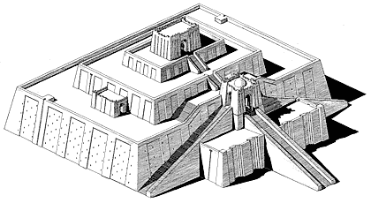
What civilization created it?

Approximately when was it created?

What purpose does it serve?

Identify/Label | 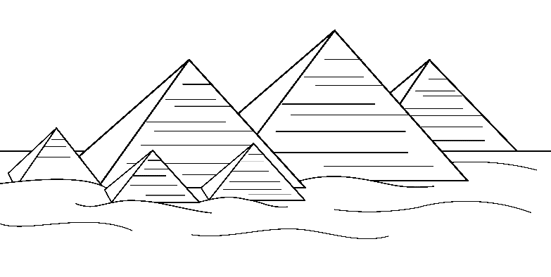
What civilization created it?

Approximately when was it created?

What purpose does it serve?

Identify/Label | 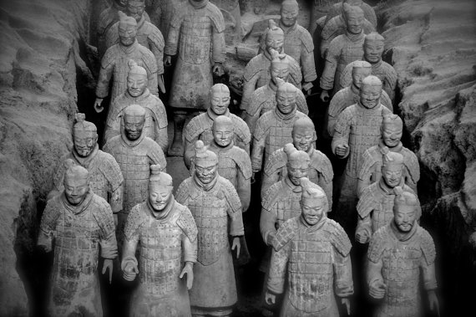
What civilization created it?

Approximately when was it created?

What purpose does it serve?

Identify/Label | 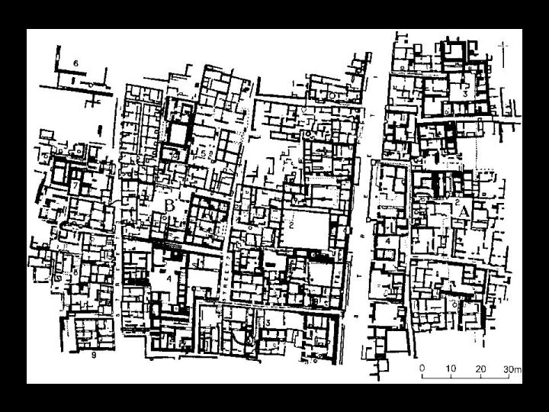
What civilization created it?

Approximately when was it created?

What purpose does it serve?

Identify/Label | 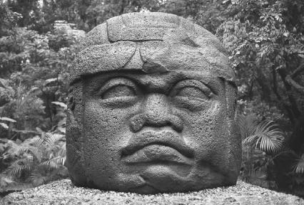
What civilization created it?

Approximately when was it created?

What purpose does it serve?

- Complete the grid below as examples of systems of record keeping that arose amongst early civilizations

Type of Writing System | 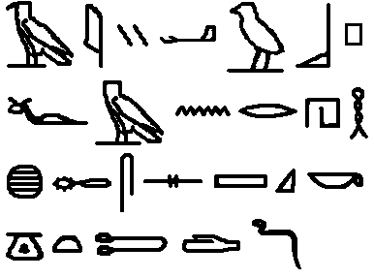
What civilization created it?

Identify a unique characteristic of the writing system

Type of Writing System | 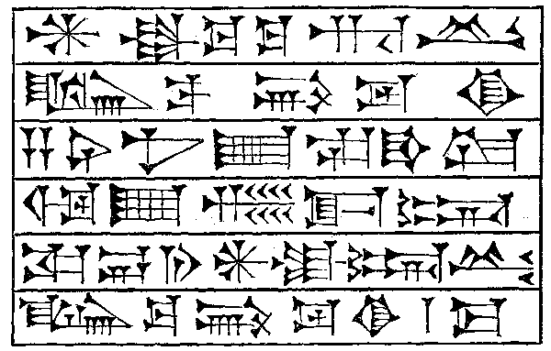
What civilization created it?

Identify a unique characteristic of the writing system

Type of Writing System | 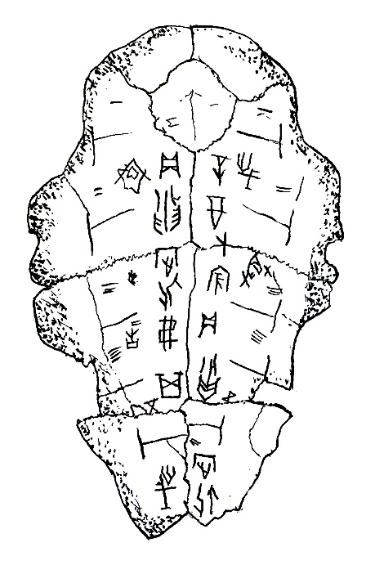
What civilization created it?

Identify a unique characteristic of the writing system

- Explain how the Code of Hammurabi was an example of a developed legal code that reflected existing hierarchies and facilitated the rule of governments over people.

____________________________________________________________________________________________________________________________________________________________________________________________________________________________________________________________________________________________________________

- Complete the grid below to identify how new religious beliefs that developed during this period, continued to have strong influences in later periods.

 | Vedic Religions | Hebrew monotheism | Zoroastrianism
Theism (mono, poly, etc)
Relative Location
Approx. Founding
Religious Text(s)
Key God(s)
Key Figures/Prophets
Moral Philosophy

- Select one of the trade routes listed and complete the grid below to explain how trade expanded throughout this period from local to region to interregional with civilizations exchanging goods, cultural ideas, and technology. Select

Trade between Mesopotamia & Egypt; Trade between Egypt & Nubia; Trade between Mesopotamia & the Indus Valley

Trade Route:
Goods, Ideas, and/or Technology Sent | Goods, Ideas, and/or Technology Received

- Select TWO civilizations from 1.3.I and explain how social hierarchies developed as states expanded and cities multiplied

Civ:

Civ:

Select TWO civilizations from 1.3.I and explain how patriarchy intensified as states expanded and cities multiplied

Civ:

Civ:

Key Vocabulary

- Civilization
- Culture
- Paleolithic Era
- Neolithic Revolution
- Sumer
- City-state
- Hammurabi
- Bablyon
- Ziggurat
- Cuneiform
- Pharaoh
- Papyrus
- Harappa/Mohenjo-Daro
- Mandate of Heaven
- Nomads
- Hittites
- Hatshepsut
- Akhenaten
- Ramesses II
- Ashurbanipal
- Israel
- Hebrew Bible
- Phoenicians
- Polynesian
- Microsocieties

- Ideology
- Cyrus the Great
- Royal Road

