DUE ¾ or 3/5 by 9pm

Constitution of 1791 (2 pts)

- Limited monarch in place of the absolute monarchy
- A new legislative assembly with the power to make laws, collect taxes, and decided on issues of war and peace
- King still has executive power to enforce laws.
- Every adult male property owner who satisfied minimal tax-paying requirements (roughly 2/3 of all adult males) could vote
- Abolished old provincial courts and reformed laws

How do you feel about the ideas in the Constitutional of 1791? Why?

A Series of Dramatic Events

- King and Queen attempted to escape but were discovered and returned to Paris
- Émigrés (nobles, clergy, and other who had fled France) reported attack on their privileges, property, religion, and their lives.
- Government banned strikes and workers feel ignored
- Inflation is through the roof
- Prussia and Austria declare war on France in order to intervene and support the French king.
- War goes badly for France and the King seems indifferent
- On August 10, 1792 a crowd of armed Parisians stormed the royal palace at the Tuileries (literally driving the King from the throne)
- Sans-culottes (urban working class men and women) demand a republic (a government ruled by elected representatives

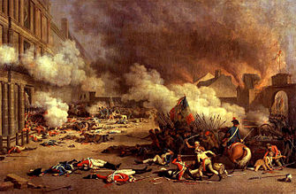

The National Convention

On the night of the attack on the Tuileries, ½ of the National Assembly fled Paris. Those who remained ordered elections for a National Convention to decide the king’s fate, to draft a republican constitution, and to govern France in the current emergency

- The newly elected Legislative Assembly survived for less than one year.
- France is declared a republic.
- Fearing a plot to force open Paris’ overcrowded jails, mobs of Parisians invaded the prisons and over the course of three days in September 1792 slaughtered more than 2,000 prisoners.
- King Louis XVI was founded guilty of treason
- Vote of 387 to 334, he was sentenced to death – by guillotine
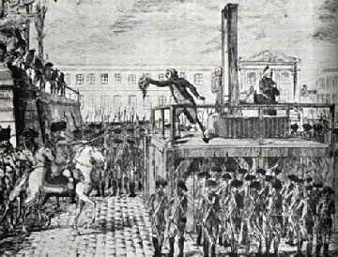
- Nine months later the queen was executed.
Left  Radical  Jacobins  Danton, Robespierre, Marat  San-culottes  “We need more change” | Center  Moderate  Girondins  “The change doesn’t need to be quite so radical.” | Right  Reactionaries  Royalists  “Let’s go back to the way things used to be.”

Where would you be on the political spectrum? Why? (2 pts)

Radical Days of the Revolution – The Reign of Terror
Jacobins | Girondin
“Friends, we are betrayed! To arms! To arms! . . Your greatest enemies are in your midst, they direct your operation . . . Yes, the counter revolution is in the Government . . . in the National Convention!  Let us rise! Yes, let us all rise! Let us arrest all the enemies of our revolution, and all suspected persons. Let us exterminate without pity, all conspirators, unless we wish to exterminate ourselves.”  Circular from the Paris Jacobin Club to local branches | I thought that the insurrectionary (rebellious) movements must cease, because, when there was no longer a tyranny to be struck down, there ought to be no longer any force in insurrection . . .  I thought that order alone could produce tranquility; that order consisted of a religious respect for the laws . . . and the safety of the individual . . . I also thought, consequently, that order, also, was a truly revolutionary measure . . .  Brissot, a leader of the Girondin Party

Which party best represents the beliefs of your character/social class? (Use the social class you did your blog for) Why? (2 pts)

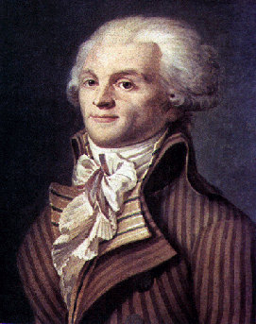
On June 22, 1793, 80,000 armed sans-culottes surrounded the meeting halls of the National Convention and demanded the immediate arrest of the Girondin faction. The Convention yielded to the mob and 29 Girondin members of the Convention were arrested.
The Jacobins believed passionately that France needed complete restricting, and they unleased a campaign of terror to promote their revolutionary goal. They sought to eliminate the influence of Christianity in French society by closing churches and forcing priests to take wives. They promoted a new “cult of reason” as a secular alternative to Christianity. The reorganized the calendar, keeping months of thirty days but replacing seven-day weeks with ten-day units that recognized no day of religious observance. The Jacobins proclaimed the inauguration of a new historical era with the Year 1, which began with the declaration of the First Republic on September 22, 1792. They encouraged citizens to display their revolutionary zeal by wearing working class clothes. They granted increase rights to women by permitting them to inherit property and divorce their husbands, although they did not allow women to vote or participate in political affairs.

By mid-1793, many people were concerned about the course of the Revolution. There was much criticism both inside and outside of France’s borders, and as a result, many of the leaders feared losing control. In order to avoid a “counterrevolution” the Jacobin, under the leadership of Maximilian Robespierre, began to make accusations, hold trials and executions in order to stop this activity. This created a wave a fear and panic throughout the country. The Jacobins made frequent use of the guillotine: between the summer of 1793 and the summer of 1794, they executed about 40,000 people and imprisoned 300,000 suspected enemies of the revolution.

How do you feel about the changes made by the National Convention/Jacobin party? Why? (2pts)

The End of the Terror
By the summer of 1794, there seem to be less need for the Terror. The Republic seemed a reality, an aristocratic conspiracy had subsided, the will to punish traitors decreased, and most sans-culottes went home to tend to business. And, as the need for the Terror decreased, so too did Robespierre's power and leadership. Some members of the Convention, fearing for their own lives, ordered the arrest of Robespierre. On July 27, 1794, Robespierre was arrested and guillotined the next day -- the sans-culottes made no attempt to save him.

Why did the Revolution become radical? Why did it end? (2 pts)

The Directory

As the Reign of Terror ended, it became necessary to create yet a new form of leadership for France, and by 1795, the government had passed into the hands of the five-man Directory. The Directory tried to preserve the Revolution of 1789 – they opposed the restoration of the ancien regime as well as popular democracy. The Directory lasted until 1799. By this time the French Revolution was over and the French tried to get back to business as usual. Radicalism had been effectively put down as well. But France was still at war with the rest of Europe.

Is the Directory what France needed after the Reign of Terror? Why or why not? (2 pts)

