Due 2/20 or 2/21 by 9pm
The causes of the
French Revolution Cartoon - 5pts

This Cartoon was produced in the 1780s and is a comment on the social situation in France at that time. It can be used to help explain the causes of the French Revolution of 1789.
You have two task for this assignment. You should use your knowledge and evidence from your lesson on the causes of the French Revolution to help you complete the tasks.

- Label the three figures in the cartoon by writing in the spaces provided:
  - Peasants
  - Priest
  - Noble
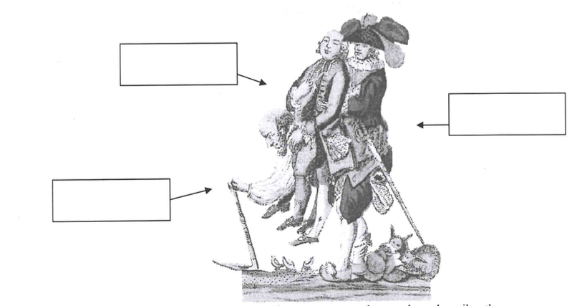
Source E

- Use your own knowledge to explain how the cartoon can be used to describe the causes of the French Revolution.

The causes of the French Revolution - 5 pts
Fill in the gaps on this sheet using the words at the bottom of the page.

There was a revolution in _________in 1789. The ruler of France before the Revolution was King __________ XVI. His wife was Queen ________________________. King Louis XVI lived in his palace at ___________________near Paris.

One of the reasons why there was a revolution in France in 1789 is that the king ran out of ____________. He spent lots of money on two wars with __________. One was in 1756 and another one was in 1778. In the second war the French were helping the ________________ break away from British control.

Another cause of the French Revolution was the problems faced by the ___________. They were so poor that they did not have enough money to feed their families. This was made worse when the crops failed to grow. ______________ failed in 1787 and 1788.

Another cause of the French Revolution was that the two _________ groups in France would not give the King more money. The ________ and ___________ had lots of land and money but would not pay more ____________. This left the king unable to find more money.

A final reason why the French had a revolution in 1789 was ideas. A new set of ideas called the _______________ attacked the power of the king and the church. These made lots of ordinary French people think that they should have some of the power of the __________________.
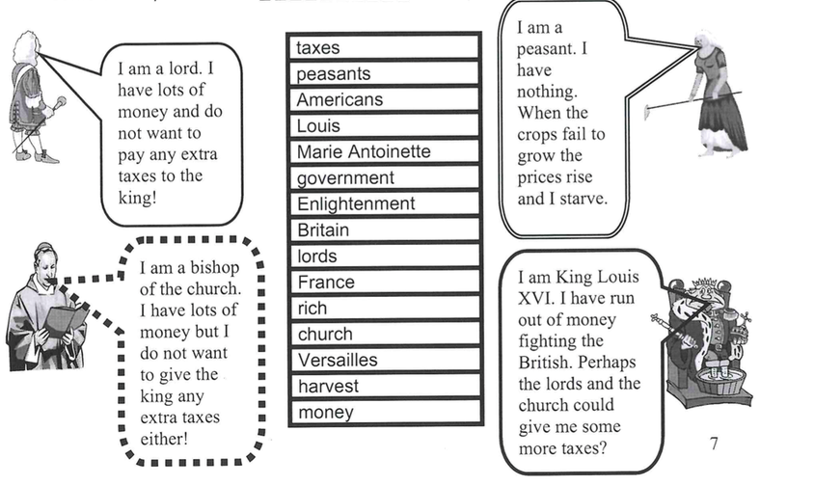

IN THE TENNIS COURT - 3pts
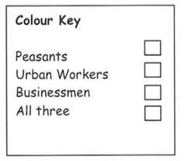
In a desperate attempt to collect even more taxes. King Louis called a meeting of the ESTATES GENERAL in 1788. However the people from the Third Estate used the meeting as a chance to tell the king what the thought was wrong with France and their lives and demand improvements. When the King refused to listen, members of the Third Estate went to a nearby Tennis Court and made an OATH saying they would not until the king had made improvements. In the Tennis Court several
people made speeches.

Below are ‘bits’ of those speeches. In one color show what
‘bits’ the peasants would have said. In another show what ‘bits’
the urban workers would have said and in a third color show
what the businessmen would have said. Use a fourth color if all
three could have said it.
