Sources:
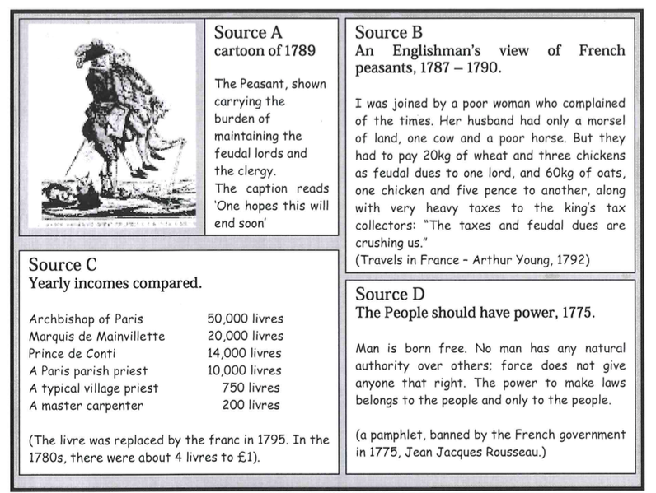

Causes of the French Revolution #1 – (15 pts)
Due by 6pm 2-19 (A day 6 pm 2-18)

- What might a French peasant have grumbled about in 1789?

- How does the author of source B describe the lives of French peasants? (remember: it is not enough to say ‘good’ or ‘bad’ - you need to give examples from the source!)

- Study sources A, B and C together. Do these sources explain why poor people in France resented the rich? Explain your answer using the sources.

- The pamphlet which source D came from was banned in 1775. Why do you think this was? Which members of French society would want it to be banned?

- Write down each of the following words or terms, and what it means: Bankrupt; Reform; Estates General; deputies; cahiers de doleances; ‘national assembly; constitution; tennis court oath. (4pts)

- Why was the French Government bankrupt in 1787? (think of more than one or two reasons)

- What effect did the poor harvest have on the ordinary people of France?

- Why might members of the third estate have felt under-represented at the meeting of the Estates General in May 1789?

- What were the hopes of each of the parties involved?

- What mistakes did Louis make at the meeting, and what did his mistake lead to?

