Chapter Summary. The recent history of China, Japan, and Vietnam has significant differences from other Asian and African states. Japan remained independent, industrialized, and became a great imperialist power. After World War II, Korea, Taiwan, and other industrializing nations gave the Pacific Rim new importance. China and Vietnam suffered from Western and Asian imperialists. With their traditional order in ruins, they had to face the usual problems of underdeveloped colonial peoples. Full-scale revolutions occurred. By the beginning of the 21st century, the result of all the changes gave east Asia a new importance in world affairs.

Introduction
- Why was Yun accused of being a spy and sent to prison?

- In what year did the Communists win in China?

- Where did the Guomindang go when the Communists, under Mao, took China?

East Asia in the Postwar Settlements.
New Divisions and the End of Empires.

- Explain why it wasn’t surprising North Korea became communist.

- What was America’s primary goal when it restructured Japan following WWII?

Japanese Recovery.
- What reforms did America force Japan to make during its restructuring?

Korea: Intervention and War.
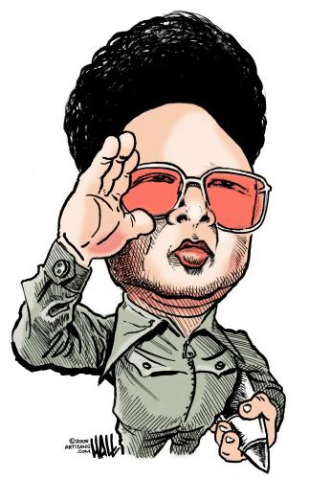

- What sort of governments has South Korea had?

- How does South Korea’s economy compare to North Korea’s?

Emerging Stability in Taiwan, Hong Kong, and Singapore.
- What happened to Hong Kong in 1997?

- Taiwan, Hong Kong, and Singapore all play influential roles on the world scene in what manner?

Japan, Incorporated.
Japan’s Distinctive Political and Cultural Style.

- What caused Japanese politics to change in the 1990s and how is this similar both to the PRI in Mexico in the late 20th century and the end of most Chinese dynasties?

- What was/is the relationship between Japanese business and government?

The Economic Surge.
- How did Japan’s economy compare to the rest of the world by the 1970s and 1980s?

- Why was Japan able to sink every bit of capital it had into its economy given it’s right next to three communist countries, USSR (during the Cold War), China, and North Korea? Why was it not worried about being attacked?

- What American sport was transferred to Japan?

The Pacific Rim: New Japans?
The Korean Miracle.
- In what product areas did Korea compete with Japan?

Advances in Taiwan and the City-States.
- Given that China is communist, why do you think the U.S. broke official ties with Taiwan in 1978?

- What city-state in East Asia gained its independence in 1965?

- What did China promise to do regarding Hong Kong? Why do some not believe it?

VISUALIZING THE PAST: PACIFIC RIM GROWTH
- List the countries that make up the Pacific Rim.

Common Themes and New Problems.
- What did the Westerners and the World Bank attempt to convince the “little tigers” they needed to do before they could get loans?

Mao’s China and Beyond.
- Chiang Kai-shek and the Guomindang (a.k.a. Kuomintang or Nationalists) nearly defeated the Chinese Communists. What happened to interfere with his victory?

- What did Mao do to improve the life of peasants and win their support?

The Communists Come to Power.

- What led to the split between the communist Soviet Union and the communist People’s Republic of China?

Planning for Economic Growth and Social Justice.

- How did Mao’s policies toward peasants change in the mid-1950s?

- The third paragraph is a bit confusing. It states that Mao was always on the side of the peasants yet it immediately follows with a description of the “Mass Line” approach. What was this approach and how did it harm peasants?

THE GREAT LEAP BACKWARD:
- What was the “Great Leap Forward” and who was it intended to help?

- Why did the GLP fail?

- What ancient Chinese factor is playing a role in the disproportionate ration of males to females today?

“WOMEN HOLD UP HALF OF THE HEAVENS.”
- List improvements made to the lives of women in China under the communists.

- What difficulties remained for women in China?

Mao’s Last Campaign and the Fall of the Gang of Four.
- Explain what the Cultural Revolution was and the role of the Red Guard in it.

- Following Mao’s death, how has China’s economy changed?

Colonialism and Revolution in Vietnam.

- What European power played a major role in Vietnam’s history?

- How did religion factor into this power’s involvement in Vietnam?

- What East Asian philosophy was favored over Catholicism?

Vietnamese Nationalism: Bourgeois Dead Ends and Communist Survival.
- How did the West’s education system once again play a role in helping start a nationalist movement, this time in Vietnam?

- When and where did Ho Chi Minh discover Marxism (communism)?

The War of Liberation against the French.
- How did the Viet Minh win support in the north? How does this compare with Mao’s tactics in China?

The War of Liberation Against the United States.
- “The United States was an imperialist power as shown by its involvement in Vietnam.” Evaluate that statement through comparison with France’s role in Vietnam.

After Victory: The Struggle to Rebuild Vietnam.
- Evaluate the successfulness of communism in Vietnam from 1975 to the present.

Global Connections: East Asia and the Pacific Rim in the Contemporary World.
- Why might the 21st century be called the “century of east Asia”?

