Chapter Summary. Deep divisions between ethnic and religious groups remained when European rulers disappeared from their former colonies. Economic life was hampered by concessions made to the departing colonizers and by an international economy that favored industrialized nations. They lacked technological and management expertise, and had to face steady population growth and environmental degradation

Introduction
- What was the motivation for the assassination of Indira Gandhi?

- Your text states that India was a “non-aligned” nation. Explain the meaning of this term.

The Challenges of Independence.
- What were the lower class groups promised by nationalists in return for their support for independence from European control?

- Why did socialism fail in the new nations of Asia, the Middle East, and Africa?

- What did East Pakistan become known as?

- What was the primary reason African countries could not feed their peoples?

The Population Bomb.
- What economic policy did leaders in the newly independent countries of Africa and Asia try to follow?

- What development from the Early Modern (1450-1750) period was an underlying cause of the population increase?

- Ending warfare is usually considered a good thing. Why was it an overall negative in some areas?

- How did railroads and steamships lead to population growth?

- How did improved health care and public works projects lead to higher population growth?

- Were the population experts of the 1970s right or wrong in their population predictions for south Asia? How so?

- If a cure for AIDS is discovered in the near future, what will the impact be on African society?

- Figure 33.3 (bar graph): the brown area represents developing areas while the green represents developed areas (exception: some parts of East Asia would be considered developed). What conclusion can you make about the developed world versus the developing world?

- Why do some peoples in Africa and Asia not use birth control?

Parasitic Cities and Endangered Ecosystems.
- What problems exist in the cities of Africa, Asia, and the Middle East?

- What challenges has rural overpopulation produced?

Women’s Subordination and the Nature of Feminist Struggles in the Postcolonial Era.
- What has been the common factor among women who have attained power in the developing world?

- Why do women generally not get higher educations in the developing world?

- What has been the impact of religious revivalism on women?

Neocolonialism, Cold War Rivalries, and Stunted Development.
- What have emerging countries depended upon to finance industrialization?
- Explain the value problem between primary products and manufactured goods in the 20th century.

- Western nations no longer possess colonies. How can it be argue that in a sense, they still do?

- What are the internal explanations for emerging countries’ failure to industrialize and grow their economies?

- List the conditions that international organizations like the World Bank or IMF have insisted emerging countries agree too in order to get loans to industrialize.

- What has been the impact of reducing state subsidies on food in the developing world?

Paths to Economic Growth and Social Justice.
- Either through your own reasoning ability or through the wonders of the internet, explain what your text means when it uses the term “social justice”. (HINT: think about what the lower classes in developing countries often wanted)

- How effective have developing countries been in creating economic growth and establishing social justice?

- Do you think that both economic growth and social justice can be established concurrently or must one come before the other?

Charismatic Populists and One-Party Rule.
- What system of government did NOT work in creating economic growth and social justice?

- Consider the cold war and its representative superpowers. Which superpower symbolizes economic growth and which symbolizes social justice?

- Given the question and your answer above plus question 39, did the cold war aid economic growth, social justice, both, or neither?

Military Responses: Dictatorships and Revolutions.
- What issues brought Nasser to power in Egypt in 1952?

- What country or alliance did Egypt align itself with under Nasser?

- Besides the answer to the question above, what did Nasser do that alienated Western investors, further harming his chances to improve the Egyptian economy.

- Cite the negative impacts of the Aswan Dam on Egypt.

- Today Egypt is the 3rd highest recipient of U.S. foreign aid in the world. Fifteen years ago it was 2nd (Today Iraq is number 1, followed by Israel, then Egypt and then Afghanistan). What did Sadat do to get so much aid from the U.S. and why does it continue to this day?

The Indian Alternative: Development for Some of the People.
- What factors distinguish India from other developing countries?

- Why did India have so many advantages over other countries when it became independent, for example, superior communication systems and more skilled middle class?

- What was (is) India’s biggest challenge? (HINT: Egypt shares this issue.)

Iran: Religious Revivalism and the Rejection of the West.
- What mistakes did the shah make in Iran?

- What changes did Ayatollah Khomeini implement in Iran?
- Iran chose to align itself with neither the Soviet Union nor the United States and the West. How did this action present a problem regarding Iraq and Saddam Hussein?

- Why did the oil-producing Arab nations support Iraq over Iran?

South Africa: The Apartheid State and Its Demise.
- List four restrictions placed on blacks by the Afrikaners.

- How did the international community help bring about an end to apartheid?

Comparison of Emerging Nations.
- Describe the religious makeup of sub-Saharan Africa today.

Visualizing the Past: Globalization and Postcolonial Societies
- Many Asian, African, and Middle Eastern farmers no longer farm but instead work producing what?

- What has been the impact on American manufacturing jobs?

Global Connections: Postcolonial Nations in the Cold War Order
- A devastating plague sweeps through the developing world, killing 30%-50% of the population. What COULD the long term impact be both on those countries and the developed world? (HINT: think wages & jobs)

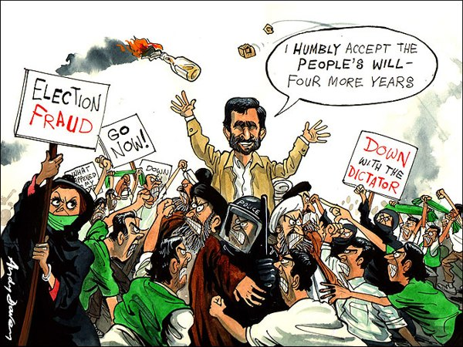
Evaluation:

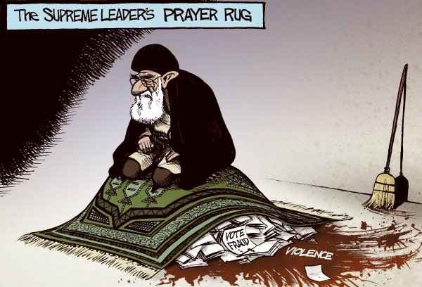
Evaluate the last sentence on the subsection entitled “Iran: Religious Revivalism and the Rejection of the West” in light of these 2 cartoons on the Iranian election held in July 2009.

