Chapter Summary. Much of the 20th century was a time of contest between the forces of reaction and revolution. The Latin American struggle was primarily one of economic disengagement and an effort to develop their own cultural and political forms. Along with other societies the peoples of the third world, developing nations, had to deal with industrialization and its growth, and with their inequality in economic matters with more developed nations. Latin America had characteristics distinguishing it from other developing countries. It had won independence earlier, and had more Western social and political structures. After 1945, Latin American economies concentrated on exports, and thus became very vulnerable to world financial changes.

Introduction
- What happened in various Latin American countries in the 1960s and 1970s?

- Identify the larger conflict Latin American countries got pulled into during the cold war.

- Identify:
  - First World

  - Second World

  - Third World

- How were Latin American countries different from other developing countries in Asia and Africa?

- To what degree did Latin America undergo revolutionary change during the 20th century?

Latin America After World War II.
- What effect did World War II have on Latin America?

- What was the impact of the cold war?

Mexico and the PRI.
- What political party dominated 20th century Mexico?

- How does the rise and fall, particularly the fall, of the PRI resemble China’s dynasty cycle?

- What promises did the PAN party make that brought it to power?

Radical Options in the 1950s.
- What was the focus of the Mexican government in the years following the revolution there?

- What ideology did many Latin American revolutionaries turn to?

- What was the primary problem/injustice in Bolivia?

Guatemala: Reform and United States Intervention.
- What is the act of taking an industry or assets into the public ownership of the state known as?

- The policy above would most likely be utilized by capitalist or socialist governments?

- Why did the United States & the CIA get involved in Guatemalan politics?

The Cuban Revolution: Socialism in the Caribbean.
- What was America’s economic role in Cuba prior to 1961?

- What individual led the opposition to Batista in Cuba?

- What type of political system did this individual state he favored at his trial following his capture?

- What Argentine played a role in the Cuban revolution and how did he help?

- How did the United States help the Cuban revolution?

- Once Batista was overthrown, what typed of political and economic system did Castro impose on Cuba?

- What impact did this change have on relations with both the United States and the Soviet Union?

- Make a small T chart below listing the positive and negative results of the Cuban revolution.
Positive Results | Negative Results

- What was the impact of the Soviet Union’s breakup on Cuba?

- What are the only 3 communist countries left in the world today?

The Search for Reform and the Military Option.
- What is Mexico’s primary source of wealth?

- What aged Western institution played a new political role in Latin America the latter half of the 20th century?
- What issues was this institution concerned with?

- Identify the new ideology this institution helped create in combination with Marxism.

dOCUMENT: THE PEOPLE SPEAK
- What conclusions can you draw about Bolivia’s educational system in comparison to our own?

- What is the most important social class distinction in Guatemalan society?

- Politicians in Guatemala obviously know the primary concern of the lower classes. What is it and how to politicians try to manipulate the lower classes?

Out of the Barracks: Soldiers Take Power.
- What was the central focus of military governments in Latin America?

- List several advancements made in Brazil under its military government.

- What key problem that most Latin American societies experience was not addressed in Brazil?

- Why did Argentina invade the Falkland Islands?

The New Democratic Trends.
- Why did the U.S. government decrease its support of anti-communist regimes in Latin America in the mid-1980’s?

- What problems continue to plague Latin America into the 21st century?

The United States and Latin America: Continuing Presence.
- Identify the main characteristics of a “banana republic”.

- Why was the Good Neighbor Policy of FDR largely ignored later by the U.S.?

- What was the positive and negative impact of globalization on Latin America?

Societies in Search of Change.
- What key group in Latin American continues to suffer from discrimination?

Slow Change in Women’s Roles.
- What country was the first to grant female suffrage in Latin America and in what year?

- What decade saw the last Latin American country grant women the right to vote?

- Why were revolutionaries opposed to women voting?

- Were their fears warranted? Explain.(HINT: Dominican Republic)

- Evaluate the impact of women after gaining the right to vote in Latin America.

- How does the role of women differentiate Latin America from other developing regions?

The Movement of People.
- What explains the dramatic population increases in the Americas between 1950 and 1985?

- While the U.S. receives many Latin American immigrants, Western Europe receives many immigrants from what areas?

- Give the other motivation for migration besides economics. Explain this motivation by giving two detailed examples.

- What has happened to cities in Latin America and what problems have resulted?

Cultural Reflections of Despair and Hope.
- What topics have Latin America literature focused on? Why?

Global Connections: Struggling Toward the Future in a Global Economy.
- How does literacy in Latin America today compare to Asia and Africa?

- Your text states that Latin America seems to moving to the left politically in the early 21st century. How do you think the U.S. will react to this shift?

Complete the following question using a Venn diagram:
- Compare and contrast the radical revolutions of the 1950s in Cuba and Guatemala.

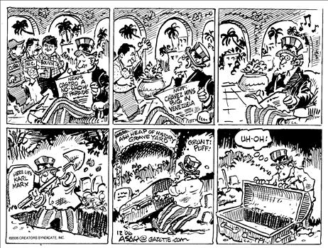
Caption:

