INSTRUCTIONS
The Urban Game (This is what we did in class) Tonight’s assignment is below.
Tonight’s assignment: Plan a city; use the back or the same size paper as your original “rural” village. Use the below requirements to PLAN an urban town around the time of 1850. After you have completed your new town, on a separate sheet of paper compare & contrast the two urban “visions”. In addition, explain why your planned town is designed this way.
World History
Design a Village, c. 1850
Using what you have learned about the evolution of a town, from a site along a fast flowing river to a bustling economic center, design a town “from scratch”.
Your town must include the following structures and spaces. Use the other side of the paper on which you created the Urban Game town. Key is attached.
1 river 3 bridges
80 modest houses 1 city hall
15 splendid houses 1 museum
10 stores 2 secondary school (public)
3 primary schools 20 tenements
1 bank 1 hospital
5 pubs 1 theater
5 restaurants 3 churches
1 courthouse/jail 2 cemeteries
10 factories (various sizes) 2 parks
2 railroad line, 2 stations 1 library
8 streets with one intersection 1 feed mill (where farmers buy grain)
3 coalmines

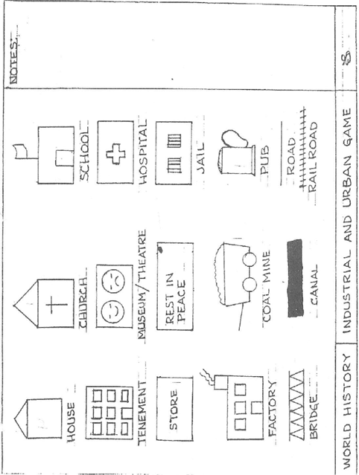

What we did in class:
Each student should have a large piece of butcher block paper (15x20). They should use a pencil for this activity (color pencils are optional).
Using the template provided, each student should make their own template. It is crucial that size for each of the “characters” in the city be the same.
As you read each of the Rounds, your pace should increase so that by Round 15 the students will only have a short time to draw their buildings.
At the conclusion of our class activity, each student should have the following totals:
125 houses 20 Tenements
50 factories 10 wealthy homes
5 schools (2 private) 5 jails
9 cemeteries 10 pubs
10 stores 4 hospitals
1 city hall 2 Theaters
1 museum 2 Railroad stations
1 Canal 5 bridges
2 railroads roads as appropriate
1 3x3 Green Area (common)

