How to write a body paragraph
Example #1 Change and Continuity over Time
Prompt: Analyze the cultural and political changes in the Roman Civilization from 100ce to 600ce

(1)The spread and change in attitude of Christianity motivated many Romans to become Christians. (2) Christianity began in the first century, and at first it faced strong persecution by Roman Emperors. (3) Christians were imprisoned, crucified and fed to the lions for sport. The fire that almost destroyed Rome in the first century (67ce) was blamed on Christians. (2) This persecution lasted until the 300s when Roman Emperor Constantine embraced Christianity and supported it. He even gave special privileges to Christians. (4) As a result, many embraced Christianity, especially merchants and scholars and the religion flourished in the empire. (3) When the capital moved East, Emperor Justinian built the Hagia Sophia to honor Christianity. (2) By the 600s, the Roman Empire that survived in the east was predominantly Christian.

- Does the paragraph have a topic sentence that is relevant to the prompt?  The spread and change in attitude of Christianity motivated many Romans to become Christians. | - Does the paragraph discuss political and/or cultural change in Roman Civilization from 100ce-600ce?  Christianity began in the first century, and at first it faced strong persecution by Roman Emperors.  This persecution lasted until the 300s when Roman Emperor Constantine embraced Christianity and supported it.  By the 600s, the Roman Empire that survived in the east was predominantly Christian.
- Does the paragraph use evidence to support the argument of the writer?  Christians were imprisoned, crucified and fed to the lions for sport. The fire that almost destroyed Rome in the first century (67ce) was blamed on Christians.  When the capital moved East, Emperor Justinian built the Hagia Sophia to honor Christianity. | - Does the paragraph show analysis (cause and/or effect) of change in culture and/or politics?  As a result, many embraced Christianity, especially merchants and scholars and the religion flourished in the empire

How to write a body paragraph
Example #2 Compare and Contrast
Prompt: Analyze similarities and difference in how the Byzantine Empire and the Islamic Caliphates used religion to govern before 1450.

(1) Though having their similarities with the role of religion in governance, they differ in terms of their laws. The Byzantine Empire was initially the Eastern Roman Empire. Because of this (2) their laws while influenced by Christianity were founded upon Roman principles. (3) They had a Roman leader (emperor), they followed Roman laws and ultimately worked their hardest to emulate Romans. (4) In fact, they didn’t even see themselves as a new empire but as a continuation of Rome. They knew themselves as Roman, not as Byzantines. (2) On the other hand, (3) Islamic law was sharia law. You paid zakat, followed ideas of Islamic punishment, and ultimately your laws were the Qur’an’s laws. Though there was religious tolerance, taxes were implemented on non-Muslims to promote conversion to Islam. (4) Such religious fervor in governance is unparalleled especially not the Byzantines. In the Islamic Caliphates religion, law governed, while in the Byzantine Empire, Christianity only mildly influenced Roman laws.

- Does the paragraph have a topic sentence that is relevant to the prompt?  Though having their similarities with the role of religion in governance, they differ in terms of their laws | - Does the paragraph discuss similarities or differences in how religion was used to govern between the Islamic Caliphates and the Byzantine Empire?  their laws while influenced by Christianity were founded upon Roman principles.  On the other hand, Islamic law was sharia law
- Does the paragraph use evidence to support the argument of the writer?  They had a Roman leader (emperor), they followed Roman laws and ultimately worked their hardest to emulate Romans  Islamic law was sharia law. You paid zakat, followed ideas of Islamic punishment, and ultimately your laws were the Qur’an’s laws. Though there was religious tolerance, taxes were implemented on non-Muslims to promote conversion to Islam. | - Does the paragraph show analysis (cause and/or effect) of the similarities or differences?  In fact, they didn’t even see themselves as a new empire but as a continuation of Rome. They knew themselves as Roman, not as Byzantines  Such religious fervor in governance is unparalleled especially not the Byzantines. In the Islamic Caliphates religion, law governed, while in the Byzantine Empire, Christianity only mildly influenced Roman laws.

How to write a paragraph
Example #3 DBQ
Prompt: Based on the following documents, analyze the responses to the spread of Buddhism in China.
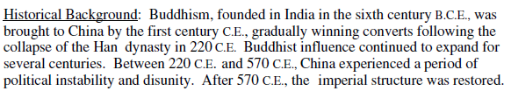
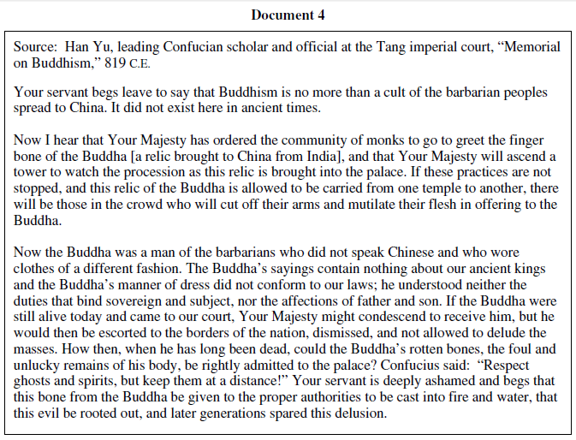
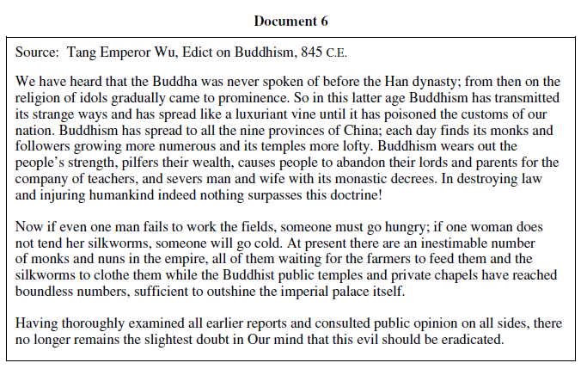

(1) Also in China, there was a negative backlash to Buddhism in the royal court where many believed that embracing the faith in China was a negative form of cultural diffusion that would only corrupt the masses and China itself. (2)Han Yu tells the ruler that Buddhism goes against everything China has stood for and goes against Confucian philosophy that many in China believed was to be followed. He claims that (3) Buddha was a foreigner who had nothing to do with China and the Chinese, so his message does not apply here. He also says that worshipping Buddha’s relic goes against the Confucian principle on keeping ghosts and spirits far away, another example of Buddhism breaking the rules of Confucianism. (doc 4). The Chinese Emperor finally responded to these claims and (4) issued an edict strongly against the faith enforcing much of what Han Yu had to say. (3) The Emperor claimed that Buddhism distracted the people and was detrimental to the economy as well as destroying marital relations (doc 6). (4)This edict looked at Buddhism as an evil to get rid of and strike down anything that was in favor of keeping the faith.
- Does the paragraph have a topic sentence that is relevant to the prompt?  Also in China, there was a negative backlash to Buddhism in the royal court where many believed that embracing the faith in China was a negative form of cultural diffusion that would only corrupt the masses and China itself. | - Does the paragraph analyze Chinese responses to Buddhism?  Han Yu tells the ruler that Buddhism goes against everything China has stood for and goes against Confucian philosophy that many in China believed was to be followed
- Does the paragraph use evidence from more than 1 document to support the argument of the writer?  Buddha was a foreigner who had nothing to do with China and the Chinese, so his message does not apply here. He also says that worshipping Buddha’s relic goes against the Confucian principle on keeping ghosts and spirits far away, another example of Buddhism breaking the rules of Confucianism. (doc 4).  The Emperor claimed that Buddhism distracted the people and was detrimental to the economy as well as destroying marital relations (doc 6). | - Does the paragraph show analysis (POV/Tone) of the speakers in the documents and relates it to the prompt?  Chinese Emperor finally responded to these claims and issued an edict strongly against the faith enforcing much of what Han Yu had to say  This edict looked at Buddhism as an evil to get rid of and strike down anything that was in favor of keeping the faith.

