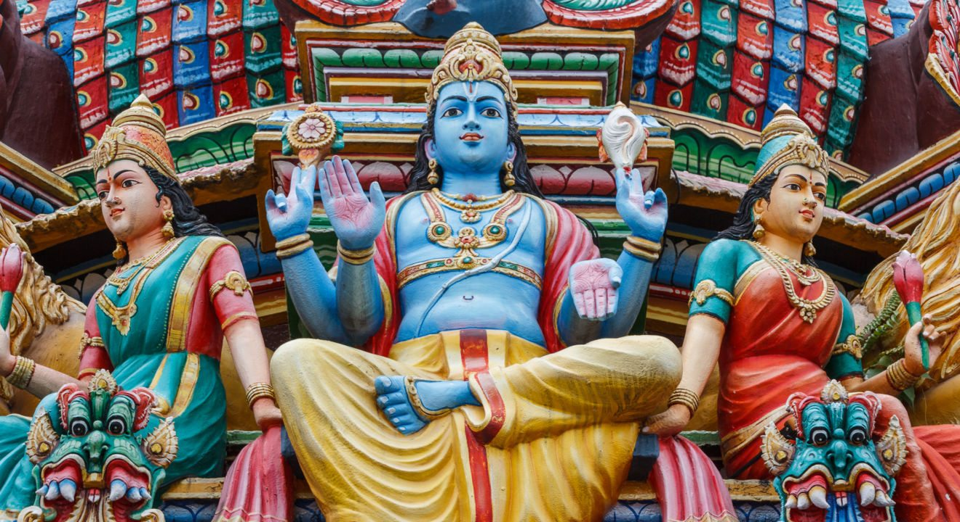
Background Information on Hinduism
Hinduism: Background, Basic Beliefs and Sacred Texts

How did Hinduism begin?
Hinduism or Sanatana Dharma ("eternal spiritual path") began about 4000 years ago in India. It was the religion of an ancient people known as the Aryans ("noble people") whose philosophy, religion, and customs are recorded in their sacred texts known as the Vedas. These texts were initially handed down by word of mouth from teacher to student. It was not until much later that they were actually written down. Archeological evidence from the Indus Valley civilization of northwestern India helps to establish Hinduism as the world's oldest living religion. Today, worldwide, there are almost one billion people professing some aspect of Hinduism. The fundamental teachings of Hinduism, which form the foundation of all its different sects, are contained in the concluding portion of the Vedas, and are therefore known as the Vedanta (the "end or concluding portion of the Vedas"). This part of the Vedas is also known as the Upanishads.
What do Hindus believe and practice?
The fundamental teaching of Hinduism, or Vedanta, is that a human being's basic nature is not confined to the body or the mind. Beyond both of these is the spirit or the spark of God within the soul. This spirit is within us and also within everything we see. All beings and all things are really, in their deepest essence, this pure or divine spirit, full of peace, full of joy and wisdom, ever united with God. This is not just theory, but it can actually be experienced. Anyone who takes the trouble to undergo the necessary training to purify and refine the mind and senses can begin to feel the truth of this. This training can take various forms and is known as yoga ("union"- union of the individual self with this inner spirit). There are four main types of yoga, meant for the four main types of human temperaments:
- Karma Yoga or the discipline of right actions is for those of active temperament, striving to eliminate selfishness, and to cultivate universal sympathy by seeing the divine reality in all.
- Bhakti Yoga is the path of devotion to God whose presence can be felt in all things. God can be worshipped as present in an image in a Temple. God can be worshipped also as present in suffering humanity by service.
- Jnana Yoga, preferred by those of analytical bent of mind, is the discipline of trying to see the divine reality within all things directly, by mentally brushing aside all the obstructing physical and mental coverings that hide it.
- Raja Yoga is the process of mental control, purity, and meditation to make the mind very calm and quiet. In that profound quiet, the inner divine light reveals itself.

What are the manifestation(s) God in Hinduism? What are the different sects of Hinduism?
The general name for God in Hinduism is Brahman. The name of the divine essence within us is Atman. They are one and the same, infinite and eternal. However, God is also present in all creation. God's manifestation in creation goes by many names. It is the one infinite, eternal, Divine Being that is manifesting in countless ways. It is like a person at the same time being called "father" by his son, "friend" by his friend, "son" by his own father, "husband" by his wife, etc. A special relationship goes with each name. So the same Divine Lord has been addressed as Shiva, Vishnu, etc and as Divine Mother, Kali, Durga, etc. God can also manifest as an extraordinary being in human form, who is then known as an incarnation of God, such as Krishna, Rama, etc. Since it is the one infinite God alone that is being looked at in different ways, all these manifestations can be prayed to for help and protection. This is the underlying principle behind all the different sects of Hinduism. Those who prefer a particular manifestation of the divinity will form a sect devoted to the contemplation and worship of that manifestation. All the sects, however, will accept the ancient teachings of the Vedas and the Vedanta as the foundation of their practice
What is reincarnation?
In this world every cause must have its effect. We are responsible for the results of our actions. Long ages ago, human beings first asked themselves, why are some people born in happy circumstances, whereas others are born to suffer all their lives? The events of this present life are not enough to account for such suffering. To reasonably explain an excess of suffering or of enjoyment in this life, it was assumed that we all have had previous existences, and that we are now reaping the results of those previous actions. It must also be true then that we can take charge of our destiny right now. We can create a better tomorrow by resolving do better actions today. However, as long as desires remain in the mind, the tendency toward rebirth will exist.
What is Maya?
In this life we do not see things very clearly. We are constantly faced with contradictions. Though we know what is right, we have trouble doing it. Our thoughts soar high, but our actions cannot rise to the level of our thoughts. The world is full of misery and injustice; as quickly as we remove some, more seems to rush in to take its place. We are told by the saints, and we also feel, that a loving God is at work in this creation, but we cannot reconcile this with what we see around us. This complex situation in which we find ourselves is called maya.
The way out of this, according to Hinduism or Vedanta, is that we are not really seeing the world properly. If we saw it properly, we would see that it is God alone before us. Instead, we superimpose all this complex world on that divine reality. The illustration given is that of a rope, mistaken in semi-darkness for a snake. The snake of this world frightens us. What is the solution? Bring a light and you will see its real nature. It is only a rope. Likewise, the real nature or essence of this world is divinity alone. Bring the light of spiritual wisdom through yoga, and you will see God alone everywhere. This is what constitutes spiritual freedom or liberation, Moksha. When this knowledge dawns, there is complete satisfaction; no desire remains in the mind, and no further impulse for rebirth remains.
What code of behavior do Hindus follow?
The code of behavior is one's dharma. This is determined by the place in society and the duties associated with it. There are four main social positions or varna; Brahmins (priests and teachers) Kshatriyas (rulers and soldiers), Vaishyas (merchants) and Shudras (workers).
There are four ideal stages of life described in Hindu scriptures: the student, the family man, the recluse, and the wandering holy man. For most Hindu people these represent a metaphorical path, not an actual path.
What are the Hindu sacred texts?
Hindu ancient, sacred texts were written in Sanskrit, the language of ancient India.
- The Vedas are the oldest - about 3000 years old. They are a collection of hymns, prayers, and magic spells.
- The Upanishads are stories and parables told by gurus (teachers) to their students
- The Mahabharata is a story of a war between two royal families. The Bhagavad Gita is a very popular part of this text.
- The Ramayana is a story of the god Rama and the rescue of his wife Sita from Ravana, the evil demon king

