- Using the documents provided and your knowledge of world history, analyze the impact of Greek culture on Alexander the Great’s empire.

Document 1
27 October 2003: "Foreign" Religions: Alexander’s Conquest and Its Effects. Lecture outline, Christine M. Thomas, UC Santa Barbara

“But the most lasting thing he did was to found cities, some 70 of them, which were outposts of Greek culture all over the known world. This is the beginning of the mass dissemination of Greek culture known as the Hellenistic age (mid-third century BCE until mid-first century BCE).
Culturally, the Hellenistic age represents the spread of Greek language, literature, and education in the characteristic institution of the gymnasiu m, the athletic facility with attached classrooms (gymnos means "nude" in Greek, since exercise was done in the nude). Literacy was on the rise; this is one of the few periods in which there was basic public schooling in literacy for girls. Hellenistic scholars made advances in the natural sciences, in geometry and geography, and in the study of literature and history. Hellenistic fine art, especially sculpture, achieved great sophistication in natural representation.”

Document 2
Map of Alexander the Great’s Empire, including the cities he founded. 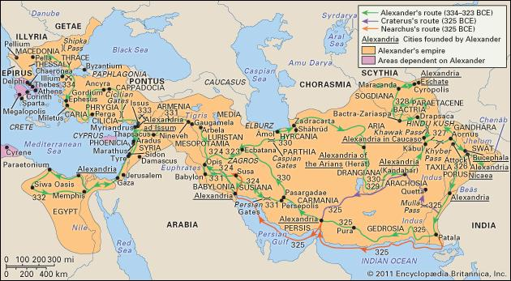

Document 3
Left: The Titan Atlas, supporting a Buddhist monument, Hadda. Personal photograph, Musee Guimet, Paris, 2004 | Right: Balustrade-holding Yaksa with Corinthian columns, Madhya Pradesh (?), Shunga period (2nd-1st century BC). Musee Guimet, Paris.
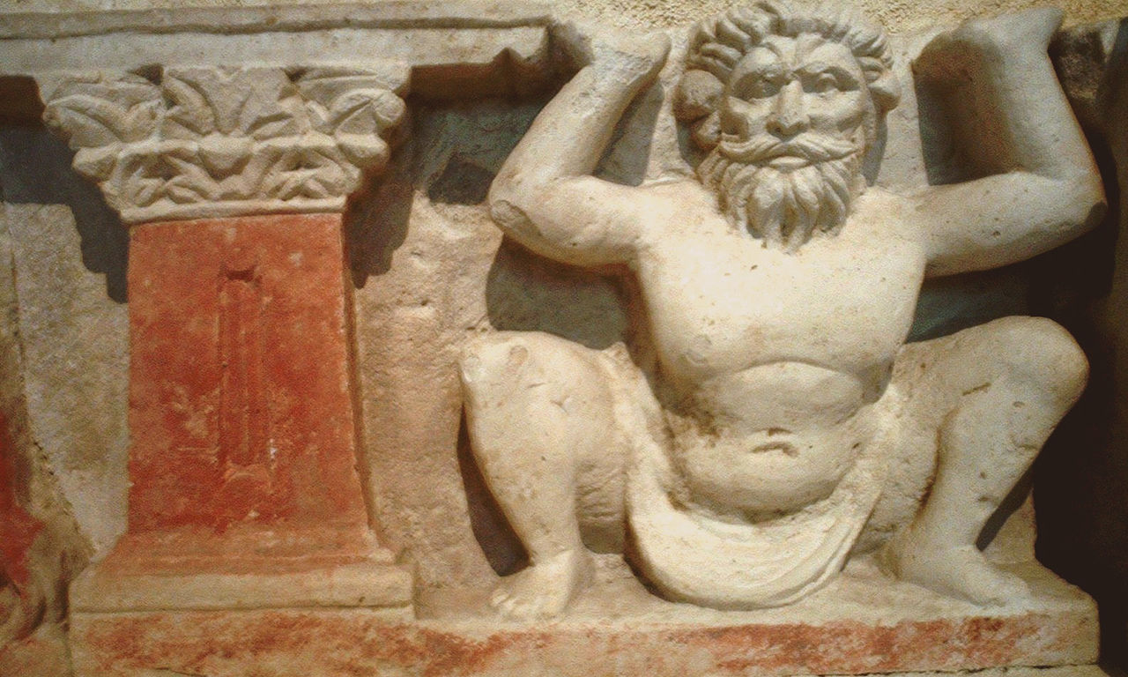 | 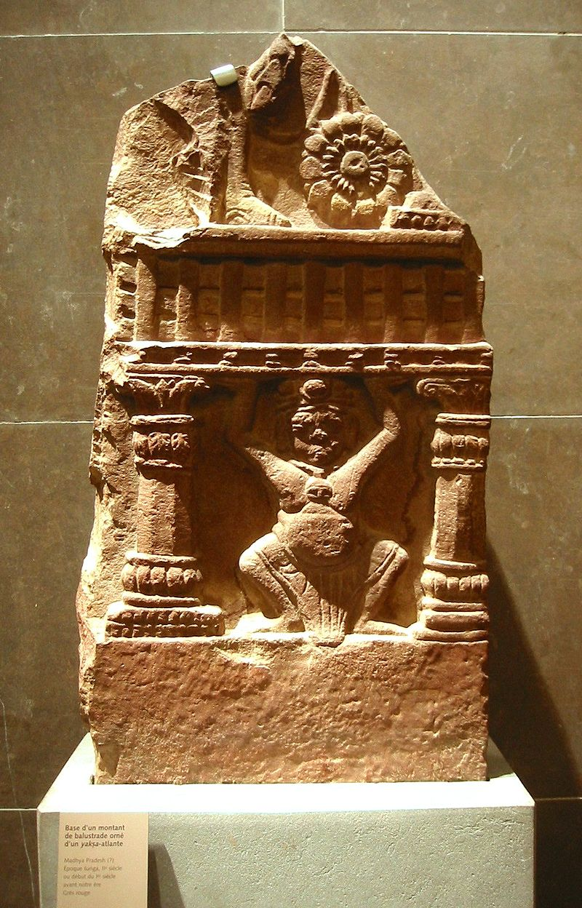

Document 4
The Rosetta Stone, a trilingual Ptolemaic decree establishing the religious cult of Ptolemy V. Includes the same information from top to bottom in the following languages: Egyptian hieroglyphics, Demotic text, and Ancient Greek text.
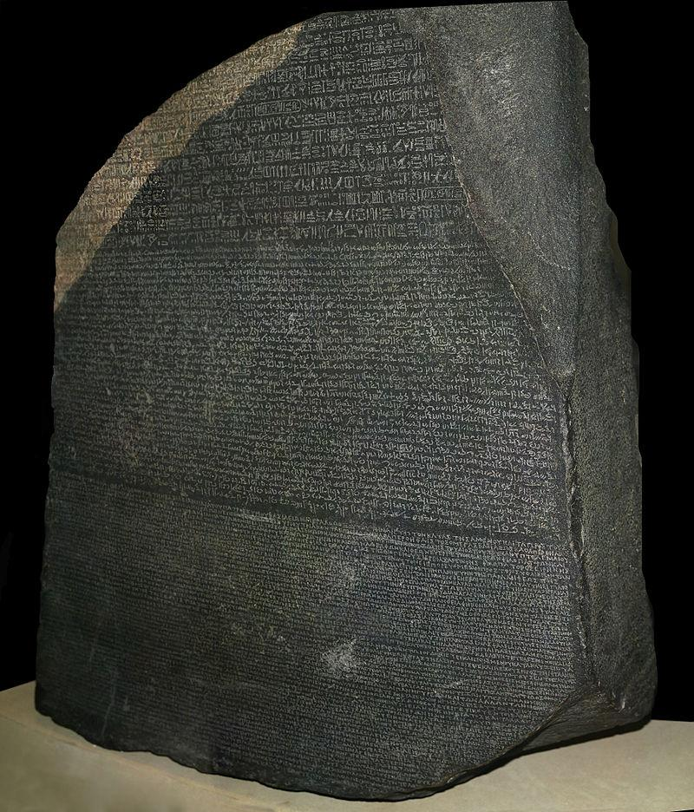
Document 5
Strayer, Robert W. Ways of the World: A Brief Global History with Sources. Boston: Bedford/St. Martin’s, 2011. Pg. 128

“From the Mediterranean to India, Greek became the language of power and elite culture. The Indian monarch Ashoka published some of his decrees in Greek, while an independent Greek state was established in Bactria in what is now northern Afghanistan. The attraction of many young Jews to Greek culture prompted the Pharisees to develop their own school system, as this highly conservative Jewish sect feared for the very survival of Judaism.”

Document 6
Al Khazneh is a temple in Petra, Jordan, built in the first century C.E. Al_Khazneh_Petra.jpg: Graham Racher from London, UK
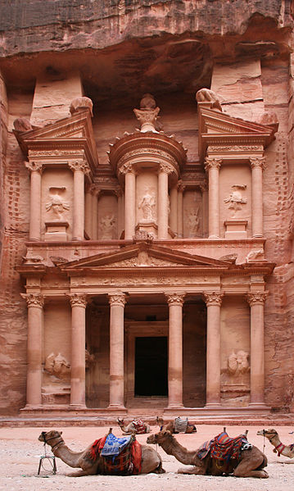

Document 7
Plutarch Greek Lives, trans. Robin Waterfield (New York: Oxford University Press, 1998), pp. 355-356. From Hansen, Valerie, and Kenneth R. Curtis. 2010.Voyages in World History. Boston: Wadsworth, Cengage Learning.

