French Revolution Packet

For the next five class periods, you will be working on assignments that deal with the French Revolution. You will have certain portions of the packet due on different days. All of these assignments in total will come out to be about 80 points skill development. You will have plenty of time to complete this assignment, so no homework. If you stay on task, you will have no problem finishing these assignments in the time allowed. This entire packet is due by March 13th. These will be the last assignments for third quarter. Below is a list of the assignments and the points for each assignment with the date they must be complete by!!!

List of Assignment due dates:

- Causes of the French Revolution #1 (page 2) [7 points] due boc 3/5 or 3/6
- Causes of the French Revolution #2 (page 3) [9 points] due 3/5 or 3/6
- Extension #1 [10 points] Write a one page paper that answers the question, “What was wrong with French Society in 1789?” Refer to sources A-D, use keywords and your own knowledge in your answer (page 4) due eoc 3/5 or 3/6
- *Extension #2 [20 points] Design a recruitment poster encouraging people from the 3rd estate to join the revolution. *due end of class 3/9 or 3/12 (page 5)
- French Revolution Cartoon [8 points] (page 6) due BR 3/7 or 3/8
- *Fill in the Gaps of the French Revolution [7.5 points] (page 7) due boc 3/9 or 3/12
- *The Tennis Court Oath and your own speech [9 points] (page 8) due boc 3/9 or 3/12
- The King & the Revolution [11 points] (page 9) due boc 3/13 or 3/14
- Execution of the King [5 points] (page 10) due boc 3/13 or 3/14
- The Reign of Terror [9 points] (page 11) due boc 3/13 or 3/14
- The Rise of Napoleon [3 points) (page 12) due 3/14
- How did France Change Under Napoleon? [10 points] (page 14)

TOTAL POINTS POSSIBLE: 108 points!!!
Sources:
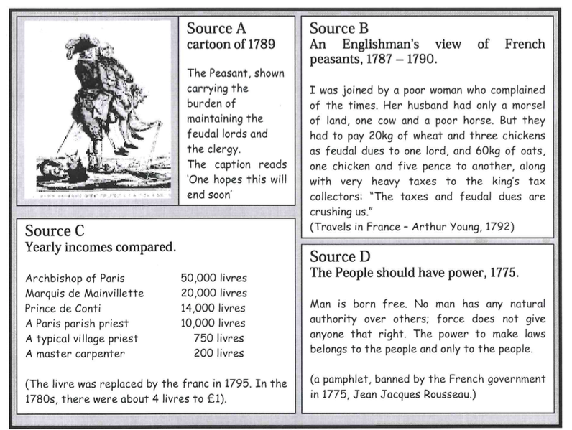

Causes of the French Revolution #1 – (15 pts)

- What might a French peasant have grumbled about in 1789?

- How does the author of source B describe the lives of French peasants? (remember: it is not enough to say ‘good’ or ‘bad’ - you need to give examples from the source!)

- Study sources A, B and C together. Do these sources explain why poor people in France resented the rich? Explain your answer using the sources.

- The pamphlet which source D came from was banned in 1775. Why do you think this was? Which members of French society would want it to be banned?

- Write down each of the following words or terms, and what it means: Bankrupt; Reform; Estates General; deputies; cahiers de doleances; ‘national assembly; constitution; tennis court oath. (4pts)

- Why was the French Government bankrupt in 1787? (think of more than one or two reasons)

- What effect did the poor harvest have on the ordinary people of France?

- Why might members of the third estate have felt under-represented at the meeting of the Estates General in May 1789?

- What were the hopes of each of the parties involved?

- What mistakes did Louis make at the meeting, and what did his mistake lead to?

French Revolution Recruitment Poster
JOIN THE REVOLUTION!!
This will be completed on a separate sheet of paper and physically turned in class
Due March 1st or 2-28 (A day)
20 points

Directions: On a piece of construction or computer paper you are to create a recruitment poster for the people of France to join in on the revolution. You are calling for people of the 3rd Estate to stand up and invoke change.

Below is a list of things you will need to include on your poster:

1. Create a slogan ex. “Join the Revolution or meet Madam Guillotine!” (5 points)
2. Somewhere on your poster include the causes of the revolution as discussed in class (5 points)
3. Cleverly tie in at least one term in some fashion: (5 points)
a. Guillotine
b. Maximilien Robespierre
c. King Louis XVI and Marie Antoinette
d. Declaration of the Rights of Man

Artistic quality will not be graded but neatness and planning will. You will need to use color, captions, and drawings to complete the poster. Remember, you are trying to recruit people to your cause, so your poster should be eye catching. Neatness and color – 5 points

The causes of the
French Revolution Cartoon - 5pts

This Cartoon was produced in the 1780s and is a comment on the social situation in France at that time. It can be used to help explain the causes of the French Revolution of 1789.
You have two task for this assignment. You should use your knowledge and evidence from your lesson on the causes of the French Revolution to help you complete the tasks.

- Label the three figures in the cartoon by writing in the spaces provided:
  - Peasants
  - Priest
  - Noble
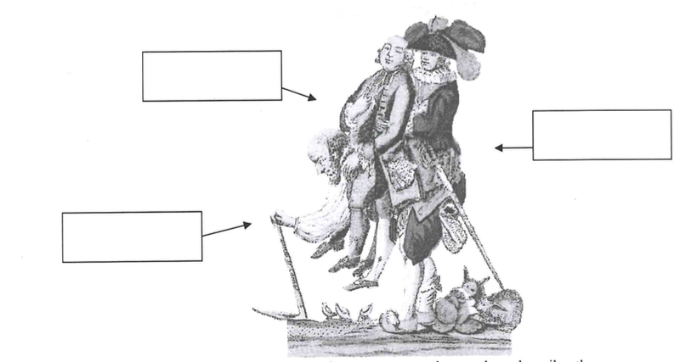
Source E

- Use your own knowledge to explain how the cartoon can be used to describe the causes of the French Revolution.

The causes of the French Revolution - 5 pts
Fill in the gaps on this sheet using the words at the bottom of the page.

There was a revolution in _________in 1789. The ruler of France before the Revolution was King __________ XVI. His wife was Queen ________________________. King Louis XVI lived in his palace at ___________________near Paris.

One of the reasons why there was a revolution in France in 1789 is that the king ran out of ____________. He spent lots of money on two wars with __________. One was in 1756 and another one was in 1778. In the second war the French were helping the ________________ break away from British control.

Another cause of the French Revolution was the problems faced by the ___________. They were so poor that they did not have enough money to feed their families. This was made worse when the crops failed to grow. ______________ failed in 1787 and 1788.

Another cause of the French Revolution was that the two _________ groups in France would not give the King more money. The ________ and ___________ had lots of land and money but would not pay more ____________. This left the king unable to find more money.

A final reason why the French had a revolution in 1789 was ideas. A new set of ideas called the _______________ attacked the power of the king and the church. These made lots of ordinary French people think that they should have some of the power of the __________________.
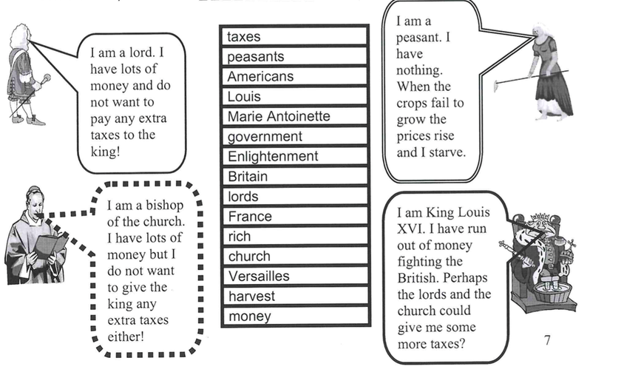

IN THE TENNIS COURT - 3pts
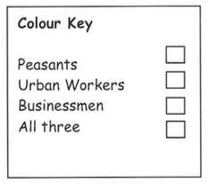
In a desperate attempt to collect even more taxes. King Louis called a meeting of the ESTATES GENERAL in 1788. However the people from the Third Estate used the meeting as a chance to tell the king what the thought was wrong with France and their lives and demand improvements. When the King refused to listen, members of the Third Estate went to a nearby Tennis Court and made an OATH saying they would not until the king had made improvements. In the Tennis Court several
people made speeches.

Below are ‘bits’ of those speeches. In one color show what
‘bits’ the peasants would have said. In another show what ‘bits’
the urban workers would have said and in a third color show
what the businessmen would have said. Use a fourth color if all
three could have said it.
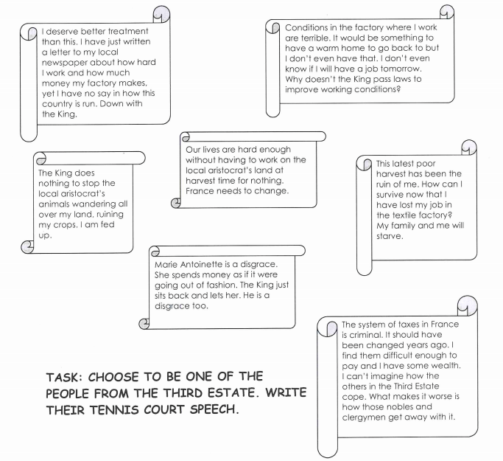

The Revolution Begins
When a people’s army took control of Paris on July 13, King Louis ordered his troops to suppress the revolt. As news of the King’s actions spread, large groups of people in Paris took arms from nearby arsenals and on July 14, 1789, stormed the Bastille, an old fortress that had been converted to a jail. The revolutionaries, who included a number of women, believed many innocent people were being held there. The angry mob killed 98 of the prison guards and, displaying the prison commander’s head on a pole, marched through the streets of Paris.

The revolutionary virus spread to the countryside. Peasants began to attack manor houses and burned records detailing their responsibilities and obligations to their lords. Many peasants stopped paying taxes and seized common lands.

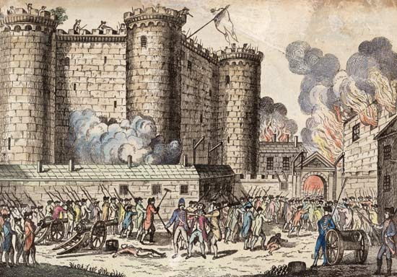

The following excerpt is an eyewitness account of the fall of the Bastille (3 pts)

“Veteran armies… have never performed greater prodigies [feats] of valor than this leaderless multitude of persons belonging to every class, workmen of all trades who, mostly ill-equipped and unused to arms, boldly affronted the fire from the ramparts and seemed to mock the thunderbolts the enemy hurled at them….

The attackers, having demolished the first drawbridge and brought their guns into position against the second, could not fail to capture the fort...…One of the [soldiers] opened the gate behind the drawbridge and asked what we wanted. ‘The surrender of the Bastille’ was the answer, on which he let us in. At the same time the besiegers lowered the great bridge....

Those who came in first treated the conquered enemy humanely and embraced the staff officers to show there was no ill-feeling. But a few soldiers posted on the platforms and unaware that the fortress had surrendered discharged their muskets, whereupon the people, transformed with rage, threw themselves on the [soldiers]….

… Several… [individuals] contended for the honor of having arrested the Marquis de Launay [the governor of the Bastille]… and a few others undertook to guard him and succeeded in getting him out of the Bastille, though he was roughly handled by the people, who were calling for his death….

But the fury of the crowd continued to increase and their blind wrath did not spare de Launay’s escort…. Exhausted by his efforts to defend his prisoner… he had to separate from M.de Launay... Hardly had he sat down when, looking after the procession, he saw the head of M. de Launay stuck on the point of a pike…. The people, fearing that their victim might be snatched away from them, hastened to cut his throat on the steps of the Hotel de Ville [City Hall]....

In the intoxication [excitement] of victory the unfortunate inmates of the dungeons of the Bastille had been forgotten. All the keys had been carried off in triumph and it was necessary to force the doors of the cells. Seven prisoners were found.”

What significance did the attack on the Bastille have as a symbol?

What do you think about these developments in France?

How should the new government, the National Assembly, address these problems?

The National Assembly Acts (2 pts)
On August 4, in a combative all-night meeting, nobles in the National Assembly voted to end their own privileges. They agreed to give up their old manorial dues, exclusive hunting rights, and special legal status. The National Assembly easily got concessions from the frightened King. They issued the Declaration of Rights of Man and Citizen as a first step to writing a constitution.

- All men were born and remain free and equal in rights
- Natural rights of liberty, property, security, and resistance to oppression.
- All male citizens are equal before the law
- Every Frenchmen had an equal right to hold public office
- Freedom of religion
- Taxes should be levied according to ability to pay

How do you feel about the ideas in the Declaration of Rights of Man and Citizen? Why?

The Civil Constitution of the Clergy (2 pts)
In order to pay off the large debt, the Assembly voted to take over and sell Church lands. They also put the French Catholic Church under state control. Under the Civil Constitution of the Clergy, issued in 1790, bishops and priests become elected, salaried officials.

How do you feel about the Civil Constitution of the Clergy? Do you support it or oppose it? Why?

French Revolution Blog (5 pts)

Read the Declaration of Rights of Man and Citizen (below) and write a blog entry below (as your social class) – To what extent do you agree or disagree with these articles and why? How do you predict they will affect change in France? Specifically reference AT LEAST 3 articles in your entry.

Characters: Based on your last name
Peasants/ Urban Workers (A - D)
Bourgeoisie (E - H)
Noble (I - L)
Clergy (M - P)
Queen Marie Antoinette (Q - T)
King Louis XVI (U - Z)

Approved by the National Assembly of France, August 26, 1789
The representatives of the French people, organized as a National Assembly, believing that the ignorance, neglect, or contempt of the rights of man are the sole cause of public calamities and of the corruption of governments, have determined to set forth in a solemn declaration the natural, unalienable, and sacred rights of man, in order that this declaration, being constantly before all the members of the Social body, shall remind them continually of their rights and duties; in order that the acts of the legislative power, as well as those of the executive power, may be compared at any moment with the objects and purposes of all political institutions and may thus be more respected, and, lastly, in order that the grievances of the citizens, based hereafter upon simple and incontestable principles, shall tend to the maintenance of the constitution and redound to the happiness of all. Therefore the National Assembly recognizes and proclaims, in the presence and under the auspices of the Supreme Being, the following rights of man and of the citizen:
Articles:
1. Men are born and remain free and equal in rights. Social distinctions may be founded only upon the general good.
2. The aim of all political association is the preservation of the natural and imprescriptible rights of man. These rights are liberty, property, security, and resistance to oppression.
3. The principle of all sovereignty resides essentially in the nation. No body nor individual may exercise any authority which does not proceed directly from the nation.
4. Liberty consists in the freedom to do everything which injures no one else; hence the exercise of the natural rights of each man has no limits except those which assure to the other members of the society the enjoyment of the same rights. These limits can only be determined by law.
5. Law can only prohibit such actions as are hurtful to society. Nothing may be prevented which is not forbidden by law, and no one may be forced to do anything not provided for by law.
6. Law is the expression of the general will. Every citizen has a right to participate personally, or through his representative, in its foundation. It must be the same for all, whether it protects or punishes. All citizens, being equal in the eyes of the law, are equally eligible to all dignities and to all public positions and occupations, according to their abilities, and without distinction except that of their virtues and talents.
7. No person shall be accused, arrested, or imprisoned except in the cases and according to the forms prescribed by law. Any one soliciting, transmitting, executing, or causing to be executed, any arbitrary order, shall be punished. But any citizen summoned or arrested in virtue of the law shall submit without delay, as resistance constitutes an offense.
8. The law shall provide for such punishments only as are strictly and obviously necessary, and no one shall suffer punishment except it be legally inflicted in virtue of a law passed and promulgated before the commission of the offense.
9. As all persons are held innocent until they shall have been declared guilty, if arrest shall be deemed indispensable, all harshness not essential to the securing of the prisoner’s person shall be severely repressed by law.
10. No one shall be disquieted on account of his opinions, including his religious views, provided their manifestation does not disturb the public order established by law.
11. The free communication of ideas and opinions is one of the most precious of the rights of man. Every citizen may, accordingly, speak, write, and print with freedom, but shall be responsible for such abuses of this freedom as shall be defined by law.
12. The security of the rights of man and of the citizen requires public military forces. These forces are, therefore, established for the good of all and not for the personal advantage of those to whom they shall be intrusted.
13. A common contribution is essential for the maintenance of the public forces and for the cost of administration. This should be equitably distributed among all the citizens in proportion to their means.
14. All the citizens have a right to decide, either personally or by their representatives, as to the necessity of the public contribution; to grant this freely; to know to what uses it is put; and to fix the proportion, the mode of assessment and of collection and the duration of the taxes.
15. Society has the right to require of every public agent an account of his administration.
16. A society in which the observance of the law is not assured, nor the separation of powers defined, has no constitution at all.
17. Since property is an inviolable and sacred right, no one shall be deprived thereof except where public necessity, legally determined, shall clearly demand it, and then only on condition that the owner shall have been previously and equitably indemnified.

Write your Blog Post Below and sign as your character:

Constitution of 1791 (2 pts)

- Limited monarch in place of the absolute monarchy
- A new legislative assembly with the power to make laws, collect taxes, and decided on issues of war and peace
- King still has executive power to enforce laws.
- Every adult male property owner who satisfied minimal tax-paying requirements (roughly 2/3 of all adult males) could vote
- Abolished old provincial courts and reformed laws

How do you feel about the ideas in the Constitutional of 1791? Why?

A Series of Dramatic Events

- King and Queen attempted to escape but were discovered and returned to Paris
- Émigrés (nobles, clergy, and other who had fled France) reported attack on their privileges, property, religion, and their lives.
- Government banned strikes and workers feel ignored
- Inflation is through the roof
- Prussia and Austria declare war on France in order to intervene and support the French king.
- War goes badly for France and the King seems indifferent
- On August 10, 1792 a crowd of armed Parisians stormed the royal palace at the Tuileries (literally driving the King from the throne)
- Sans-culottes (urban working class men and women) demand a republic (a government ruled by elected representatives

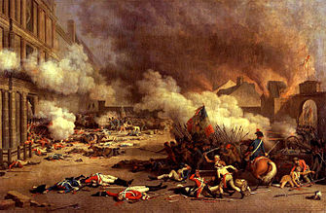

The National Convention

On the night of the attack on the Tuileries, ½ of the National Assembly fled Paris. Those who remained ordered elections for a National Convention to decide the king’s fate, to draft a republican constitution, and to govern France in the current emergency

- The newly elected Legislative Assembly survived for less than one year.
- France is declared a republic.
- Fearing a plot to force open Paris’ overcrowded jails, mobs of Parisians invaded the prisons and over the course of three days in September 1792 slaughtered more than 2,000 prisoners.
- King Louis XVI was founded guilty of treason
- Vote of 387 to 334, he was sentenced to death – by guillotine
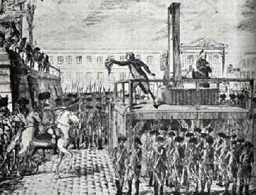
- Nine months later the queen was executed.
Left  Radical  Jacobins  Danton, Robespierre, Marat  San-culottes  “We need more change” | Center  Moderate  Girondins  “The change doesn’t need to be quite so radical.” | Right  Reactionaries  Royalists  “Let’s go back to the way things used to be.”

Where would you be on the political spectrum? Why? (2 pts)

Radical Days of the Revolution – The Reign of Terror
Jacobins | Girondin
“Friends, we are betrayed! To arms! To arms! . . Your greatest enemies are in your midst, they direct your operation . . . Yes, the counter revolution is in the Government . . . in the National Convention!  Let us rise! Yes, let us all rise! Let us arrest all the enemies of our revolution, and all suspected persons. Let us exterminate without pity, all conspirators, unless we wish to exterminate ourselves.”  Circular from the Paris Jacobin Club to local branches | I thought that the insurrectionary (rebellious) movements must cease, because, when there was no longer a tyranny to be struck down, there ought to be no longer any force in insurrection . . .  I thought that order alone could produce tranquility; that order consisted of a religious respect for the laws . . . and the safety of the individual . . . I also thought, consequently, that order, also, was a truly revolutionary measure . . .  Brissot, a leader of the Girondin Party

Which party best represents the beliefs of your character/social class? (Use the social class you did your blog for) Why? (2 pts)

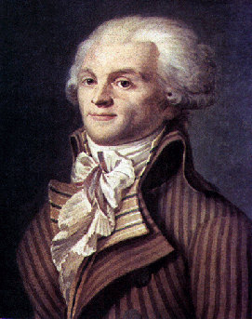
On June 22, 1793, 80,000 armed sans-culottes surrounded the meeting halls of the National Convention and demanded the immediate arrest of the Girondin faction. The Convention yielded to the mob and 29 Girondin members of the Convention were arrested.
The Jacobins believed passionately that France needed complete restricting, and they unleased a campaign of terror to promote their revolutionary goal. They sought to eliminate the influence of Christianity in French society by closing churches and forcing priests to take wives. They promoted a new “cult of reason” as a secular alternative to Christianity. The reorganized the calendar, keeping months of thirty days but replacing seven-day weeks with ten-day units that recognized no day of religious observance. The Jacobins proclaimed the inauguration of a new historical era with the Year 1, which began with the declaration of the First Republic on September 22, 1792. They encouraged citizens to display their revolutionary zeal by wearing working class clothes. They granted increase rights to women by permitting them to inherit property and divorce their husbands, although they did not allow women to vote or participate in political affairs.

By mid-1793, many people were concerned about the course of the Revolution. There was much criticism both inside and outside of France’s borders, and as a result, many of the leaders feared losing control. In order to avoid a “counterrevolution” the Jacobin, under the leadership of Maximilian Robespierre, began to make accusations, hold trials and executions in order to stop this activity. This created a wave a fear and panic throughout the country. The Jacobins made frequent use of the guillotine: between the summer of 1793 and the summer of 1794, they executed about 40,000 people and imprisoned 300,000 suspected enemies of the revolution.

How do you feel about the changes made by the National Convention/Jacobin party? Why? (2pts)

The End of the Terror
By the summer of 1794, there seem to be less need for the Terror. The Republic seemed a reality, an aristocratic conspiracy had subsided, the will to punish traitors decreased, and most sans-culottes went home to tend to business. And, as the need for the Terror decreased, so too did Robespierre's power and leadership. Some members of the Convention, fearing for their own lives, ordered the arrest of Robespierre. On July 27, 1794, Robespierre was arrested and guillotined the next day -- the sans-culottes made no attempt to save him.

Why did the Revolution become radical? Why did it end? (2 pts)

The Directory

As the Reign of Terror ended, it became necessary to create yet a new form of leadership for France, and by 1795, the government had passed into the hands of the five-man Directory. The Directory tried to preserve the Revolution of 1789 – they opposed the restoration of the ancien regime as well as popular democracy. The Directory lasted until 1799. By this time the French Revolution was over and the French tried to get back to business as usual. Radicalism had been effectively put down as well. But France was still at war with the rest of Europe.

Is the Directory what France needed after the Reign of Terror? Why or why not? (2 pts)

The King & the Revolution – 4 pts
- In what three ways did Louis behave badly in the years 1789-1791? Explain each fully.

- How did Louis show that he could not be trusted during this time?

Execution of Louis XIV- 2 pts
- Do you think Louis should have been sentenced to death? Explain your answer.

The Reign of Terror – 7 pts
- Explain in a paragraph or two, what happened in France following the execution of King Louis. (3 points)

- What were the main causes of the Reign of Terror?

- How and why do you think the Terror came to an end?

- Was Robespierre to blame for the Terror? (2 pts)
The Rise of Napoleon – 1 pt
- Why did some people think it strange that the French people accepted Napoleon as their New Emperor?

How did France Change under Napoleon - 10 pts
- In what ways did Napoleon reform the education system in France?

- Which aspects of Napoleon’s education system did not change?

- In what ways were the governments of King Louis XVI (pre-Revolution) and Napoleon different?

- In what ways were they similar?

- Read the Napoleonic code. (Found on class website) List the points of the code which you think are:
  - Fair? b.) unfair? give reasons for your choices.

- How did Napoleon try to restrict individual rights and freedoms?

- Why do you think Napoleon felt it was so important to control the press?

- How did Napoleon try to control religion in France?

- What was the appeal of Napoleon to:
  - The Peasants? b.) the nobility?

- How did Napoleon Improve France’s cities and towns?

