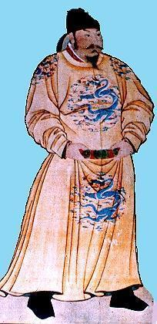 | Inventions, Innovations, and Other Contributions  from Ancient China | 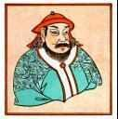

Dynasty and Time Period | Inventions / Contributions |  | Dynasty and Time Period | Inventions / Contributions
Qin or Ch'in dynasty (approx. 221-207 B. C.) | - Legalism  - Standardized writing and language  - Standardized money  - Standardized system of measurement  - Irrigation projects  - Building of the Great Wall  - Terra cotta army  - Expanded Network of Roads and Canals  - Multiplication Table |  | Tang Dynasty  (approx. 618-907 A. D.) | - Tea  - Po Chu-i (poet)  - Scroll painting  - Three Doctrines (Buddhism, Confuscianism, Taoism)  - Gunpowder  - Civil Service Exams  - Brandy and whiskey  - Flame-thrower  - Dance and Music
Han Dynasty  (approx. 202 B. C. - A. D. 220) | - Silk Road  - Papermaking  - Iron technology (cast iron) plowshares;Moldboard plow (kuan)  - Glazed pottery  - Wheelbarrow  - Seismograph (Chang Heng)  - Compass  - Ship's rudder  - Stirrups  - Drawloom weaving  - Embroidery for decorating garments  - Hot Air Balloon  - Chinese Examination System |  | Five Dynasties period  (approx. 907 - 960 A.D.) | - Tea Trade  - Translucent Porcelain  - Paper Money and Certificates of deposit  - Taoism  - Painting
Era of Disunity (Age of Division - (approx. 220 - 581 A. D.)  - Chin Dynasty  - Northern and Southern Dynasties) | - Tea  - Padded horse collar (collar harness)  - Calligraphy  - Stirrups  - Growth of Buddhism and Taoism  - Kite  - Helicopter rotor and propeller  - Matches  - Odometer  - Umbrella  - Paddle Wheel Ship |  | Song or Sung dynasty  (approx. 960-1279 A. D.) | - Magnetic compass  - Rocket and multi-stage rockets  - Printing (movable type)  - Guns and Cannons  - Landscape painting  - Winemaking  - Chinese Opera  - Porcelain  - Chain Drive Mechanism
Sui Dynasty  (approx. 581 - 618 A. D.) | - Porcelain  - Block Printing  - Grand Canal  - Coinage Standardization |  | Yuan or Mongol Dynasty  (approx. 1279 - 1368 A.D. ) | - Paper money  - Magnetic Compass  - Blue and white porcelain  - Guns and Gunpowder  - Landscape painting  - Chinese Theater, Opera, and Music  - Decimal Numbers

