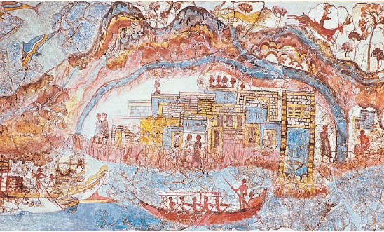

Trade in Minoan Society

Look at the image above, and explain what it suggests about the role of trade in Minoan society.
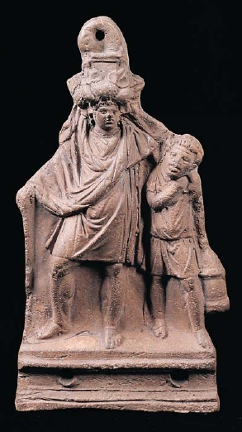Slave and Drunken Master

Using the image and the text, discuss the roles and duties of slaves in classical Greek society.

Plato and Students
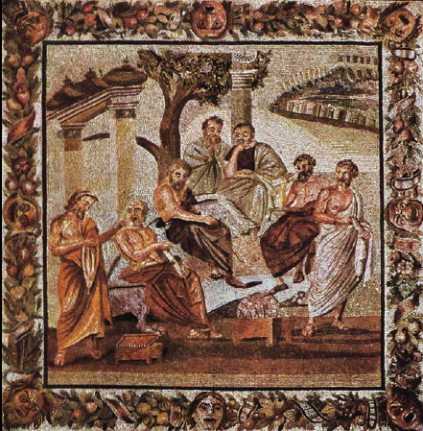

Look at the image of Plato and his students. What does it suggest about the connections between philosophical knowledge and civilization?

