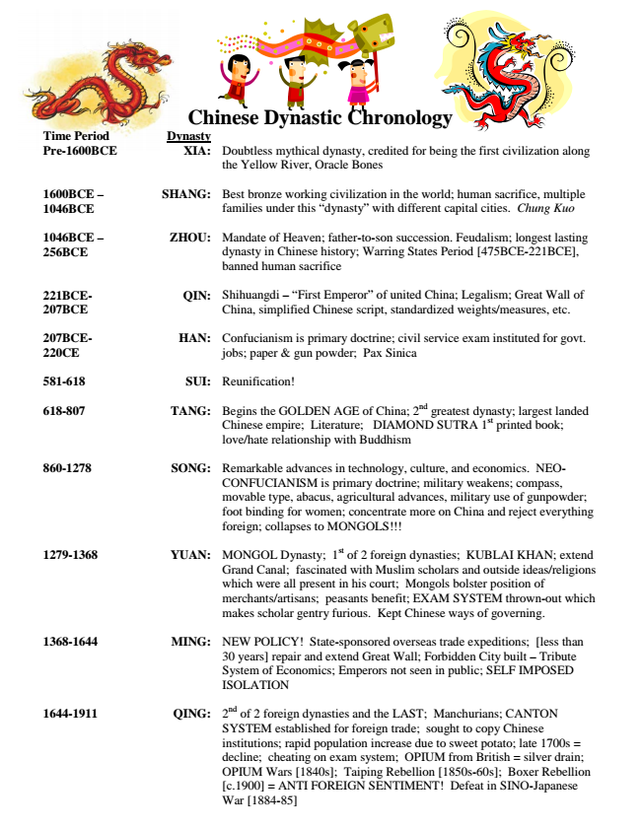
Chinese Dynastic Chronology Time Period Dynasty Pre-1600BCE XIA: Doubtless mythical dynasty, credited for being the first civilization along
the Yellow River, Oracle Bones
1600BCE – 1046BCE
SHANG: Best bronze working civilization in the world; human sacrifice, multiple
families under this “dynasty” with different capital cities. Chung Kuo
1046BCE – 256BCE
ZHOU: Mandate of Heaven; father-to-son succession. Feudalism; longest lasting
dynasty in Chinese history; Warring States Period [475BCE-221BCE], banned human sacrifice
221BCE- 207BCE
QIN: Shihuangdi – “First Emperor” of united China; Legalism; Great Wall of
China, simplified Chinese script, standardized weights/measures, etc.
207BCE- 220CE
HAN: Confucianism is primary doctrine; civil service exam instituted for govt.
jobs; paper & gun powder; Pax Sinica
581-618 SUI: Reunification!
618-807 TANG: Begins the GOLDEN AGE of China; 2nd greatest dynasty; largest landed
Chinese empire; Literature; DIAMOND SUTRA 1
st
printed book; love/hate relationship with Buddhism
860-1278 SONG: Remarkable advances in technology, culture, and economics. NEO-
CONFUCIANISM is primary doctrine; military weakens; compass, movable type, abacus, agricultural advances, military use of gunpowder; foot binding for women; concentrate more on China and reject everything foreign; collapses to MONGOLS!!!
1279-1368 YUAN: MONGOL Dynasty; 1st of 2 foreign dynasties; KUBLAI KHAN; extend Grand Canal; fascinated with Muslim scholars and outside ideas/religions which were all present in his court; Mongols bolster position of merchants/artisans; peasants benefit; EXAM SYSTEM thrown-out which makes scholar gentry furious. Kept Chinese ways of governing.
1368-1644 MING: NEW POLICY! State-sponsored overseas trade expeditions; [less than
30 years] repair and extend Great Wall; Forbidden City built – Tribute System of Economics; Emperors not seen in public; SELF IMPOSED ISOLATION
1644-1911 QING: 2
nd
of 2 foreign dynasties and the LAST; Manchurians; CANTON SYSTEM established for foreign trade; sought to copy Chinese institutions; rapid population increase due to sweet potato; late 1700s = decline; cheating on exam system; OPIUM from British = silver drain; OPIUM Wars [1840s]; Taiping Rebellion [1850s-60s]; Boxer Rebellion [c.1900] = ANTI FOREIGN SENTIMENT! Defeat in SINO-Japanese War [1884-85]
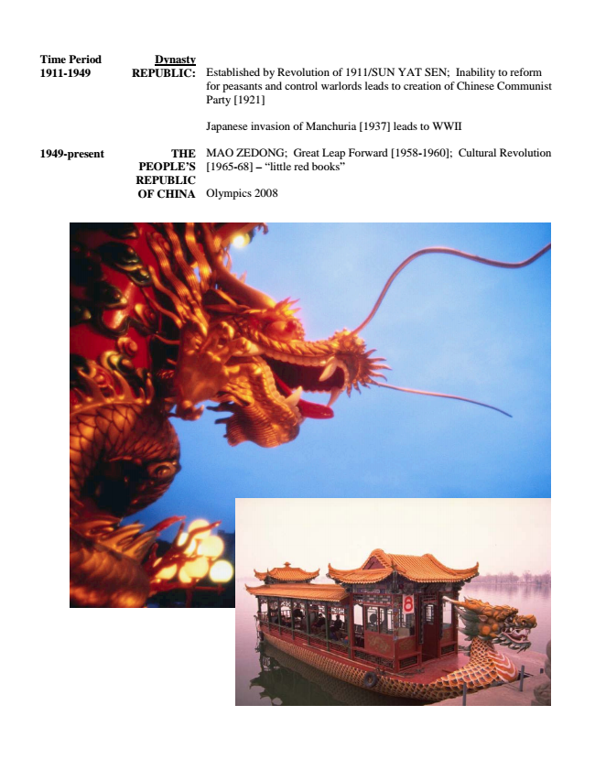
Time Period Dynasty 1911-1949 REPUBLIC: Established by Revolution of 1911/SUN YAT SEN; Inability to reform
for peasants and control warlords leads to creation of Chinese Communist Party [1921]
Japanese invasion of Manchuria [1937] leads to WWII
1949-present THE PEOPLE’S REPUBLIC OF CHINA
MAO ZEDONG; Great Leap Forward [1958-1960]; Cultural Revolution [1965-68] – “little red books”
Olympics 2008

