WORLD HISTORY AP TEST REVIEW
Session Three: 600 C.E. – 1450 C.E.

ISLAM BEGINS
- _________________________________________________ in Mecca, early 7th century
- Message from __________ was to make his people (____________) of one religion (____________________________) to unify themselves and submit to his will
- Polytheistic ___________________ rejected him, forcing the ________________ to Medina in __________ C.E.
- Muhammad and his ___________ return to Mecca and conquer it, thus beginning the spread of _________________ throughout the world
- After Muhammad’s death in ________, Abu Bakr takes over and becomes the first ________________________ (political and religious leader combined)
- Islam will continue to grow and spread into ___________________________, Africa, and ______________________
- Sunni and ______________ Islam split over the issue of ________________________ of Muhammad

UMAYYAD CALIPHATE
- Capital located in _________________________, Syria
- ______________________ became the official __________________________
- Gold and silver became the monetary standard
- Conquered people were encouraged to convert to _______________ for the sake of ______________ ; those who did not convert were ________________
- In power from __________________________
- Arabs were the higher _________________ class (original _______________ became the preferred social class)

ABASSID CALIPHATE
- Reigned from ______________________ C.E.
- “Golden Age” of _________________
- Built magnificent capital at _________________________
- ________________________ was a priority for Abbasids
- Huge ______________________ in sciences, math, medicine, literature
- Established _________________________ that helped preserve ____________________ culture
- ______________ helped convert people to Islam through their mystical, romantic methodology which stressed ___________________________________ with Allah
- Converts to Islam (the ________________________) were treated better than in the ___________________________ Caliphate where ________________ were elites

WOMEN IN ISLAM
- Typical of a ____________________________ society, women were viewed as ____________________ and had little rights
- Women’s testimony in court was worth ______ of a man’s
- _________________ established basic rights for women and gave them ___________________ before God
- Khadija, _____________________________________________, was an influential figure
- Women were veiled in ___________________ (modesty and _____________________)
- Women were kept mostly at home since domestic duty was their _____________________ ____________________ in life
- Men could have _________ wives but women were required to be __________________ to one man

DECLINE OF THE ABBASID
- Weakened by:
  - _______________________ between Sunni and Shia
  - Different ____________________ groups in expanding Muslim world
  - Turkish _________________ revolted (military slaves)
  - Seljuk Turks were also a threat
  - __________________________ invasion was the _________________ blow

THE BYZANTINE EMPIRE
- The _________________ Empire in the East
- _________________ speakers (not ____________ like in West)
- ______________________ Christianity (not __________________________)
- Byzantine rulers had ___________________ authority (________________________________ = both emperor and pope)

JUSTINIAN AND THE JUSTINIAN CODE
__________________________________________________________________________________________________________________________________________________________________________________________________________________________________________________________________________________________________________________________________________________________________________________________________________________________

JUSTINIAN’S REIGN
- _____________________________ glory was restored
- Trade and the __________ flourished
- ____________________________________ made laws ____________________ and kept Roman legal principles alive
- ________________________ was constructed (now a Mosque)

ORTHODOX vs. CATHOLIC
- The two _______________________________ were at odds with each other over several theological issues
  - _______________________ of the liturgy
  - Marriage of _________________
  - ________________________
  - ____________________ nature of God
- Eventually there was a _________________ in 1054 CE when both church leaders __________________________________ each other

RUSSIA
- ______________________converts the people of _________________ to Orthodox Christianity; will stay distinct from ___________________________________ as a result
- __________________________ uses the Greek alphabet to create a ________________ alphabet in order to better reach his potential ________________________

FRANKS vs. MUSLIMS
- In Europe, _____________________ was growing but so was the threat from _________________
- King Clovis of the _______________ (Germanic tribe) unified the region under Catholicism, making it easier to fight Islam
- ___________________________________ helped defeat the Muslim army at the ____________________________________ in 732 (stopped Islam from dominating Europe)
- Martel forms the _________________________ Dynasty and crowns his son ______________ (who gets blessed by the Pope, a sign of the power of the ____________________ in Western Europe)

THE HOLY ROMAN EMPIRE
- Pepin’s son (______________________________) will build the empire and it will be called the ____________________________________________
- The Holy Roman Empire was small, ____________________________, and relatively weak
- Local __________ had a great deal of power and did not consult _________________________________ on everything
- Charlemagne did not ____________________________ and did not build a very strong empire
- Treaty of __________________ in 843 CE breaks HRE into thirds

VIKINGS
- Rampaging throughout Northern Europe during this time, looking for treasure…sadly never realizing that the real treasure was the fond memories they were creating

THE NORSEMEN (VIKINGS)
________________________________________________________________________________________________________________________________________________________________________________________________________________________________________________________________________________________________________________________________________

FEUDALISM IN EUROPE
- Feudal Pyramid
  - King > Nobles > __________________ (Vassals) > Lesser Vassals > ___________________(Serfs)
- _______________________ were given to vassals (Estates = FIEFS = MANORS)
- Lord and peasants lived on the manor
- ____________________ worked for the lord in exchange for homes and protection
- Code of _______________________
- Women of ________________ elite class were treasured for their feminine qualities but still essentially considered _______________________________

HANSEATIC LEAGUE
- A ________________________ alliance throughout ____________________ Europe
- Possible due to the _____________________ of towns thanks to the _______________________ of the manor system and the ___________________ of the middle class

ARCHITECTURE: GOTHIC STYLE
- Cathedrals and castles with _________________ reaching skyward
- Flying ______________________ as opposed to rounded, Romanesque arches
- ___________________ glass

THE CRUSADES
- ________________________ campaigns to take back the _____________________________ and convert Muslims and non-Christians to Christianity
- Control of the ____________________________________ of the Mediterranean and the _____________Roads was also vital

THE CHURCH MILITANT
- Pope _________________________ III issued decrees on church doctrine
- ______________ and _________________________ were persecuted (tortured, excommunicated, killed, or exiled)
- Inquisition by _______________________________________

BUBONIC PLAGUE
- Estimated ________ million deaths
- Started in _______________________ and spread due to _________________ and the Mongol control of the Silk Road
- Helped bring an end to ________________________ in Europe
- Social and economic changes were sped up
- ____________________ lost power and believers

CHANGES IN EUROPE
- England unifies under ______________________________________
  - __________________________ in 1215 CE gives rights to ______________ and limits the absolute power of the king
- ______________________ and Italian city-states decentralize
- “Countries” start to form, along ________________________ and _______________________ lines
- France and ____________________ begin fighting and haven’t really stopped hating each other since…____________________________________________ (1337-1453)
- Queen Isabella marries _______________________ and unifies ____________________ with the Catholic Church’s blessing and assistance
- Spain becomes a ___________________________ and the world is about to change in a big way

CHINA (TANG DYNASTY)
- ______________ Dynasty rules from 680-907 and expanded into Manchuria, ___________________, Tibet, and Korea
- Continued _____________ _________________ exams for bureaucracy
- ________________ built which increased trade
- Extensive __________________ system with Annam and other neighboring peoples
- Overexpansion led to _____________ of control and warlords seized power, Tang collapsed
________________________________________________________________________________________________________________________________________________________________________________________________________________________________________________________________________________________________________________________________________________________________________________________________________________________________________________________________________________________________________________________________________________________________________________________________________________________________________________________________________________

EMPRESS WU ZHAO
- Tang Dynasty had a _______________________emperor (unique)
- Blame it on ___________________________ (Confucianists were not happy with this development)

FOOT BINDING DURING THE SONG DYNASTY
- To keep _______________ in their place (for ______________this meant home), Chinese practiced foot binding to keep the female feet small and childlike (big feet = male trait)

JAPAN
- __________________________ Clan takes over leadership, claiming to be direct descendants of the ________ goddess, one of the main _________________ of Shinto religion
- Yamato stayed in power for 1500 years (even today)
- Hereditary social ______________________, different than Confucianist China and civil service exams based on ___________________ rather than family
FEUDAL JAPAN
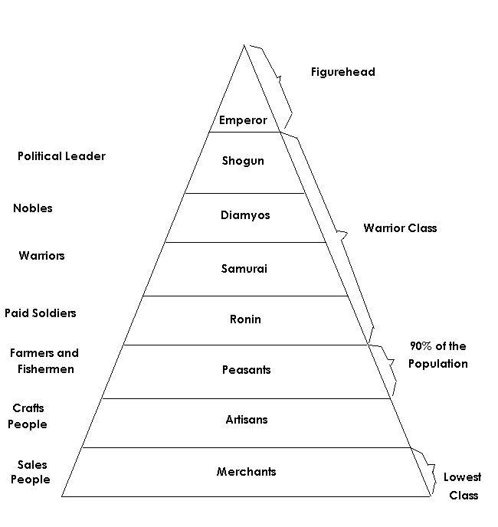
BUSHIDO (CHIVALRY CODE)
- Justice
- ________________________
- Benevolence
- Veracity
- ________________________
- Honor
- ________________________

DELHI SULTANATE INDIA
- Islamic ______________________ took over NW India and tried to convert _____________________ or tax them
- Northern India changed, many converted to ______________________ while those in the South stayed Hindu
- Much _________________________________ happened during this time for India

THE MONGOLS
- Excellent ________________________ and _____________________
- Genghis Khan in the early _____________ unified the various Mongol tribes and began conquest of much of ________________________

MONGOL HORDES
- Golden Horde conquered __________________________
- Kublai Khan ruled in __________________________ (Yuan Dynasty)
- _________________________________ in SW ASIA
- Chagatai Horde in ____________________________________

PAX MONGOLICA
- _____________________ flourished thanks to Mongol control of ______________________ routes (no one dared messed with traders since the Mongols would exact revenge if the money did not reach them
- Mongols were in the game solely for ______________________________________, not promotion of their own culture (unlike the ________________ and later the Brits and French)
- Absorbed whatever _____________________ they were in (converted to that __________________, spoke that language)

AFRICA
- ____________________ in western Africa (city of Timbuktu)
- _________________________________ travels to Mecca and shows off the great wealth of his kingdom (gold)
- Africa had plenty of __________ and _______________, big trade items for the world
- Much of ______________________________ Africa converted to Islam and made trade easier
- Trans-Sahara Trade Routes grow in _______________________

TRANS-SAHARA TRADE ROUTES
- Gold and Salt come from here across Africa and to Europe and Asia
- Not as important as Silk Roads but still vital to economies of all three continents

THE AMERICAS
- _______________ in Central America
- Inca in the _______________ Mountains of South America
- Aztec in ________________________

AZTEC EMPIRE
- ________________________________ capital city of Aztec Empire
- Tens of thousands of ______________________________________ to deities (mostly from war captives)
- ________________________________ were the elite social class
- Tribute required of ____________________________ states

INCA EMPIRE
- Mit’a system in place to keep the empire running smoothly
- Sun God very important deity
- Maccu Picchu city high in the Andes Mountains
- ____________________________________________________________________________________________________________________________________________________________________________________________________________________________________

MAYAN EMPIRE
- Largely agricultural ________________________ population
- ____________________frequent
- Large cities of up to _________________ people
- Abandoned about ____________ CE (systems collapse is the theory)

INDIAN OCEAN TRADE
______________________________________________________________________________________________________________________________________________________________________________________________________________________________________________________________________________________________________________________________________________________________________________________________________________________________________________________________________________________________________________________________________________________________________________________________

THE SILK ROADS
__________________________________________________________________________________________________________________________________________________________________________________________________________________________________________________________________________________________________________________________________________________________________________________________________________________________

