33 Maps that Explain Terrorism
Use the website below to complete the activity.
http://www.vox.com/2015/12/15/10133138/terrorism-maps

- What event does the article mark as the beginning of Modern Terrorism?
In what ways is this similar to and different from modern terrorism?

Can you think of earlier historical events that might be considered terrorism?

- According to the map, what was the purpose of the KKK?
What are some parallels that the authors of the article see between this domestic terrorism and modern terrorism?

- What were the goals of the anarchists?
What were some actions they took that could be considered terrorism?

- What characterizes the 1970’s? How do some historians explain the rise in terrorism during this time?

What were some terrorist groups during this era and what were their aims?

- What have been the two main European terrorist groups? What are they fighting for/against?

- What happened at the 1972 Olympics?
Why might an attack on this event be particularly symbolic?
What did other terrorists learn from this?

- Where and did the idea of suicide bombings originate?
How did this group develop suicide bombing?

Why did groups like ISIS adopt this tactic?

- Describe what happened in the Tokyo subway in 1995. What lessons did terrorists learn from this attack?

- What region of the world is a consistent hotspot for terrorism during the entire 15 year period seen on the map? What other general trends do you notice?

- How many were killed in the 9/11 attacks? How does this demonstrate the nature and purpose of terrorism?

- How did some Muslim scholars’ reactions to the Western occupation brought forth by Sykes-Picot lay the foundation for modern Islamic terrorist ideology?

- How does the Middle East differ politically from much of the rest of the world? According to the authors, how does this explain the rise of terrorism there?

- In at least three sentences, explain how the 1979 Soviet invasion of Afghanistan marked a turning point in the organization of terrorism.

- How and why did the soldiers who participated in the Mujahedeen in Afghanistan transform the struggle into a fight against the United State?

- What were the goals of the September 11 attacks?
How were they successful?

How were they unsuccessful?

- Explain how ISIS was created partially as a result of the US invasion of Iraq.

- Explain how the US invasion of Iraq following 9/11 shifted the geographic center of Al Qaeda.

- Explain the global structure of Al Qaeda

- IN what places has the US launched drone attacks in response to terrorism?
How many have been killed as a result?
Has this been effective? Explain.

- What regions contain Al Qaeda’s strongest affiliates? Explain the actions of the networks in each region.

- Explain how the US topple of Saddam Hussein in Iraq has contributed to religious devisions that shaped the rise of ISIS.

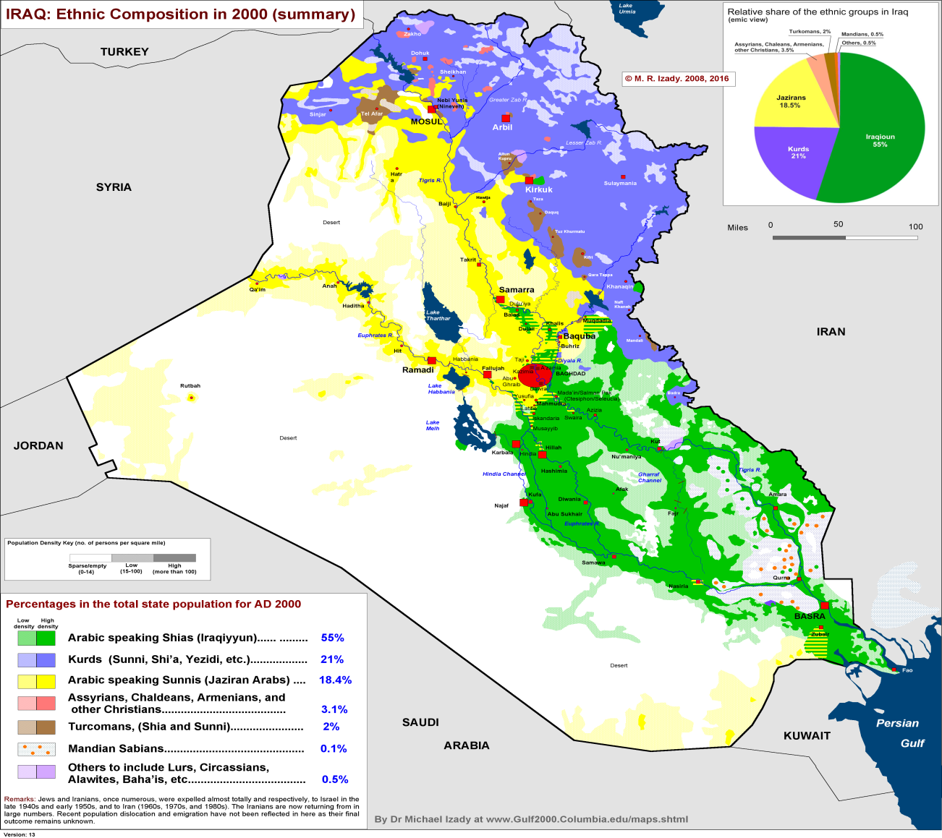

- What nations does ISIS expect to include in its caliphate?

What is the main ideological difference between Al Qaeda and ISIS.

- How did the peaceful demonstrations of Arab Spring initially appear to be antithetical to terrorism?

How did thes uprisings end up strengthening these movements?

- How did the Syrian Civil War contribute to the rise of ISIS?

- How did the invovlement of other nations contribute to the rise of ISIS?

- How did the leadership put into place in Iraq after the US invasion help lead to the rise of ISIS?

- Explain the origins of the name ISIS

- What regions of Iraq were captured by ISIS in 2014? What historical term was used by ISIS to describe their state? Where does this term come from?

- How has the Syraian Civil war led to the growth of ISIS? Why is this trend particularly troubling?

- What is the current state of ISIS? What are its weaknesses?

32 and 33. Explain why ISIS will be a threat for the foreseeable future.

